
C++ Document


December 18, 2022
PavanKumar Balija

Table of Contents
Section 1: Introduction 7
1.1 What is C++ 7
1.2 C++ history 7
1.3 What are the Programming Approaches? 7
Procedural-oriented 7
Structural-oriented 7
Object-oriented 7
Section 2: Basics 8
2.1 Compilation process 8
2.2 C++ Program 9
2.3 C++ Data Types 10
2.4 C++ Keywords 10
2.5 C++ Operators 10
2.6 C++ Arrays 11
Single Dimensional Array 11
Multidimensional Array 12
C++ Passing Array to Function 12
Advantages of C++ Array 12
Disadvantages of C++ Array 12
2.7 C++ Functions 13
Call by value 13
Call by Reference 13
Functor 14
Advantage of functions in C 14
2.8 C++ Pointers 15
Double pointer 15
Function Pointer 16
Function Pointer as Function Parameter 16
Array of Function Pointers 17
Typedef for Function Pointer 17
Array of Pointer 18
Pointer of Array 19
Void pointer 19
Advantages of Pointers 19
2.9 C++ Reference 20
Reference to pointer 20
Reference to Array 21
Reference to function 21
Advantages of reference 21
2.10 C++ String 21
String Implementation 22
Advantages of string 23
2.11 C++ Namespaces 23
Sample namespace 23
using directive 23
Using declarative 24
Nested namespace 24
using namespace directive 25
Advantages of namespace 25
2.12 C++ Storage Classes 25
auto 26
register 27
extern 27
static 28
mutable 28
2.13 Memory Layout 29
Text Segment (Code Segment) 29
Data Segment 29
Stack 30
Heap 30
2.14 C++ Dynamic Memory Allocation 30
Advantages 31
2.15 C++ Enumeration 32
2.16 C++ Inline Functions 32
Advantages of inline function 33
Disadvantages of inline function 33
2.17 C++ Const Keyword 33
1. Const variable 34
2. Constant pointer 34
3. Pointer to constant variable 34
4. Constant function Arguments 35
5. Const Member function of class 35
6. Constant Data Members of class 36
7. Constant Objects 37
2.18 C++ explicit & Implicit Keywords 37
Implicit Type Conversion (Type Coercion) 37
Explicit Type Conversion (Type Casting) 38
2.19 C++ Static Keyword 38
Advantage of C++ static keyword 38
C++ Static Field 38
C++ Static Function 39
Class objects as static 39
C++ global static objects 40
Section 3: Object Oriented Programming (OOP) 41
3.1 Introduction to OOPs in C++ 41
Advantages of Oops 41
3.2 Class & Object 41
Class 41
Object 42
3.3 Encapsulation 43
3.4 Data Abstraction 44
Public 44
Private 45
Protected 45
3.5 Polymorphism 46
Compile time polymorphism 46
Run time polymorphism 46
Function Overloading 47
Operator Overloading 49
Virtual Functions 50
Pure Virtual Function 52
Virtual constructor 52
Virtual Destructor 53
What is vTable? 53
Override keyword in virtual 54
3.6 Inheritance 55
Types of Inheritance 58
Advantage of C++ Inheritance 62
3.7 Singleton Class 62
Advantages of Singleton class 63
Section 4: Constructor and Destructor 63
4.1 Constructor 63
Advantages of constructor and destructor 63
Default constructor 63
Parameterized constructor 64
Copy constructor and Copy assignment operator 64
Dynamic constructor 68
Move constructor and Move assignment operator 69
Destructor 70
Can a constructor be private in C++? 71
Section 5: C++ Friend function 72
5.1 Friend function 72
5.2 Friend Class 73
5.3 Advantage of friend function 74
5.4 Disadvantage of friend function 74
Section 6: C++ Templates 75
6.1 Function Template 75
6.2 Class Template 77
Section 7: C++ Smart Pointers 78
7.1 Pointer vs Smart Pointer 78
7.2 Types of Smart Pointers 80
auto_ptr 80
unique_ptr 80
shared_ptr 83
Weak_ptr 85
Section 8: C++ Type Conversions 86
8.1 Implicit Type Conversion 86
8.2 Explicit Type Conversion 86
Section 9: Exception Handling 92
Section 10: C++ STL concepts 102
10.1 About STL (Standard Template Library) 102
10.2 Containers 103
Sequence containers 104
Associative containers 120
Derived containers 130
10.3 Iterators 136
Input Iterator 139
Output Iterator 139
Forward Iterator 141
Bidirectional iterator 142
Random Access Iterator 143
Providers of Iterators 144
Iterators and their Characteristics 145
Advantages of iterator 145
Disadvantages of iterator 145
10.4 Algorithms 145
1. sort 145
2. find 147
3. count 147
4. accumulate (from <numeric>) 147
5. copy 148
6. remove 148
7. reverse 149
8. transform 149
9. unique 150
10. partition 150
11. for_each 151
12. replace 151
13. fill 152
14. max_element 152
15. min_element 153
16. next_permutation 153
17. prev_permutation 154
18. Rabdom_shuffle 154
19. lower_bound 155
20. upper_bound 155
21. binary_search 155
Section 11: C++ Advance concepts 156
C++11 156
C++11 includes the following new language features 156
C++11 includes the following new library features 196
C++14 231
C++14 includes the following new language features 231
C++14 includes the following new library features: 238
C++17 242
C++17 includes the following new language features 242
C++17 includes the following new library features 256
map / set extract, merge 277

Section 1: Introduction

1.1 What is C++
C++ is an object-oriented programming language. It is an extension to C programming.
C++ is a middle-level language, as it encapsulates both high and low-level language features.

1.2 C++ history
C++ programming language was developed in 1980 by Bjarne Stroustrup at bell laboratories of AT&T (American Telephone & Telegraph), located in U.S.A. Bjarne Stroustrup is known as the founder of C++ language.

It was developed for adding a feature of OOP (Object Oriented Programming) in C without significantly changing the C component.
C++ programming is "relative" (called a superset) of C, it means any valid C program is also a valid C++ program.

1.3 What are the Programming Approaches?

Procedural-oriented
If write the program with the help of (LV,GV,GOTO,Function) then that type of approaches is called as “Procedural-oriented”.
EX: C-language, Pascal, Cobal...etc.

Structural-oriented
C is a structural and procedural oriented programming language.
If write the program with the help of (LV,GV,GOTO,Function,Control Statements) then that type of approaches is called as “Structural-oriented”.
EX: C-language, Pascal, Cobal...etc.

Object-oriented
In C++, object-oriented concepts like data hiding, encapsulation, and data abstraction can easily be implemented using keyword class, private, public, and protected access specifiers. Object-oriented makes development and maintenance easier.
EX: C++

Section 2: Basics

2.1 Compilation process
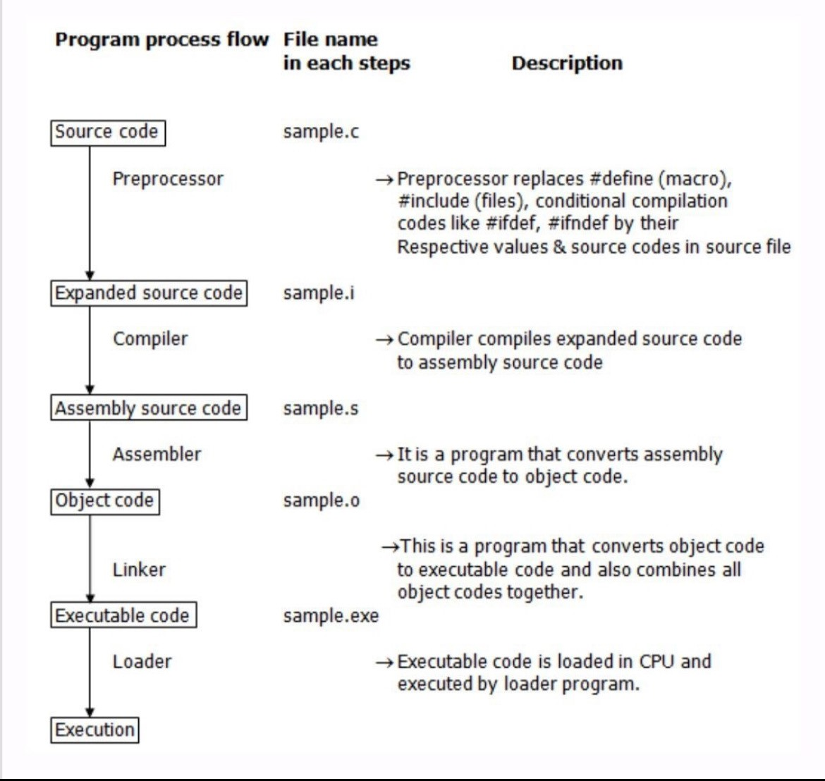
Explanation:
1. Preprocessing
- The preprocessor handles all directives such as #include, #define, and #ifdef.
- It expands macros, includes header files, and removes comments.
- The output is a "pure" source code file ready for compilation.
2. Compilation
- The compiler converts the preprocessed code into assembly code for the target machine.
- This stage checks for syntax errors, performs semantic analysis, and generates the corresponding machine-level instructions.
- Output: Assembly language file (.s file).
3. Assembly
- The assembler converts the assembly code (.s file) into machine code (binary instructions that the CPU can execute).
- The result is an object file (.o or .obj), which is still not a complete program because it may have unresolved references to external libraries or functions.
4. Linking
- The linker combines all object files (.o or .obj) and resolves references to external libraries or functions (like cout from iostream).
- It produces the final executable file (.exe or a.out).
- Any unresolved references at this stage will cause a linker error.
5. Loading (Execution)
- Once compiled and linked, the operating system loads the executable into memory and begins execution.
- This stage involves runtime initialization, such as setting up the stack, heap, and global variables.

2.2 C++ Program
Basic program of C++ below:
#include <iostream>
int main()
{
std::cout<<"Hello World";
return 0;
}
Execution: C++ filename.cpp

- The extension of file is .cpp
- iostream is a header file, I is input and o is output, stream is nothing flow of data one end to another end.
- << is (Insertion operation).
- >> is (Extraction operation).
- Cout << is object of ostream class.
- Cin >> is object of istream class.

2.3 C++ Data Types
There are 4 types of data types in C++ language Below listed:
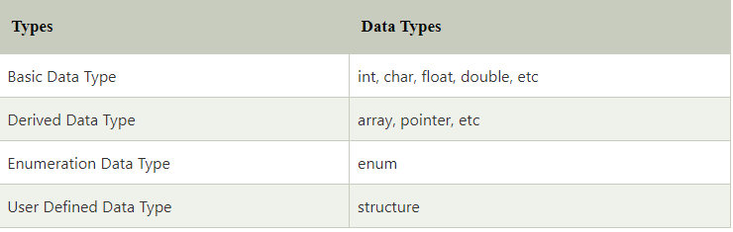

2.4 C++ Keywords
A keyword is a reserved word. You cannot use it as a variable name, constant name etc.
A list of 32 Keywords in C++ Language which are also available in C language are given below:
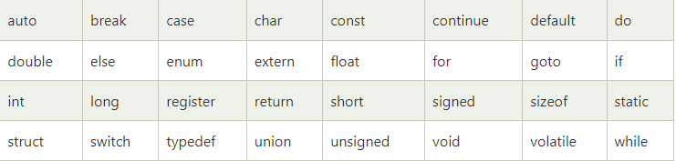
A list of 30 Keywords in C++ Language which are not available in C language are given below:
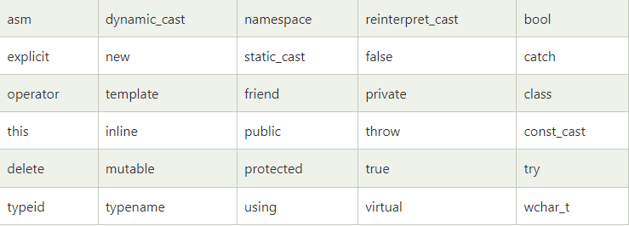

2.5 C++ Operators
An operator is simply a symbol that is used to perform operations. There can be many types of operations like arithmetic, logical, bitwise etc.
There are following types of operators to perform different types of operations in C and C++ languages.
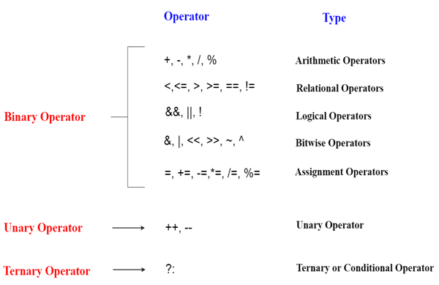

2.6 C++ Arrays
Array is collection of all data types store in contiguous memory location.
There are 2 types of arrays in C++ programming:

Single Dimensional Array
Let's see a simple example of C++ array:
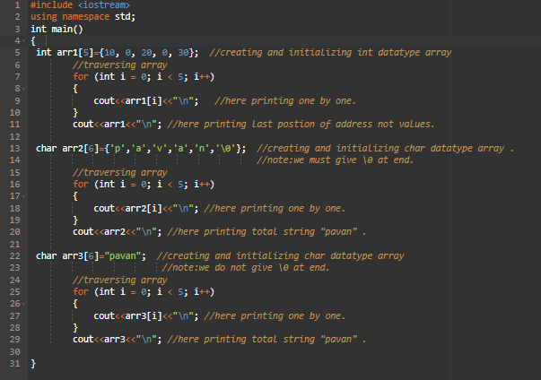
Note: The \0 is essential because it acts as a marker that indicates where the string ends. Without this null terminator, string-handling functions (like strlen, strcpy, strcat, or printf) would not know where to stop processing characters
EX: Char arr3[6] = {‘p’,’a’,’v’,’a’,’n’,’\0’};
If you use Char arr3[6] = “pavan”; The compiler takes care of adding the null terminator. If you string literal.

Multidimensional Array
It is also called as 2D array, 2d array is nothing but collection of 1d array.
Let's see a simple example of C++ 2D array:
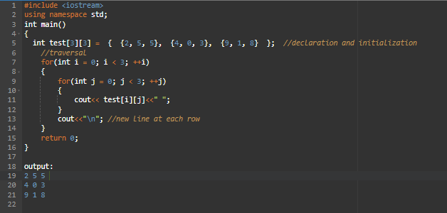

C++ Passing Array to Function
In C++, to reuse the array logic, we can create function. To pass array to function in C++, we need to provide only array name.
Syntax: Functionname (arrayname); //passing array to function
Let's see an example of C++ function which prints the array elements:
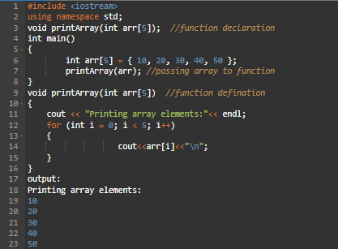

Advantages of C++ Array
- Code Optimization (less code)
- Random Access
- Easy to traverse data
- Easy to sort data etc.

Disadvantages of C++ Array
- Fixed size.

2.7 C++ Functions
set of instruction placed together to perform specific task is called function
Let's see an example of C++ function:
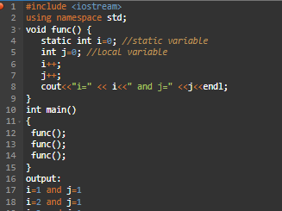

Call by value
The values pass the actual argument, in call by value, original value is not modified.
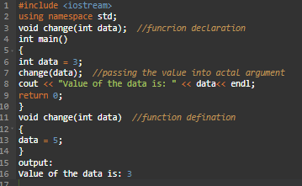

Call by Reference
The address passes the actual arguments, in call by reference, original value is modified because we pass reference (address).
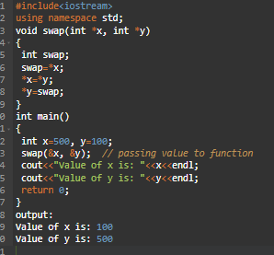

Functor
A functor (also called a function object) is an object that can be called as if it were a function. This is achieved by overloading the operator() for the class. Functors are often used in situations where objects need to behave like functions, such as in algorithms.
Let's see the simple example of Funtor:
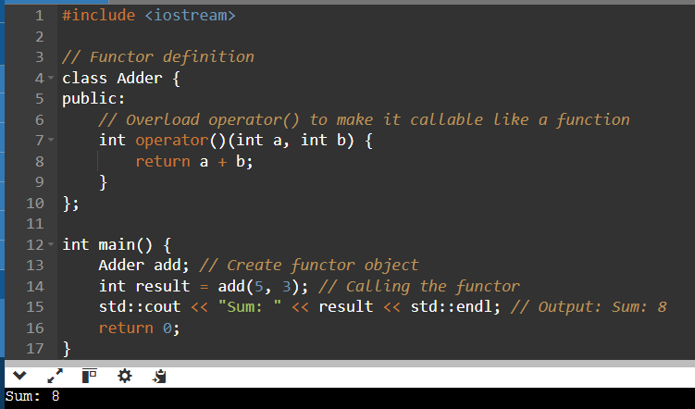
Note: Functors are useful when you need an object that behaves like a function but also needs to hold state, such as when using them with STL algorithms (e.g., std::sort), or when you want to customize the behavior of a function-like object.

Advantage of functions in C
- Code Reusability
- Code optimization

2.8 C++ Pointers
pointer is a variable that stores the address of another variable.
Let's see the simple example of using pointers printing the address and value:
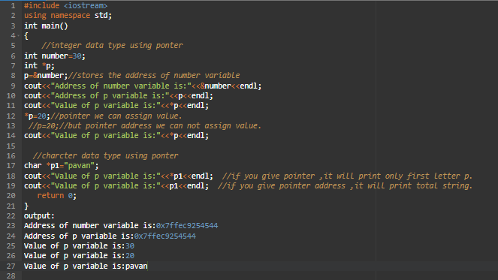

Double pointer
The first pointer is used to store the address of the variable. Second pointer store the address of first pointer.
Let's see the simple example of double pointer:
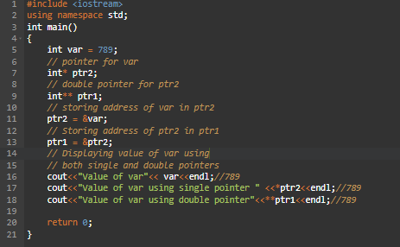

Function Pointer
The function pointer is a pointer used to point functions. It is basically used to store the address of a function. We can call the function by using the function pointer, or we can also pass the pointer to another function as a parameter.
Syntax: int (*FuncPtr) (int,int);
Let's see the simple examples of function pointer:
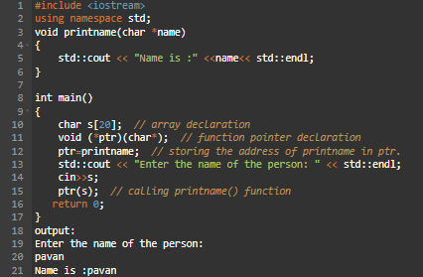

Function Pointer as Function Parameter
Let's see the simple example of Function Pointer as Function Parameter:
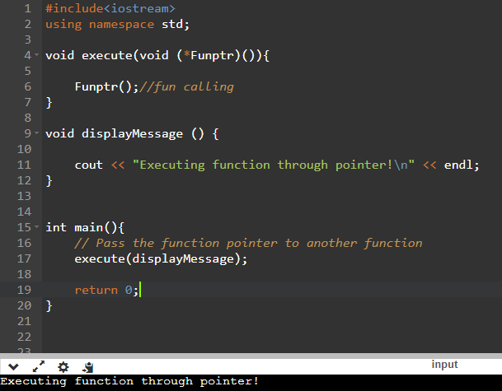

Array of Function Pointers
Let's see the simple example of Array of Function Pointers:
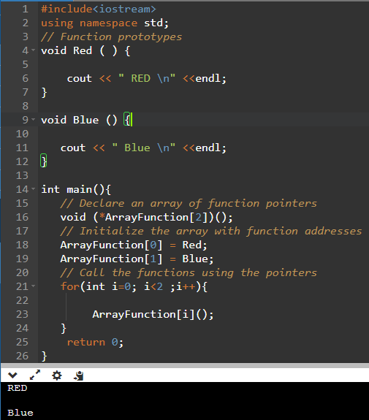

Typedef for Function Pointer
Let's see the simple example of Typedef for Function Pointer:
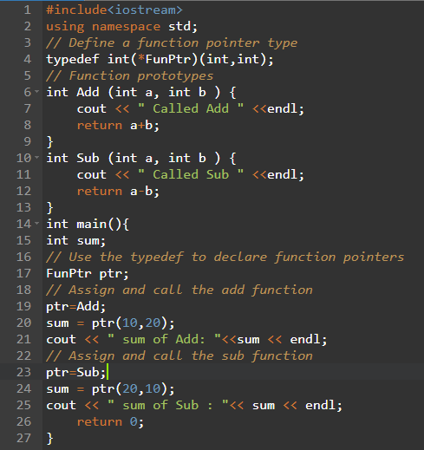

Array of Pointer
An array of pointers is an array that consists of variables of pointer type, which means that the variable is a pointer addressing to some other element. Suppose we create an array of pointer holding 5 integer pointers; then its declaration would look like.
Syntax: datatype *ptr[size of ele]; // array of 5 integer pointer.
Let's see the simple example of array of pointer:
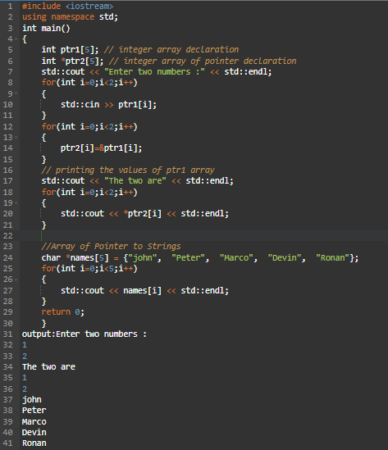
Note:
- With *: cout << *name[i]; prints the first character of each string in the array.
- Without *: cout << name[i]; prints each entire string in the array.

Pointer of Array
In C++, Pointers are variables that hold addresses of other variables. Not only can a pointer store the address of a single variable, it can also store the address of cells of an array.
Syntax: data_type (*var_name)[size_of_array];
Let's see the simple example of pointer of array:
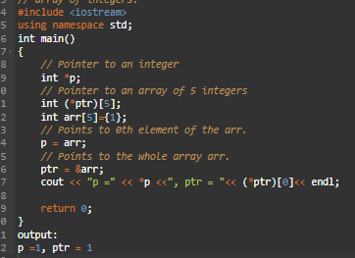

Void pointer
void pointer is pointing to all data types. which doesn't have any specific type.
Syntax: void *ptr;

Let's see the simple example of void pointer:
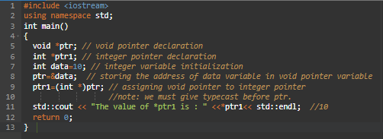

Advantages of Pointers
- Pointer reduces the code and improves the performance, it is used to retrieving strings, trees etc. and used with arrays, structures and functions.
- We can return multiple values from function using pointer.
- It makes you able to access any memory location in the computer's memory.

2.9 C++ Reference
It is used to provided alias name/duplicate name for an existing variable is called “Reference”.
Syntax: data_type &new_name = existing_name;
- Reference variable must be initialized.
- Reference variable should not be used const variable.
- Reference variable does not get a separate memory.
- One reference variable can refer only one variable on its lifetime.
- One variable can have multiple references.
- Reference to reference not possible.
- Reference variable work like a pointer(internally).
- Reference variable automatically dereference(internally).
- Pointer to reference is not possible.
Let's see the simple example of reference variable:
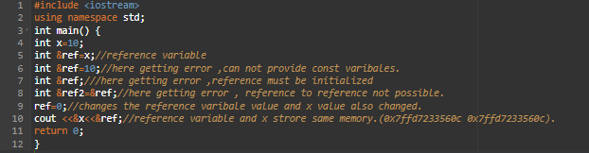

Reference to pointer
Provide the alias name to the pointer variable is called “Reference to pointer”.
Syntax: data_type* &new_name = existing_name;
Let's see the simple example of reference variable:
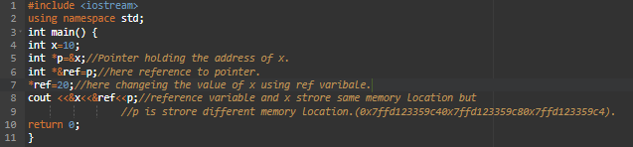
Note: pointer to reference not possible because of reference variable does not have any separate memory location.
Ex: int &*ref=p;

Reference to Array
Provide the alias name to the array is called “Reference to Array”.
Syntax: data_type (&new_name) [size]= existing_name;
Let's see the simple example of reference variable:
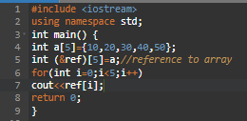
Note: array to reference is not possible.
Ex: int &ref[5]=a;

Reference to function
Provide the alias name to the function is called “Reference to function”.
Syntax: data_type &function_name (arg);
Let's see the simple example of reference variable:
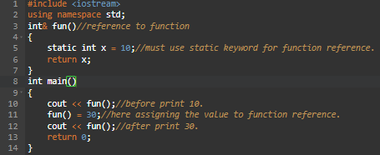

Advantages of reference
- In references - To access the value of actual variable, we do not need to explicitly dereference the reference variable, they get de-referenced automatically.
- Reference variables are cleaner and modish as compared to the pointers; they can also be used while passing in the function as arguments, known as call by references.

2.10 C++ String
string is a data type, it is printed n number of character, with space and without space. Size of string in 64 bits is 32bits (4 bytes).
Syntax: string variable_name;

Let’s see example of string:
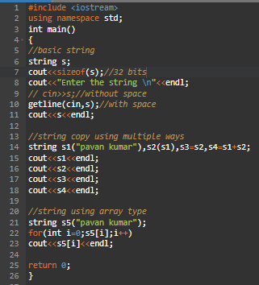

String Implementation
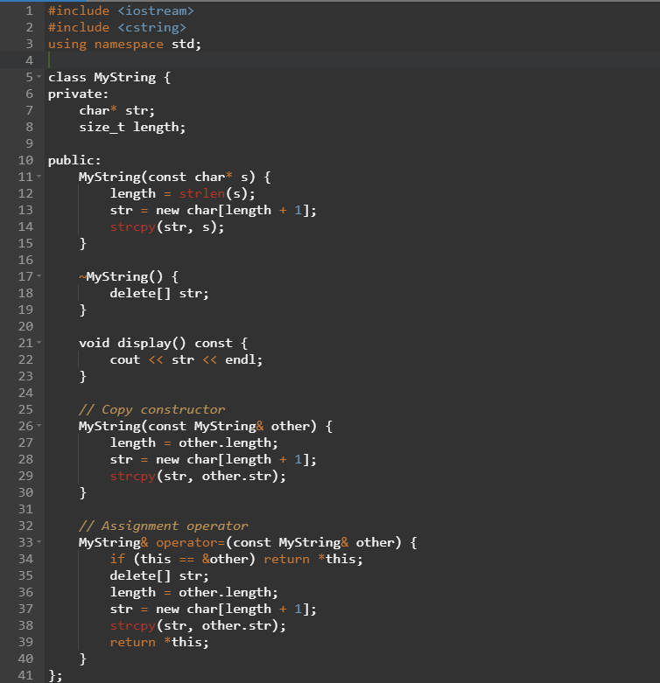
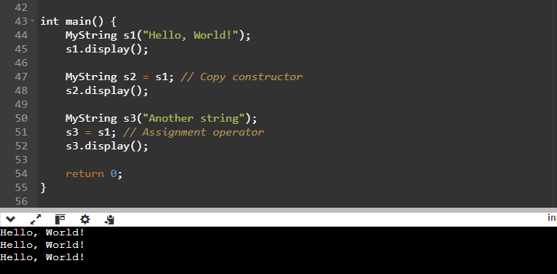

Advantages of string
String Pool is possible because String is immutable. Hence saving memory and fast performance. More secure since we can't change the value of string object. Thread safety while working with strings in a multi-threaded environment.

2.11 C++ Namespaces
A namespace is a declarative region that provides a scope to the identifiers (the names of types, functions, variables, etc) inside it. Namespaces are used to organize code into logical groups and to prevent name collisions that can occur especially when your code base includes multiple libraries.
Syntax: namespace namespace_identifier {
Definitions of variables,functions and classes etc..
}

Sample namespace
Let's see the simple example of C++ Namespaces:
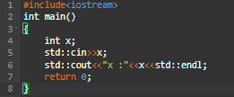

using directive
The using directive allows the all names in a namespace to be used without the namespace-name as An explicit qualifier.
Syntax: using namepace std;

Let's see the simple example of using directive:
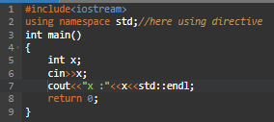

Using declarative
The using declarative allows an individual name to be used without qualification.
Let's see the simple example of Using declarative:
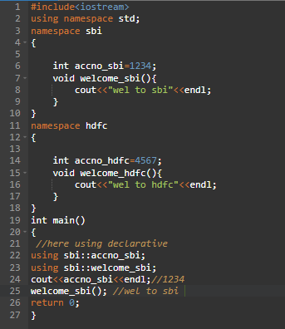

Nested namespace
Namespace inside another name space as an element is called nested namespace.
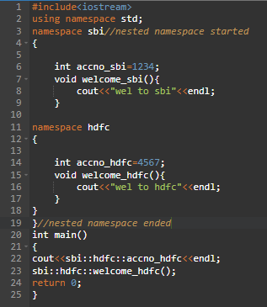

using namespace directive
Let's see the simple example of using namespace directive:
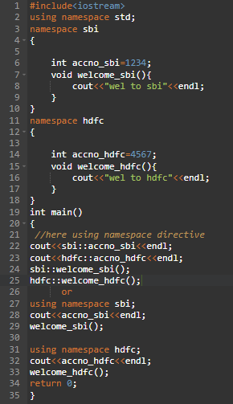

Advantages of namespace
- In one program, namespace can help define different scopes to provide scope to different identifiers declared within them.
- By using namespace - the same variable names may be reused in a different program.

2.12 C++ Storage Classes
Storage Classes are used to describe the features of a variable/function. These features basically include the scope, visibility and life-time which help us to trace the existence of a particular variable during the runtime of a program.
Syntax: storage_class var_data_type var_name;
C++ uses 5 storage classes, namely:
- auto
- register
- extern
- static
- mutable
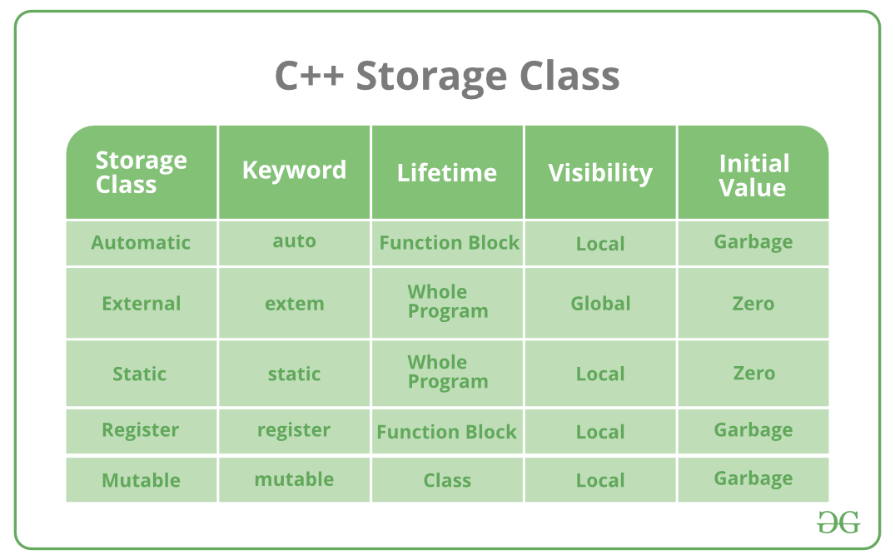
Below is the detailed explanation of each storage class:

auto
It is the default storage class for all local variables. The auto keyword is applied to all local variables automatically.
Let’s see example of auto:
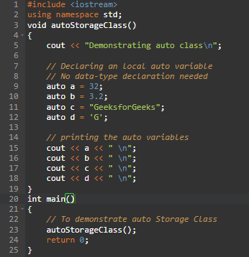

register
The register variable allocates memory in register than RAM. Its size is same of register size. It has a faster access than other variables.
It is recommended to use register variable only for quick access such as in counter.
Note: We can't get the address of register variable.
Let’s see example of register:
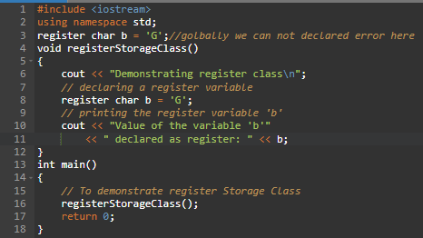

extern
The extern variable is visible to all the programs. It is used if two or more files are sharing same variable or function.
Let’s see example of extern:
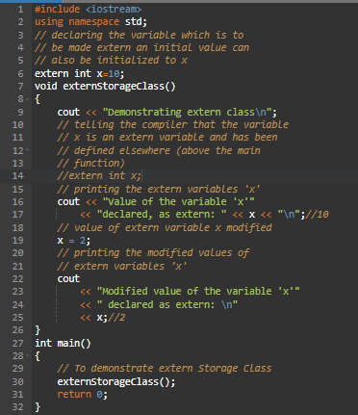

static
The static variable is initialized only once and exists till the end of a program. It retains its value between multiple functions call.
The static variable has the default value 0 which is provided by compiler.
Let’s see example of static:
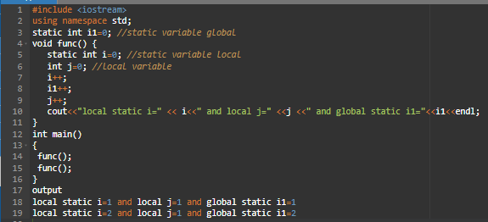

mutable
The keyword mutable is mainly used to allow a particular data member of const object to be modified. When we declare a function as const, this pointer passed to function becomes const. Adding mutable to a variable allows a const pointer to change members.
Let’s see example of mutable:
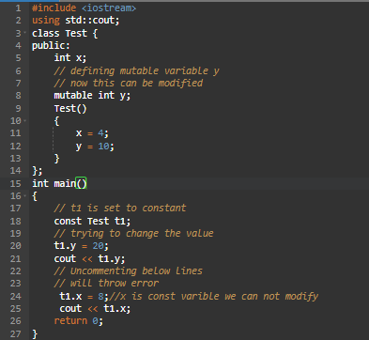

2.13 Memory Layout
The memory layout can be shown below:
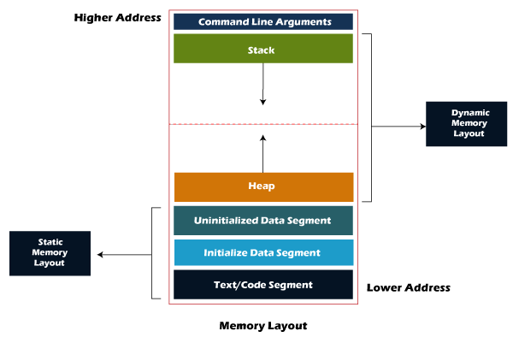

Let's understand each section one by one.

Text Segment (Code Segment)
What it is:
- Stores compiled machine instructions (the actual code).
- Read-only to avoid accidental modification.
- Loaded from the executable file (like .exe, a.out) into RAM.

Why in RAM, not HDD?
RAM is faster because it's connected directly to CPU via data/address bus.
HDD is slow due to serial access.

Example:
void sayHello() {
std::cout << "Hello!" << std::endl;
}
The machine code of sayHello() is stored in the text segment.

Data Segment
Divided into two parts:
- Initialized Data Segment
- Stores global/static variables with a value.

- Loaded with the initial value during program load.

int x = 5; // Stored in initialized data segment
static int y = 10; // Also stored here

- Uninitialized Data Segment (.bss)
- Stores global/static variables without a value.
- They are automatically initialized to zero.

int z; // Stored in .bss segment (value = 0 by default)
static int count; // Also in .bss

Stack
What it is:
Stores:
- Function arguments
- Local variables
- Return addresses
- Memory is managed automatically.
- LIFO (Last In, First Out) structure.

Key Point: Allocated at compile time (Static Memory Allocation)

void add(int a, int b) {
int sum = a + b; // a, b, sum → stored in stack
}
Every function call creates a stack frame.

Heap
What it is:
- Used for dynamic memory allocation.
- Memory is manually allocated and freed by the programmer.
- Grows upward (opposite direction of the stack).

Functions used:
malloc(), calloc() → allocate memory
free() → deallocate memory

Example:
int* ptr = (int*)malloc(sizeof(int)); // Memory allocated in heap
*ptr = 100;
free(ptr); // Always free heap memory!

2.14 C++ Dynamic Memory Allocation
- Dynamic memory allocated heap section.
- Dynamic memory allocated in C++ by new and delete operators.
- new operator used to allocate the memory in heap section.
- delete operator used to de-allocate the memory in heap section.
- new operator automatically finds the size of data type.
- new operator returns the exact pointer type.
- No need of typecasting.
- Memory initialization also possible.
Syntax for new operator: Variable: new data_type;
Array: new data_type[size];
Syntax for delete operator: Variable: delete pointer_variable
Array: delete [] pointer_variable
Let’s see examples of new and delete operators:
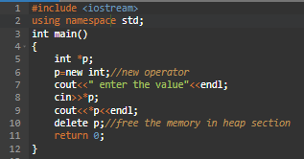
Let’s see example of initialization new operators:
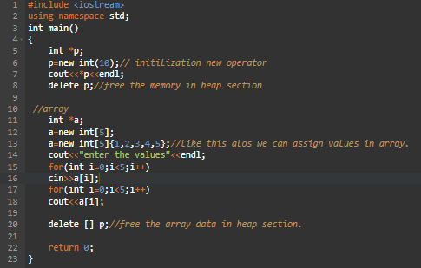
Let’s see example of double pointer using new operators:
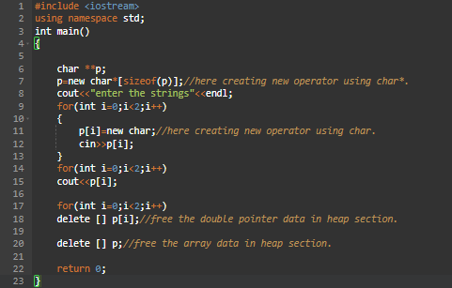

Advantages
C++ supports dynamic allocation and deallocation of objects using the new and delete operators. These operators allocate memory for objects from a pool called the free store (also known as the heap).

2.15 C++ Enumeration
- Enum in C++ is a data type that contains fixed set of constants.
- It can be used for days of the week (SUNDAY, MONDAY, TUESDAY, WEDNESDAY, THURSDAY, FRIDAY and SATURDAY) , directions (NORTH, SOUTH, EAST and WEST) etc.
- The C++ enum constants are static and final implicitly.
- C++ Enums can be thought of as classes that have fixed set of constants.
Syntax: enum enumerated-type-name {value1, value2, value3…..valueN};
Points to remember for C++ Enum:
- enum improves type safety
- enum can be easily used in switch
- enum can be traversed
- enum can have fields, constructors and methods
- enum may implement many interfaces but cannot extend any class because it internally extends Enum class
Let’s see example of enum:
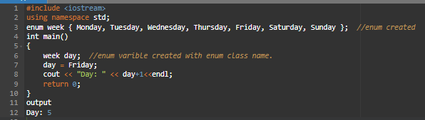

2.16 C++ Inline Functions
If make a function as inline, then the compiler replaces the function calling location with the function definition of the inline function at compile time.
Any changes made to an inline function will require the inline function to be recompiled again because the compiler would need to replace all the code with a new code; otherwise, it will execute the old functionality.
Syntax for an inline function:
inline return_type function_name(parameters) {
// function code?
}

Let’s see example of inline function:
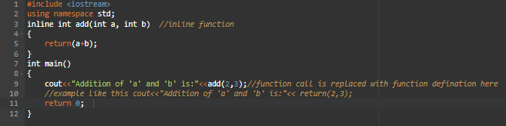
We cannot provide the inline to the functions in the following circumstances:
- If a function is recursive.
- If a function contains a loop like for, while, do-while loop.
- If a function contains static variables and a switch or go to statement.
An inline function can be used in the following scenarios:

Advantages of inline function
- Faster Execution: Inline functions eliminate the overhead of function calls by directly inserting the function's code into the caller, improving execution speed.
- Reduced Function Call Overhead: No stack operations (like pushing/popping parameters or return addresses) are needed, as the function code is directly expanded.
- Improved Readability with Efficiency: Combines the clarity of function calls with the performance of direct code insertion.

Disadvantages of inline function
- Increased Code Size: Inline functions duplicate code at each call site, which can lead to larger binary size (code bloat).
- Reduced Debugging Ease: Debugging becomes harder since there's no distinct function call in the stack trace.
- Compiler Dependency: The compiler decides whether to inline a function, so it might not always happen, even if requested.

2.17 C++ Const Keyword
This section will discuss the const keyword in the C++ programming language. It is the const keywords used to define the constant value that cannot change during program execution. It means once we declare a variable as the constant in a program, the variable's value will be fixed and never be changed. If we try to change the value of the const type variable, it shows an error message in the program.

Use const keywords with different parameters:

1. Const variable
It is a const variable used to define the variable values that never be changed during the execution of a program. And if we try to modify the value, it throws an error.
Syntax: const data_type variable_name
Let’s see example of const variables:
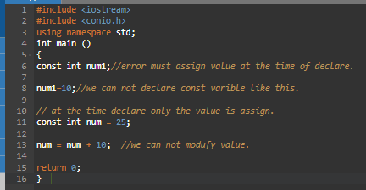

2. Constant pointer
To create a const pointer, we need to use the const keyword before the pointer's name. We cannot change the address of the const pointer after its initialization, which means the pointer will always point to the same address once the pointer is initialized as the const pointer.
Syntax: data_type* const variable_name
Let’s see example of const pointer:
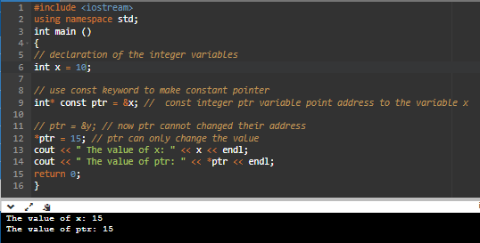

3. Pointer to constant variable
It means the pointer points to the value of a const variable that cannot change.
Syntax: Const int* x; ( or ) char const* y;
Let’s see example of pointer to const:
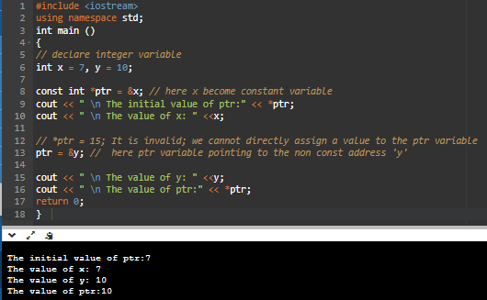

4. Constant function Arguments
We can declare the function arguments as the constant argument using the const keyword. And if the value of function arguments is declared const, it does not allow changing its value.
Syntax: return_type fun_name (const int x) {}
Let’s see example of const function argumentes:
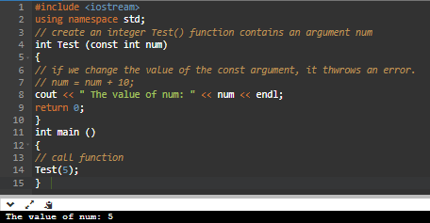

5. Const Member function of class
- A const is a constant member function of a class that never changes any class data members, and it also does not call any non-const function.
- It is also known as the read-only function.
- We can create a constant member function of a class by adding the const keyword after the name of the member function.
Syntax: return_type mem_fun() const {}
Let’s see example of const member function:
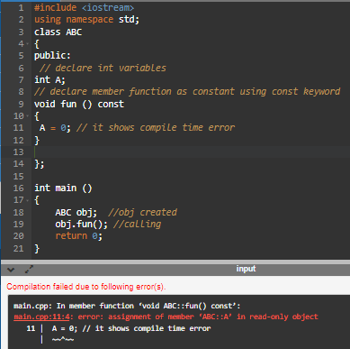

6. Constant Data Members of class
Data members are like the variable that is declared inside a class, but once the data member is initialized, it never changes, not even in the constructor or destructor. The constant data member is initialized using the const keyword before the data type inside the class. The const data members cannot be assigned the values during its declaration; however, they can assign the constructor values.
Let’s see example of Constant Data Members of class:
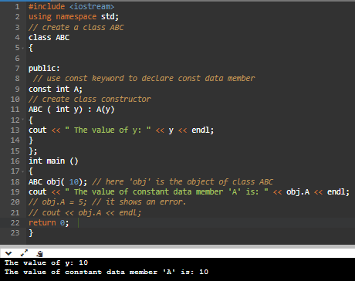

7. Constant Objects
When we create an object using the const keyword, the value of data members can never change till the life of the object in a program. The const objects are also known as the read-only objects.
Syntax: const class_name obj_name;
Let’s see example of const object:
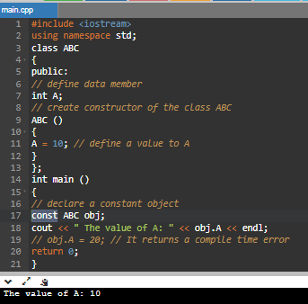

2.18 C++ explicit & Implicit Keywords

Implicit Type Conversion (Type Coercion)
In C++, implicit type conversion, also known as type coercion or automatic type conversion, happens when the compiler automatically converts one data type into another without requiring any explicit action from the programmer.
This is also referred to as "type promotion." For example, when you assign an integer value to a floating-point variable, an implicit conversion from int to float takes place.
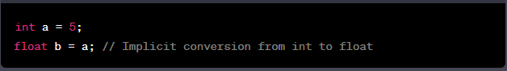
Implicit Constructor Calls: When you create an object of a class using the constructor, the constructor is implicitly called to initialize the object. This is the standard way of creating objects in C++.
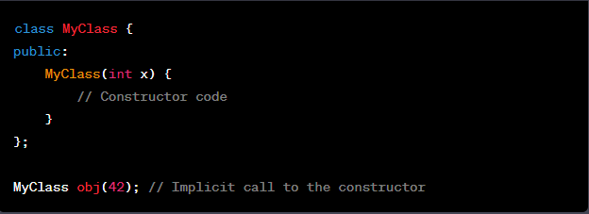

Explicit Type Conversion (Type Casting)
In contrast, explicit type conversion, also known as type casting, requires the programmer to specify the type conversion explicitly. It tells the compiler to convert a value from one data type to another in a way that might result in data loss or other implications. This can be done using casting operators like static_cast, dynamic_cast, const_cast, and reinterpret_cast.
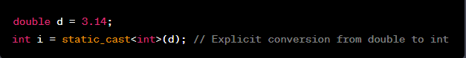

2.19 C++ Static Keyword
In C++, static is a keyword or modifier that belongs to the type not instance. So, instance is not required to access the static members. In C++, static can be field, method, constructor, class, properties, operator and event.

Advantage of C++ static keyword
Memory efficient: Now we don't need to create instance/object for accessing the static members, so it saves memory. Moreover, it belongs to the type, so it will not get memory each time when instance is created.
Static functions: Stored in the text segment (code segment) of memory.
Static variables: Stored in the data segment (static memory area).

C++ Static Field
A field which is declared as static is called static field. Unlike instance field which gets memory each time whenever you create object, there is only one copy of static field created in the memory. It is shared to all the objects.
It is used to refer the common property of all objects such as rateOfInterest in case of Account, companyName in case of Employee etc.
Let’s see example of static field:
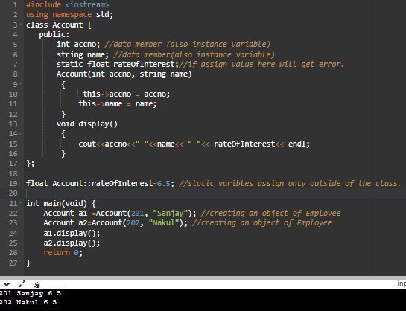

C++ Static Function
Just like the static data members or static variables inside the class, static member functions also do not depend on object of class. We are allowed to invoke a static member function using the object and the ‘.’ operator but it is recommended to invoke the static members using the class name and the scope resolution operator. Static member functions are allowed to access only the static data members or other static member functions, they cannot access the non-static data members or member functions of the class.
Let’s see example of static function:
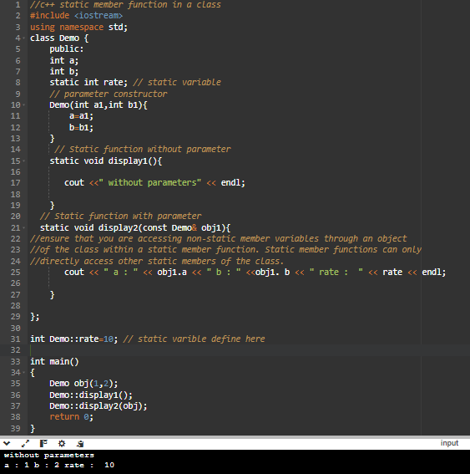

Class objects as static
Just like variables, objects also when declared as static have a scope till the lifetime of program.
Let’s see example of static object:
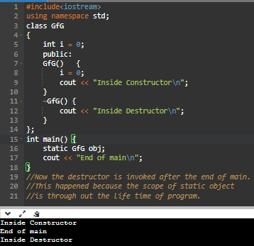

C++ global static objects
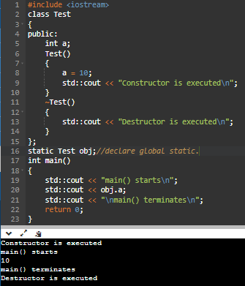

Some interesting facts about static member functions in C++:
- static member functions do not have this pointer.
- A static member function cannot be virtual.
- A static member function cannot be declared const, volatile, or const volatile.
- Member function declarations with the same name and the name parameter-type-list cannot be overloaded.
Let’s see example of all above:
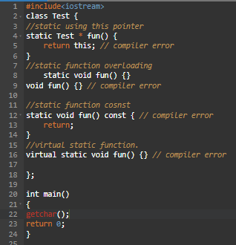

Section 3: Object Oriented Programming (OOP)

3.1 Introduction to OOPs in C++
OOPs (Object Oriented Programming System):
Object means a real word entity such as pen, chair, table etc. Object-Oriented Programming is a methodology or paradigm to design a program using classes and objects. It simplifies the software development and maintenance by providing some concepts:
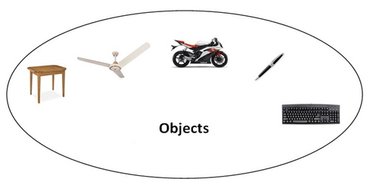

- Object
- Class
- Inheritance
- Polymorphism
- Abstraction
- Encapsulation

Advantages of Oops
- Productivity of software development increased
- Software maintenance improved
- Quicker improvement
- Good quality software
- Cost of development lowered

3.2 Class & Object

Class
- A Class is a user defined datatype which has collection of data member and member function.
- Size of the class depends only on the data members.
- The size of the empty class is 1 byte (to show the variable existence C++ compiler create the min 1 byte of memory).
- By default, All the members of the class are present in private section.

Syntax of a class:
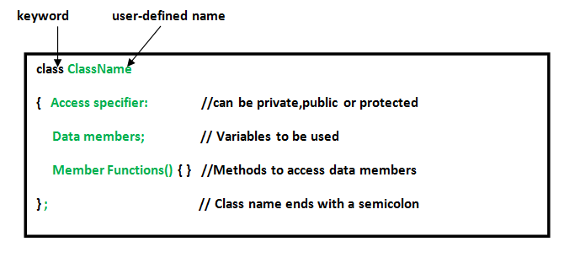

Object
- Object is instance of a class.
- Object is real world entity of a class.
Syntax of an object: ClassName ObjectName;
Let’s see example of class and object:
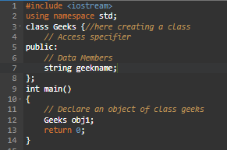

Member Functions in Classes:
There are 2 ways to define a member function:
- Member function: function is a member of a class is called “member function”.
- Non- Member function: function does not belong to same class is called “non-member function”.

Let’s see example of functions in a class:
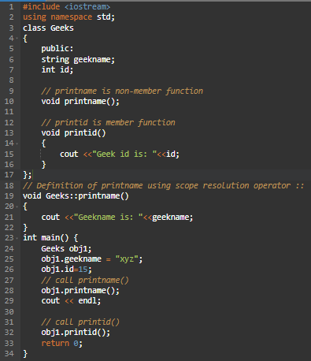

3.3 Encapsulation
Encapsulation is a wrapping up of a data member and member function into a single unit is a called as “encapsulation”.
Advantages: Data security.
Let’s see example of encapsulation:
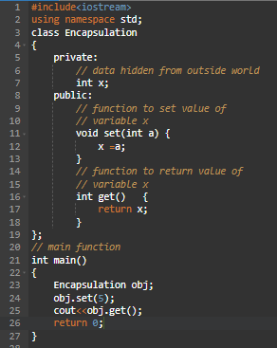

3.4 Data Abstraction
Data Abstraction means hiding the internal details and showing only essential features of an object.
Advantages: Data hiding.
There are 3 types of access modifiers available in C++:

Public
Public is a low-level security, Writing the instruction under public section can access by all the parts of the code.
Let’s see example of public:
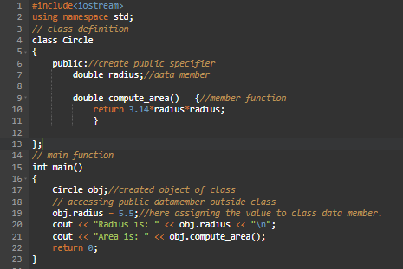

Private
Private is a very high-level security, Writing the instruction under private section can access by particular part of the code.
Let’s see example of private:
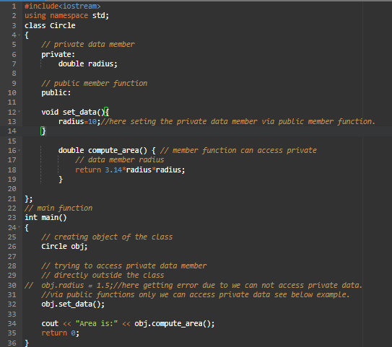

Protected
The protected access modifier is similar to the private access modifier in the sense that it can’t be accessed outside of its class unless with the help of a friend class. The difference is that the class members declared as Protected can be accessed by any subclass (derived class) of that class as well.
Let’s see example of protected:
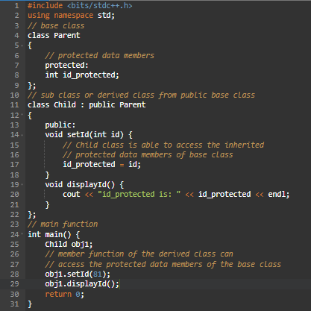

3.5 Polymorphism
A single entity can exit in more than one form is called as “polymorphism”.
There are two types of polymorphism in C++:
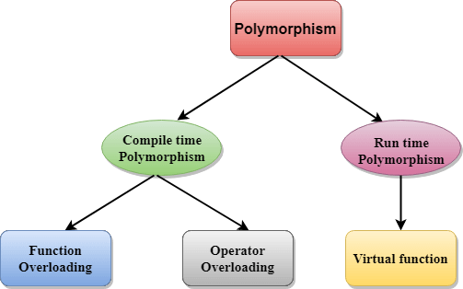

Compile time polymorphism
- The function to be invoked is known at the compile time.
- It is also known as overloading, early binding or static binding.
- Overloading is a compile time polymorphism where more than one method is having the same name but with the different number of parameters or the type of the parameters.
- It is achieved by function overloading and operator overloading.
- It provides fast execution as it is known at the compile time.
- It is less flexible as mainly all the things execute at the compile time.

Run time polymorphism
- The function to be invoked is known at the run time.
- It is also known as overriding, late binding or Dynamic binding.
- Overriding is a run time polymorphism where more than one method is having the same name, number of parameters and the type of the parameters.
- It is achieved by virtual functions and pointers.
- It provides slow execution as it is known at the run time.
- It is more flexible as all the things execute at the run time.

Function Overloading
Defining multiple function with the same name is called as “function overloading”. These functions must be differed in their numbers, orders and types of arguments.
Parameters should have a different type:
Ex: add (int a, int b)
add (double a, double b)
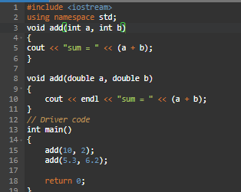

Parameters should have a different number:
Ex: add (int a, int b)
add (int a, int b, int c)
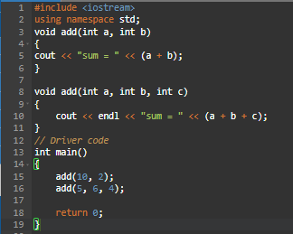

Parameters should have a different sequence of order:
Ex: add (int a, double b)
add (double a, int b)
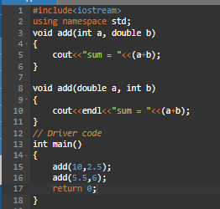

Function overloading on const keyword:
C++ allows functions to be overloaded on the basis of the const-ness of parameters only if the const parameter is a reference or a pointer.
Let’s see example of function overloading on const keyword:
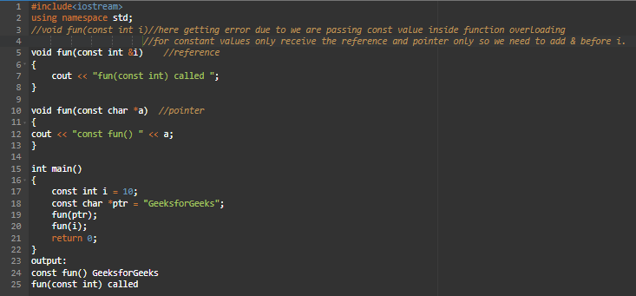

Operator Overloading
C++ the facility of giving a special meaning to an operator without changing the existing meaning is referred to as “operator overloading”.
Syntax: return_type class_name : : operator op(argument_list) {
// body of the function.
}
Operator that cannot be overloaded are as follows:
- Scope operator (: :)
- Sizeof operator
- member selector(.)
- member pointer selector (*)
- ternary operator (?:)
let’s see examples of operator overloading 1:
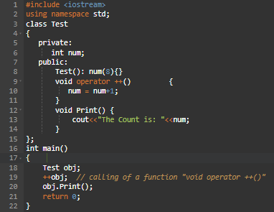
let’s see examples of operator overloading 2:
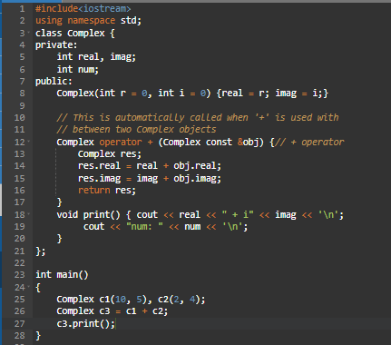

Virtual Functions
- The virtual keyword is used to avoid the duplication of the data.
- In C++, the virtual keyword is used to allow function overriding in inheritance.
It ensures that the derived class's function is called, even if you use a base class pointer.
- A C++ virtual function is a member function in the base class that you redefine in a derived class. It is declared using the virtual keyword.
- There is a necessity to use the single pointer to refer to all the objects of the different classes. So, we create the pointer to the base class that refers to all the derived objects. But, when base class pointer contains the address of the derived class object, always executes the base class function. This issue can only be resolved by using the 'virtual' function.
- When the function is made virtual, C++ determines which function is to be invoked at the runtime based on the type of the object pointed by the base class pointer.
Rules of Virtual Function
- Virtual functions must be members of some class.
- Virtual functions cannot be static members.
- They are accessed through object pointers.
- They can be a friend of another class.
- A virtual function must be defined in the base class, even though it is not used.
- The prototypes of a virtual function of the base class and all the derived classes must be identical. If the two functions with the same name but different prototypes, C++ will consider them as the overloaded functions.
- We cannot have a virtual constructor, but we can have a virtual destructor.
- We should create pointer to base class only not in derived class.

Let’s see examples of virtual and without virtual programmes:
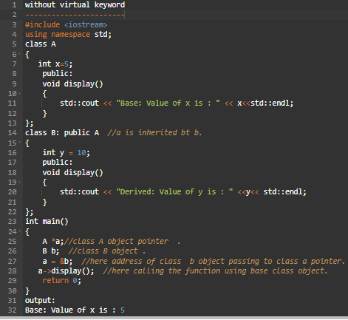

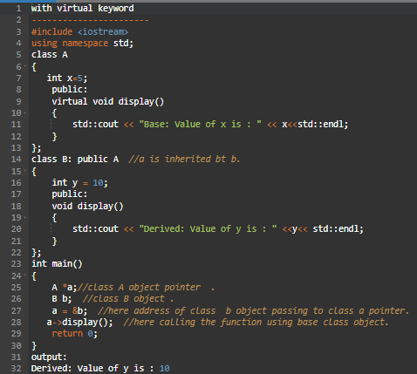

Pure Virtual Function
A virtual function that is declared but not defined in a bass class is referred to as a pure virtual function.
Abstract class:
- If a class contain at least one pure virtual function is called as “abstract class”.
- You cannot create objects of an abstract class.It’s meant to be inherited by other classes that provide the actual implementation.
Syntax: virtual <return_type> function__name(arguments)=0;
Let’s see example of Abstract class:
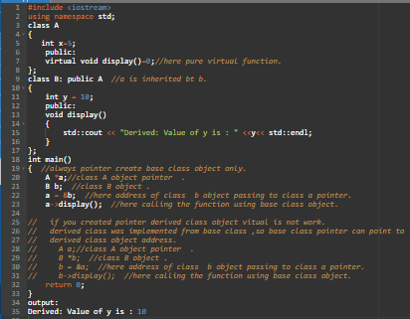

Virtual Copy Constructor
A virtual copy constructor is a way to achieve polymorphic copying when working with base class pointers.
Let’s see example of virtual copy constructor:
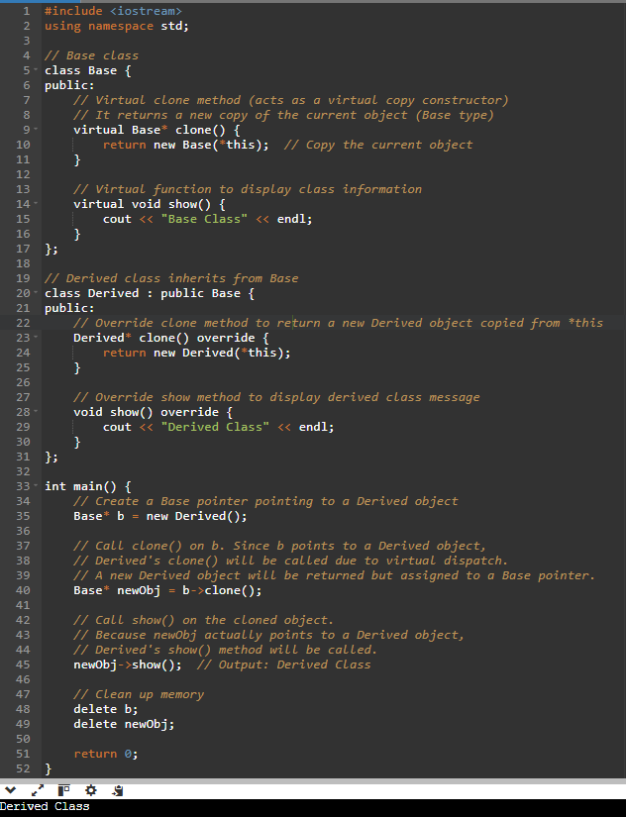

Virtual constructor
Virtual constructor is not possible in virtual.
- Constructor executed before project creation, without constructor object will not create. If object not created, then no use of virtual function because virtual function (vtable) creates after object creation only.
- If you combined virtual and constructor as a single unity then ambiguity will occur, because of complier does not know which property need to take either constructor or virtual that’s way
- complier unable to create the object – causes ambiguity.
- You can use a virtual destructor (not constructor) for polymorphic deletion.
- To achieve runtime object creation polymorphically, use the Factory Design Pattern.

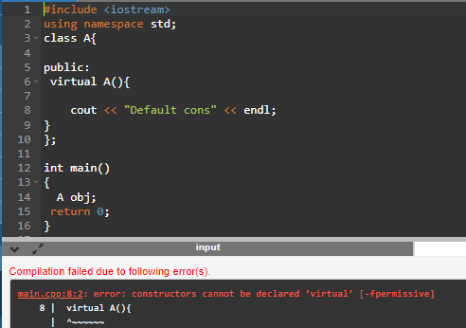
Since constructors can't be virtual, we can use a factory method to return objects dynamically.
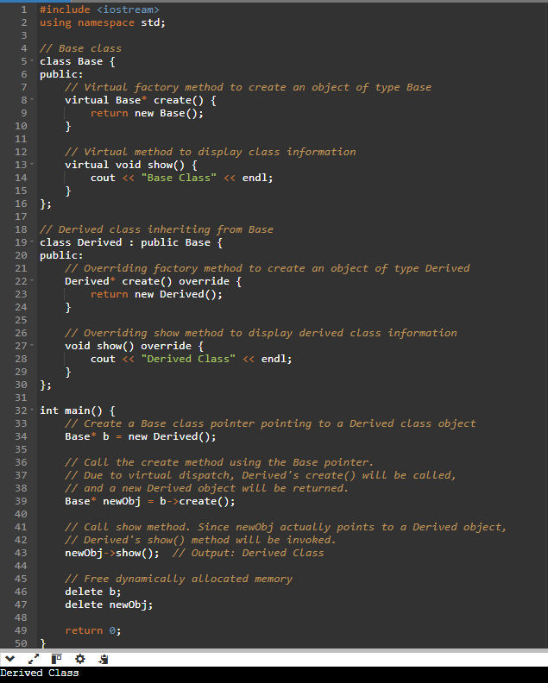

Virtual Destructor
A virtual destructor ensures that the destructor of the derived class gets called when deleting an object via a base class pointer.
Use of Virtual Destructor:
- A virtual destructor is used when you delete a derived class object using a base class pointer.
- The Derived destructor is never called, leading to memory leaks.To resolve this, you need to declare the destructor in the Base class as virtual. This ensures that the destructor of the derived class is called when an object is deleted through a base class pointer.
Let’s see example of Virtual Destructor:
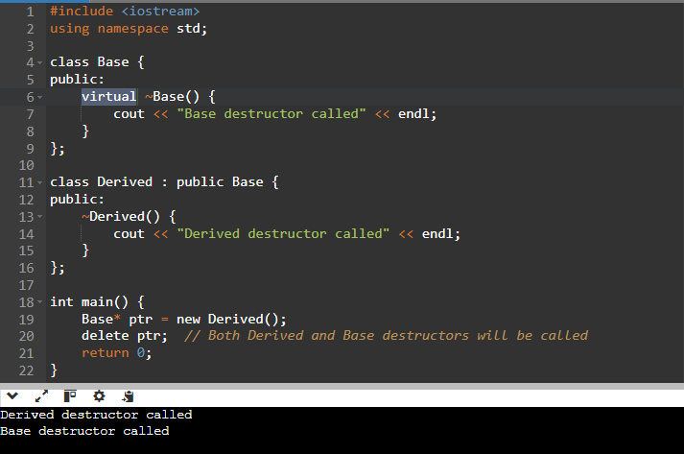

Pure Virtual Destructor
A pure virtual destructor is used when a class is abstract but still requires a destructor.
Let’s see example of Pure Virtual Destructor:
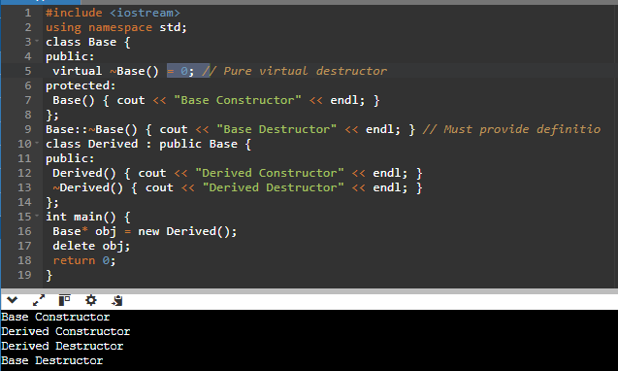

Virtual Class
- Used in multiple inheritance to avoid the "Diamond Problem".
- Prevents duplicate copies of base class members in derived classes.
Let’s see example of Virtual Class:

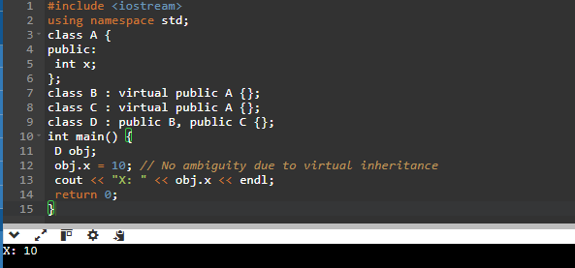
Note: Without virtual , x would be ambiguous in D .

What is vTable?
The vTable, or Virtual Table, is a table of function pointers that is created by the compiler to support dynamic polymorphism. Whenever a class contains a virtual function, the compiler creates a Vtable for that class. Each object of the class is then provided with a hidden pointer to this table, known as Vptr.
The Vtable has one entry for each virtual function accessible by the class. These entries are pointers to the most derived function that the current object should call.
What is vPtr (Virtual Pointer)?
The virtual pointer or _vptr is a hidden pointer that is added by the compiler as a member of the class to point to the VTable of that class. For every object of a class containing virtual functions, a vptr is added to point to the vTable of that class. It’s important to note that vptr is created only if a class has or inherits a virtual function.
Understanding vTable and vPtr here is a simple example with class Base and class Derived:
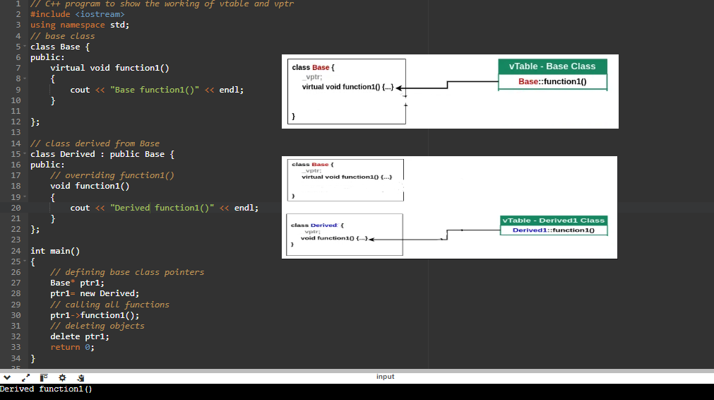

Override keyword in virtual
In C++, the override keyword serves as a way to explicitly indicate that a function in a derived class is intended to override a virtual function declared in a base class. It helps in ensuring that the function is indeed overriding a virtual function from the base class, providing additional safety and clarity in your code.
Here's how the override keyword is used and its purpose:
Safety and Clarity: When you use the override keyword, it explicitly tells the compiler that the function is supposed to override a virtual function from the base class. This helps catch errors at compile time if the function signature doesn't match any virtual function in the base class. It also improves code readability, making it clear that a function is intended to be an override.
Preventing Mistakes: Without the override keyword, if you mistakenly misspell the function name or get the signature wrong in the derived class, you might think you're overriding a function when you're not. This could lead to unexpected behavior in your program.

Here's a simple example demonstrating the usage of the override keyword:
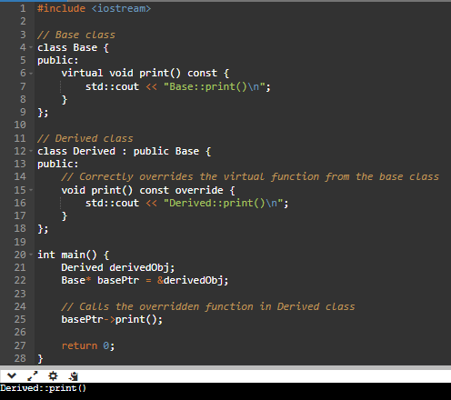

3.6 Inheritance
- Inheritance is the process of acquiring the properties of one class into another class.
- Sub Class: The class that inherits properties from another class is called Subclass or Derived Class.
- Super Class: The class whose properties are inherited by a subclass is called Base Class or Superclass.
- new class is derived class, existing class is base class.
- Base class can be accessing only bass class members and object.
- Derived class can be accessing base + derived class members and objects.
- Syntax: class base {
base class member;
};
class derived: public/protect/private(base) {
derived class member;
};
- Private member of base class is not inheritance of derived class.
- In C++, the default mode of visibility is private.
- Base class constructor and destructors can't be inheritance (because of con and des scope of belongs to same class).
- The size of base class is depending only on the data members of base class.
- The size of derived class is depending on base class data members as well as derived class data members.
Let’s see example of inheritance class:
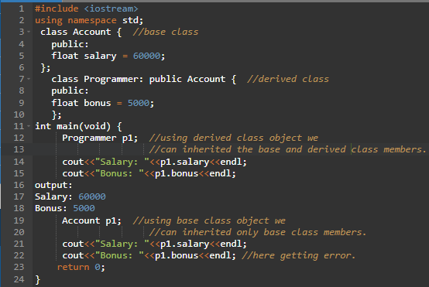
Inheritance using access specifier:
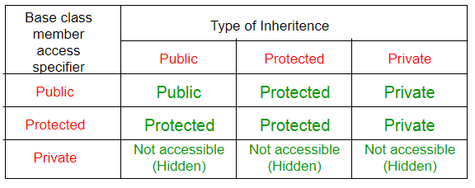

Public
When the member is declared as public, it is accessible to all the functions of the program.
Let’s see example of public:
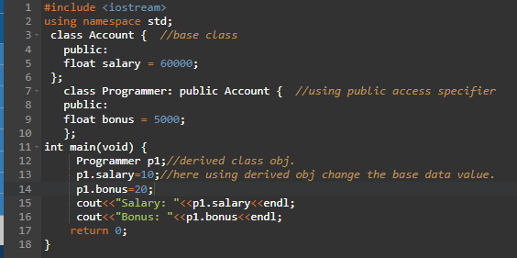
Private
When the member is declared as private, it is accessible within the class only.
Let’s see example of private:
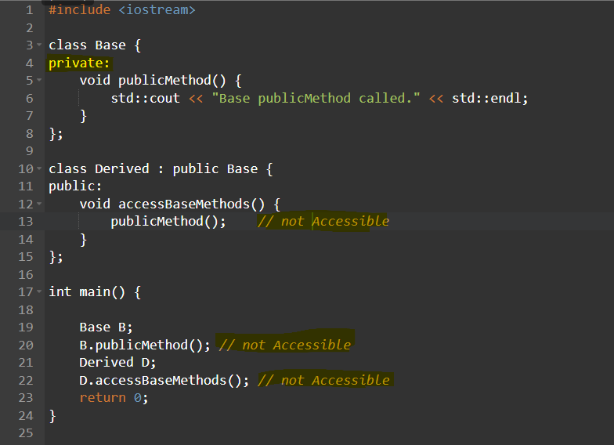

Protected
When the member is declared as protected, it is accessible within its Base class as well as derived class.
Let’s see example of protected:
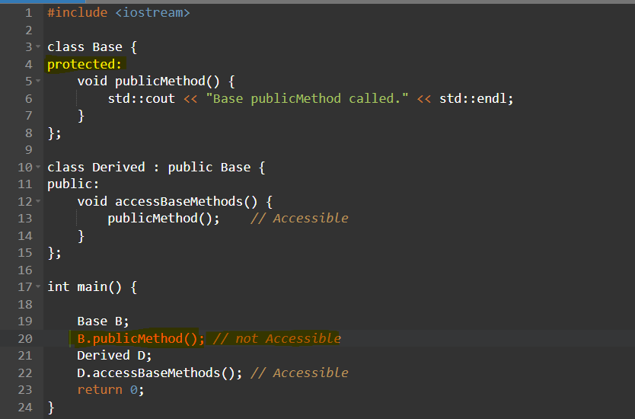

Types of Inheritance
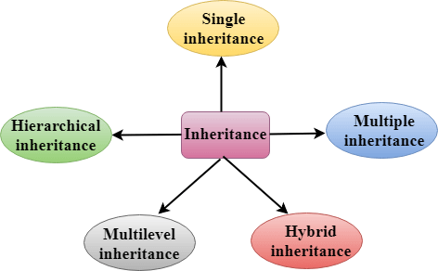

C++ Single Inheritance
Single inheritance is defined as the inheritance in which a derived class is inherited from the only one base class.

Where 'A' is the base class, and 'B' is the derived class.
Example shown in above codes.

C++ Multiple Inheritance
Multiple inheritance is the process of deriving a new class that inherits the attributes from two or more classes.
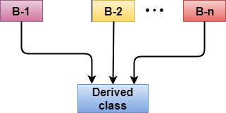

Let's see a simple example of multiple inheritance:
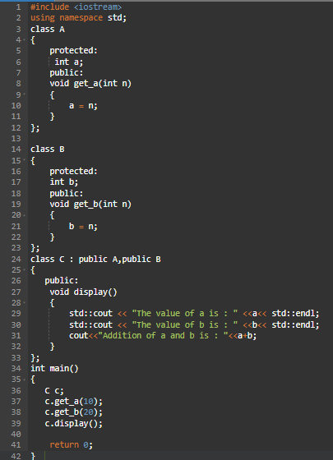

C++ Multilevel Inheritance
Multilevel inheritance is a process of deriving a class from another derived class.

Let's see the example of multi-level inheritance in C++:
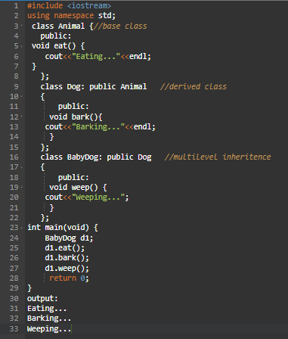

C++ Hybrid Inheritance
Hybrid inheritance is a combination of more than one type of inheritance.
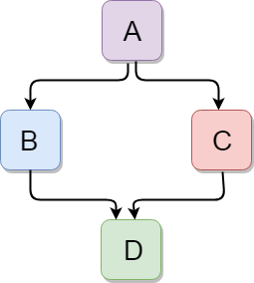
Let's see a simple example:
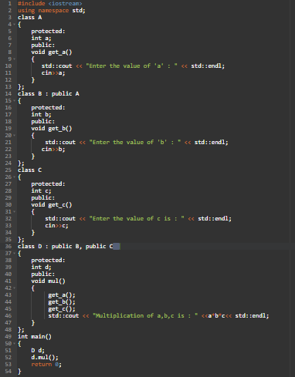

C++ Hierarchical Inheritance
Hierarchical inheritance is defined as the process of deriving more than one class from a base class.
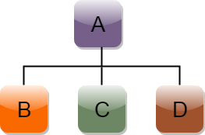
Let's see a simple example:
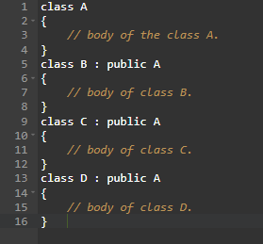

Advantage of C++ Inheritance
Code reusability: Now you can reuse the members of your parent class. So, there is no need to define the member again. So, less code is required in the class.

3.7 Singleton Class
A singleton class is a special type of class in object-oriented programming which can have only one object or instance at a time.
Steps to Implement Singleton Class in C++:
- Make all the constructors of the class private.(because no obj creation).
- Delete the copy constructor and assignment operator of the class.
- Make a private static pointer that can point to the same class object (singleton class).
- Make a public static method that returns the pointer to the same class object (singleton class).
Let’s see example of singleton class:
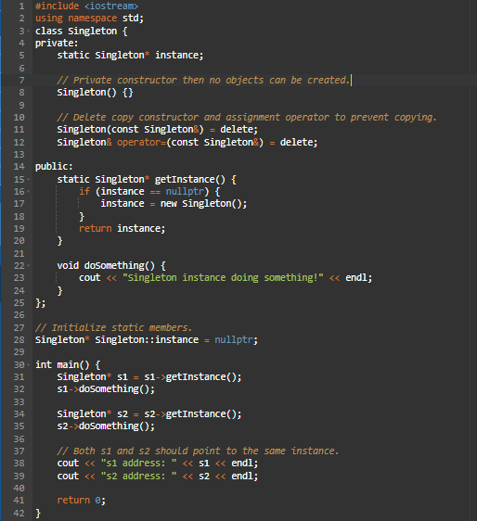
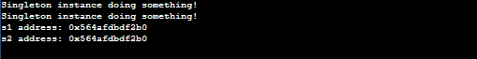

Advantages of Singleton class
- Single Instance: Ensures that only one instance of the class is created, saving memory and preventing multiple objects with conflicting states.
- Global Access: Provides a global point of access to the instance, allowing any part of the code to use it easily.
- Controlled Initialization: The instance is created only when needed, optimizing resource usage and improving performance.

Section 4: Constructor and Destructor

4.1 Constructor
A constructor is a special member of a class which is invoked automatically, when an object of the same class is created the object get automatically initialization by the constructor is called as “constructor”.

Advantages of constructor and destructor
- Constructor is used to initialize an object of the class and assign values to data members corresponding to the class.
- While destructor is used to deallocate the memory of an object of a class.
Characteristics of constructor:
- Constructor name same as a class name.
- Constructor does not have return type.
- Constructor used for initialization purpose.
- Constructor constructing object.
- Constructor call only one time to an object.
- Address of the constructor cannot be access.
- Constructor must be declared in the public section.
- Constructor cannot be friend.
- Constructor cannot be inherited.
- Constructor cannot be virtual.

Default constructor
A constructor which has no argument is known as default constructor. It is invoked at the time of creating object.
Syntax: class_name() { }

Let's see the simple example of C++ default Constructor:
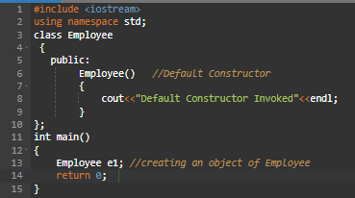

Parameterized constructor
A constructor which has parameters is called parameterized constructor. It is used to provide different values to different objects.
Syntax: class_name(arg …) { }
Let's see the simple example of C++ Parameterized Constructor:
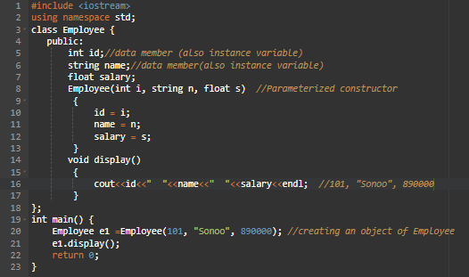

Copy constructor and Copy assignment operator
A copy constructor is a special constructor in C++ used to creates a new object by copying data from another object.
Copy Constructor is called in the following scenarios:
- An object is passed by value to a function (display(box1)).
- A function returns an object by value (Box box2 = createBox()).
- An object is explicitly copied (like assignment Box box2 = box1).

Copy Constructor are two types:
Default Copy constructor: The compiler defines the default copy constructor. If the user defines no copy constructor, compiler supplies its constructor.
User Defined constructor: The programmer defines the user-defined constructor.
Syntax: Class_name(const class_name &old_object);
Let's see a simple example of the Default Copy constructor:
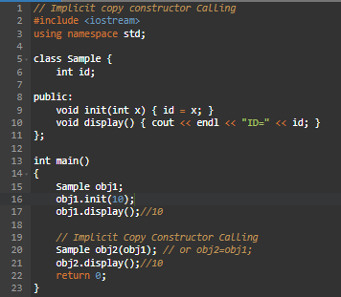
Let's see a simple example of the User Defined Copy constructor:
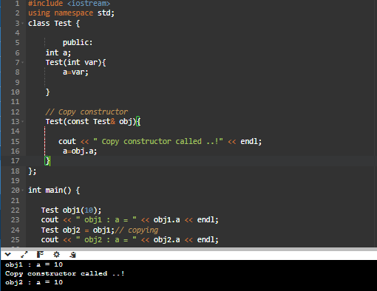

Let's see a simple example of the User Defined Copy Assignment operator:
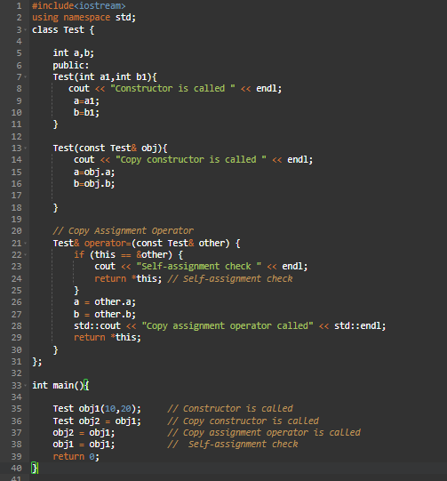
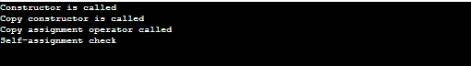
Note:
Why copy constructor colleting argument as reference (&).
Ans: if copy constructor accepting the parameters to collect the with non-reference argument, then copy constructor will get call recursively and it leads to runtime error to avoid this copy constructor colleting augments with reference type only.
Two types of copies are produced by the constructor:
- Shallow copy
- Deep copy

Shallow Copy
Copy one object data to another object with the help of compiler provided (internal) copy constructor/assignment operator is called as “shallow copy”.
Characteristics of shallow copy:
- If the copy having pointer to dynamically allocated memory, then both objects pointing to same memory.
- If one object modified, then another object automatically will get reflected.
- If object copy will not support properly.
Let’s see example of shallow copy:
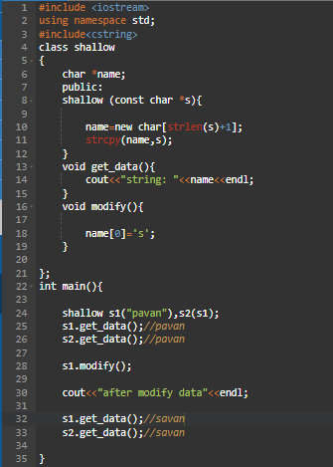

Deep Copy
Copy one object data to another object with the help of user provided (external) copy constructor/assignment operator is called as “deep copy”.
Characteristics of deep copy:
- If the copy having pointer to dynamically allocated memory, then both objects pointing to different memory.
- If one object modified, then another object automatically will not get reflected.
- If object member is pointer, then deep copy will support properly.
Let’s see example of deep copy:
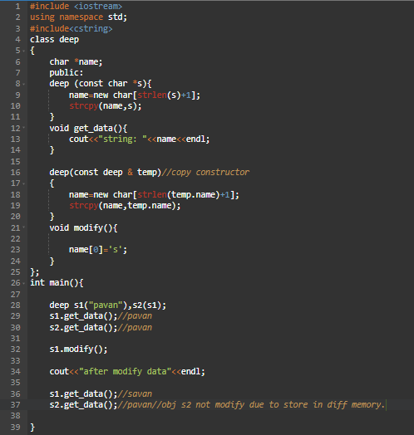

Dynamic constructor
The constructor is used to allocate the memory at runtime is called dynamic constructor.
Let’s see example of dynamic constructor:

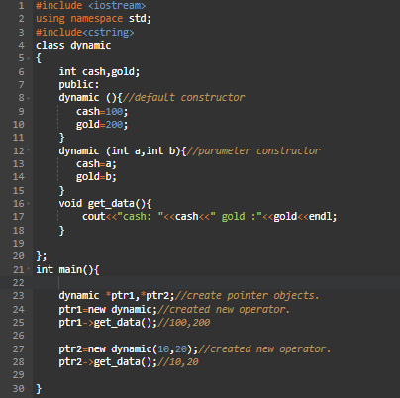

Move constructor and Move assignment operator
Move Constructor
The move constructor transfers the resources from a source object (other) to a new object. After the move, the source object is typically left in a valid but unspecified state, often set to a default or null state.
Move Assignment Operator
The move assignment operator transfers the resources from a source object (other) to an existing object. Similar to the move constructor, the source object is left in a valid but unspecified state after the move.
Let’s see example of Move constructor and Move assignment operator:
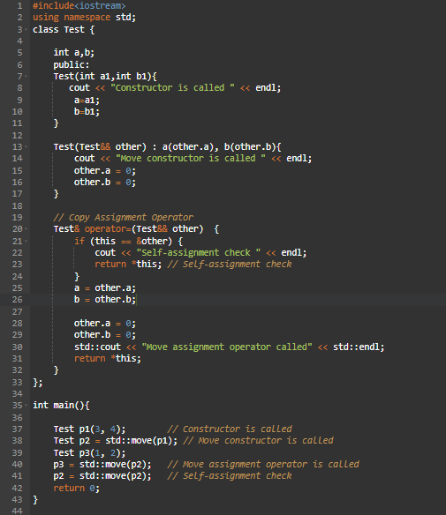
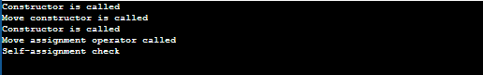

Destructor
A destructor is special member of a class which is invoked automatically to destroy the object when the scope of the object is completed.
Syntax: ~ class_name();
Characteristics of Destructor:
- Destructor also invoking same name as class name.
- Destructor is destroying a class object.
- Destructor cannot be overloaded.
- Destructor can be virtual.
- Destructors execute reverse order of constructing execution.
Let’s see example of destructor:
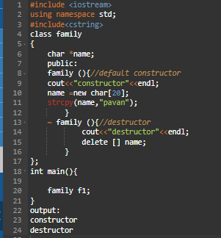
Let’s see example of private destructor:
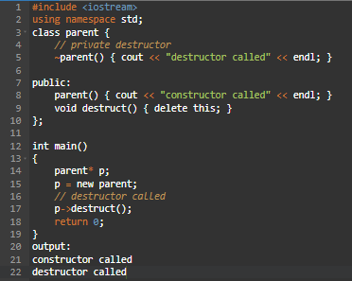

Can a constructor be private in C++?
Yes, Constructor can be defined in private section of class.
- Using Friend Class: If we want that class should not be instantiated by anyone else but only by a friend class.
- Using Singleton design pattern: When we want to design a singleton class. This means instead of creating several objects of class, the system is driven by a single object or a very limited number of objects.
- using static method.
Using Friend Class:
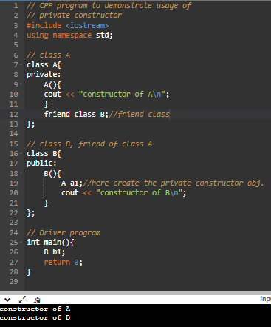
using static method:
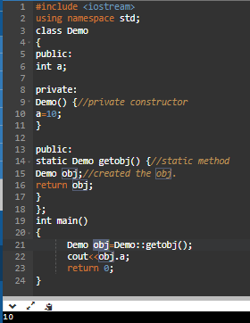

Section 5: C++ Friend function

5.1 Friend function
friend function is a non-member function where it can be accessing private data of a class.
Syntax: friend return_type fun_name(arg…);
Characteristics of friend function:
- Friend function does not belong to same class.
- Friend function does not have this pointer.
- Friend function will invoke without object.
- Friend function can access members of class with object.
- The scope of friend function belongs to N number of classes.
- A friend function can be declared in any section of the class i.e. public or private or protected.
Let's see the simple example of C++ friend function:
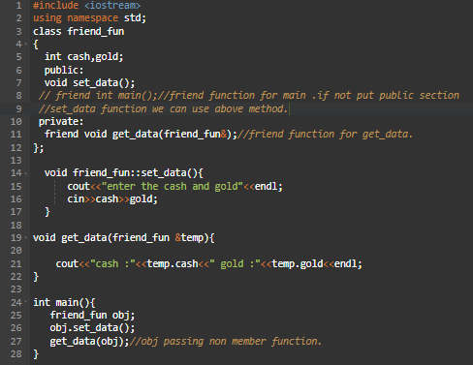

Let’s see example of friend function can be friend N number of classes:
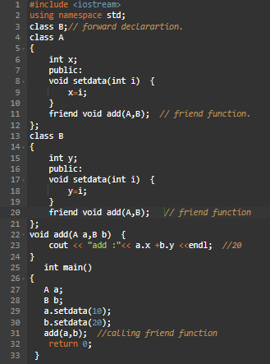

5.2 Friend Class
friend class is a class one class all the member functions can access private data of another class.
Syntax: friend class class_name;
Let's see a simple example of a friend class:
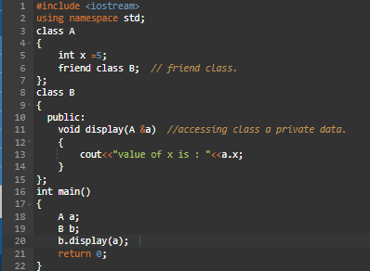

Particular member function of a class can make friend to another class.
Syntax: friend return_type class-name :: fun_name(arg..);
Let’s see example of a member function of another class as a friend function:
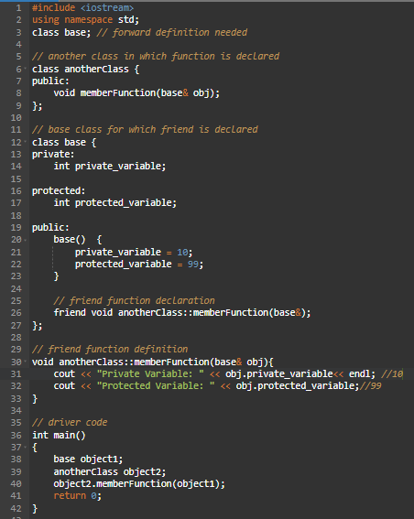

5.3 Advantage of friend function
- The declaration can be anywhere in the code.
- There is no need to create an object to call it.
- Non-public members of the class can also be accessed using the friend function.
- It can add extra functionality.
- Enables programming experience to be more efficient than ever before.

5.4 Disadvantage of friend function
- It is not passed to the derived class
- They don't have a storage-specified class.
- The friend function comes in handy when multiple classes are tied together.
- Allows private and protected members to be shown as the information of the class.
- It can have both public and private protected members in the same class in which it has been defined.

Section 6: C++ Templates
- Template are used to avoid the function overloading problems.
- A C++ template is a powerful feature added to C++.
- It allows, you to define the generic classes and generic functions and thus provides support for generic programming.
- Generic programming is a technique where generic types are used as parameters in algorithms so that they can work for a variety of data types.
Characteristics of Template:
- A template allows us to create a family of classes or family of functions to handle different data types.
- Template classes and functions eliminate the code duplication of different data types and thus makes the development easier and faster.
- Multiple parameters can be used in both class and function template.
- Template functions can also be overloaded.
- We can also use non-type arguments such as built-in or derived data types as template arguments.
Templates can be represented in two ways:
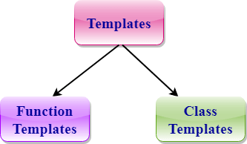

6.1 Function Template
Generic functions use the concept of a function template. Generic functions define a set of operations that can be applied to the various types of data.
For example, if we have an add () function, we can create versions of the add function for adding the int, float or double type values.
Syntax of Function Template:
template < class Ttype> ret_type func_name(parameter_list)
{
// body of function.
}
Note: we can use both typename and class in template functions and classes.
Let’s see example of function template:
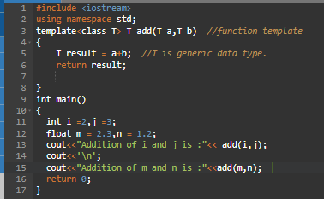
Function Templates with Multiple Parameters:
We can use more than one generic type in the template function by using the comma to separate the list.
Syntax:
template<class T1, class T2,..>
return_type function_name (arguments of type T1, T2....)
{
// body of function.
}
Let’s see example below:
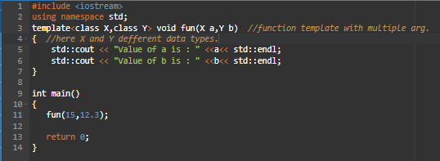
Overloading a Function Template:
We can overload the generic function means that the overloaded template functions can differ in the parameter list.

Let’s see example below:
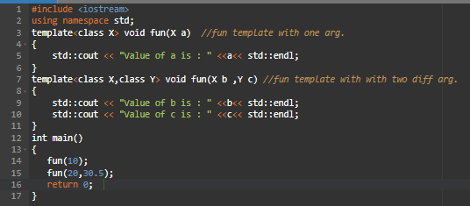

6.2 Class Template
Class Template can also be defined similarly to the Function Template. When a class uses the concept of Template, then the class is known as generic class.
Syntax:
template<class T1, class T2,..>
class class_name {
// body of class.
} ;
Now, we create an instance of a class:
class_name<type1,type2,…> ob;
Let's see a simple example:
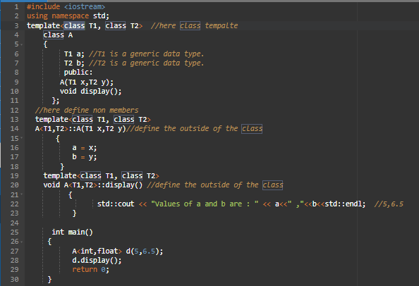

Non-type Template Arguments:
Let's see a simple example:
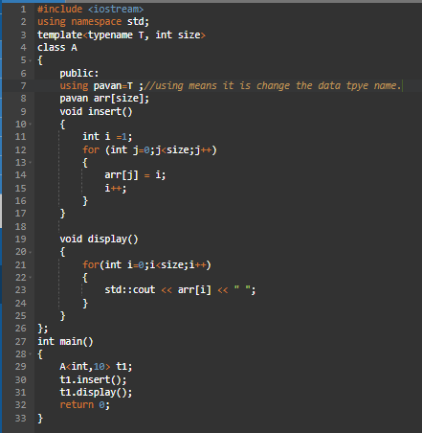

Section 7: C++ Smart Pointers

7.1 Pointer vs Smart Pointer
Pointer:
A pointer in C++ is a variable that holds the memory address of another variable. Instead of storing a data value directly, a pointer stores the address where the data is located in memory.
Example:
Smart Pointer:
Smart pointers are used to make sure that an object is deleted if it is no longer used (referenced).
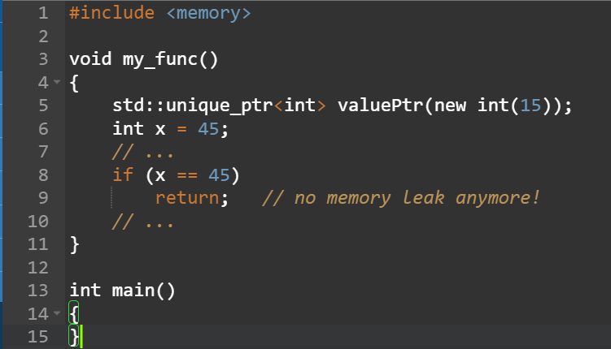
Smart Pointer Implementation
- We will implement smart pointers such that they will release the memory of unused resources.
- Create a class with a pointer, overloaded operators (->, *) and destructors.
- The destructor will be automatically called when its object goes out of the scope, and automatically the dynamically allocated memory will be deleted. No need to use delete operator here.
Let’s see sample example:
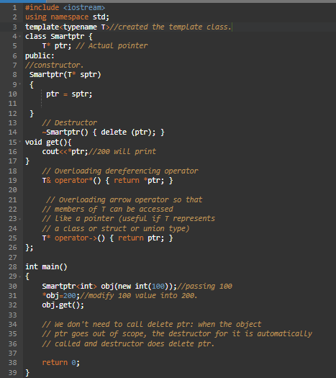

7.2 Types of Smart Pointers

auto_ptr
auto_ptr is a smart pointer that manages an object obtained via new expression and deletes that object when auto_ptr itself is destroyed. It may be used to provide exception safety for dynamically allocated objects.
Let’s see example of auto_ptr:
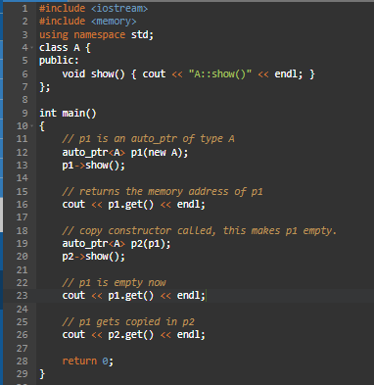

unique_ptr
A unique_ptr can only be moved. This means that the ownership of the memory resource is transferred to another unique_ptr and the original unique_ptr no longer owns it.
Key points:
- Ownership: Only one unique_ptr can own the object at a time.
- Automatic Deletion: When the unique_ptr goes out of scope, the memory is automatically freed.
- No Copying: You can't copy a unique_ptr, but you can transfer ownership using std::move.

Let’s see example of unique_ptr:
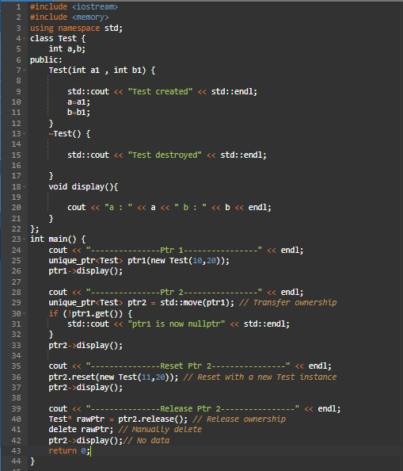
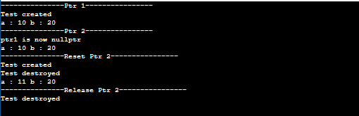

Implementation of unique_ptr class:
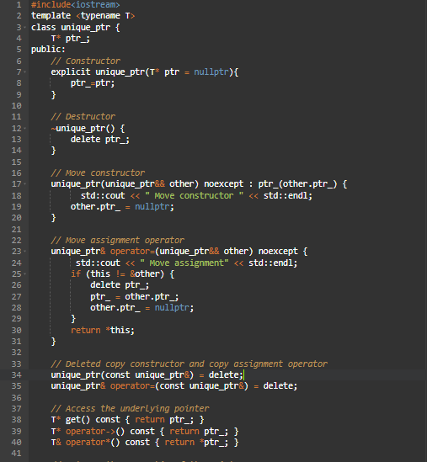
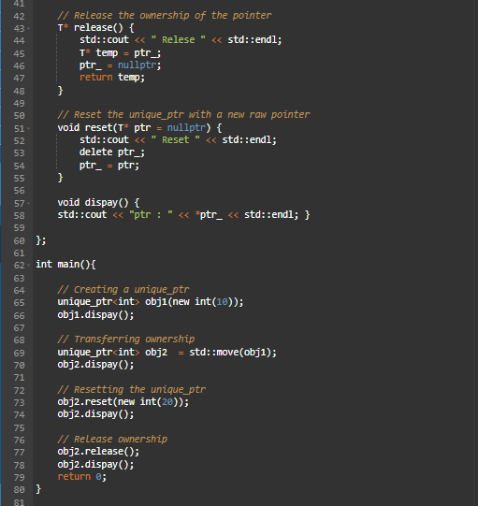
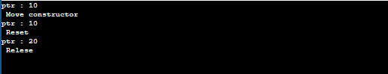

shared_ptr
A shared_ptr is a smart pointer in C++ that allows multiple pointers to share ownership of the same object. It automatically manages the object's memory.
Key Points:
- Multiple Owners: Several shared_ptrs can point to the same object.
- Reference Counting: Each shared_ptr keeps track of how many shared_ptrs are pointing to the same object. When the last shared_ptr is destroyed, the object is automatically deleted.
- Automatic Cleanup: No need to manually delete the object; it happens automatically when the last owner goes out of scope.
Let’s see example of shared _ptr:
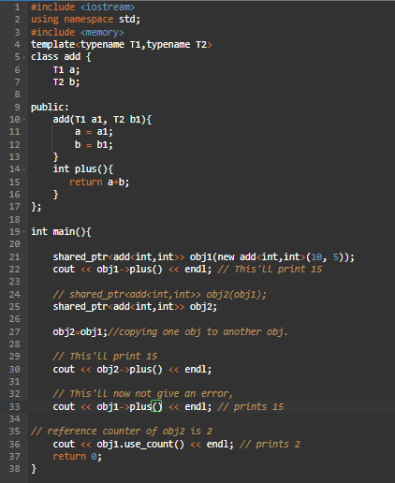

Implementation of shared_ptr class:
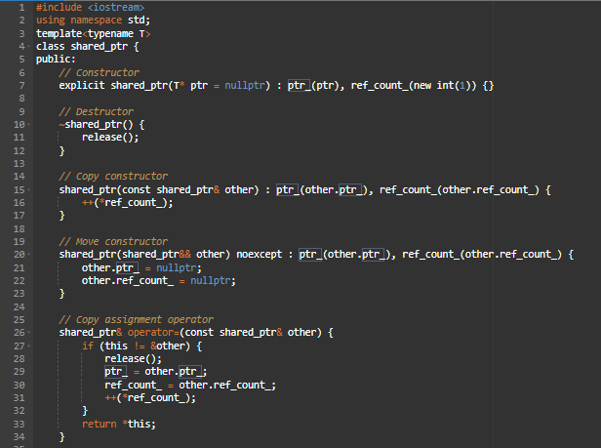
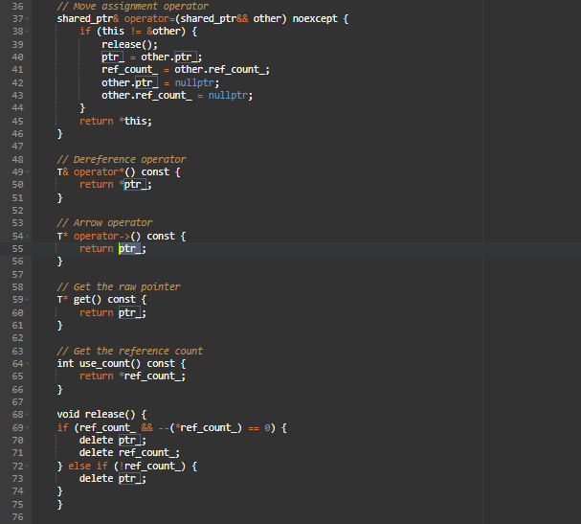
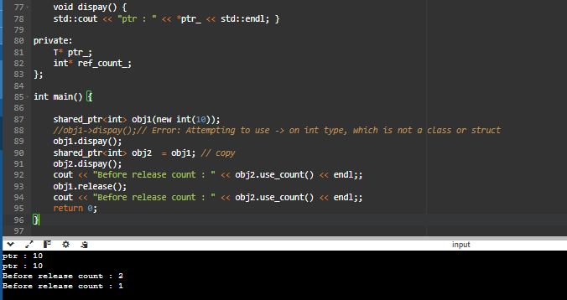

Weak_ptr
Weak_ptr is similar to the shared pointer. The difference is that it does not maintain a reference counter and there is no strong hold of the object on the pointer. This property may result in a deadlock as different objects will try to hold the pointer.
Advantage:
std::weak_ptr is used to avoid memory leaks caused by circular references in std::shared_ptr.
Why No Reference Counting?
No Ownership: weak_ptr is not responsible for the lifetime of the object, so it doesn't need to keep track of how many weak_ptrs exist. The object is managed by shared_ptr, and weak_ptr is just an observation tool.
Example:
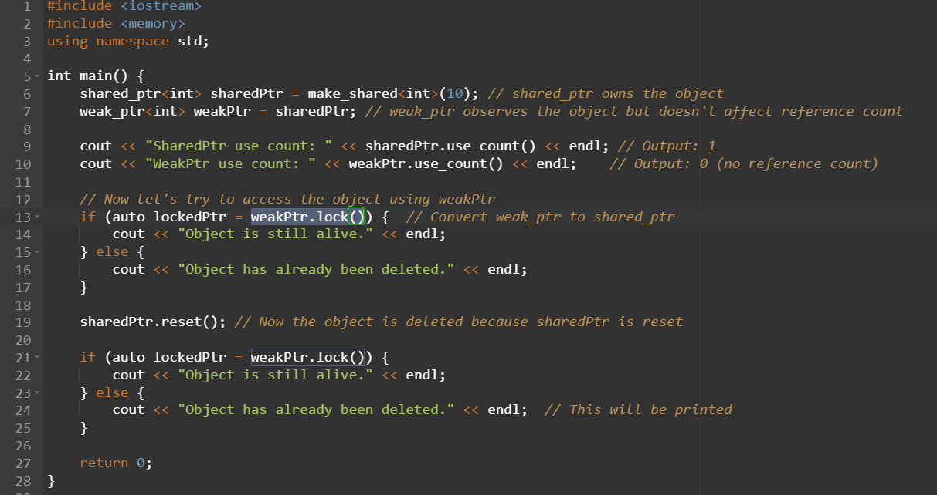

Section 8: C++ Type Conversions
A type cast is basically a conversion from one type to another.
There are two types of type conversion:
- Implicit Type Conversion
- Explicit Type Conversion

8.1 Implicit Type Conversion
The implicit type conversion is the type of conversion done automatically by the compiler without any human effort. It means an implicit conversion automatically converts one data type into another type based on some predefined rules of the C++ compiler. Hence, it is also known as the automatic type conversion.
Let’s see example of type implicit conversion:
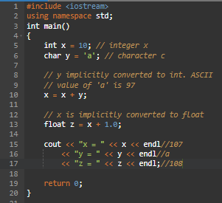

8.2 Explicit Type Conversion
This process is also called type casting, and it is user-defined. Here the user can typecast the result to make it of a particular data type.
In C++, it can be done by two ways:
- Converting by assignment.
- Conversion using Cast operator.
Converting by assignment:
This is done by explicitly defining the required type in front of the expression in parenthesis. This can be also considered as forceful casting.
Syntax: (type) expression

Let’s see example of converting by assignment:
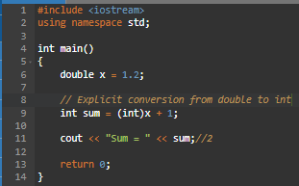
Conversion using Cast operator:
A Cast operator is a unary operator which forces one data type to be converted into another data type.
C++ supports four types of casting:
- Static Cast
- Dynamic Cast
- Const Cast
- Reinterpret Cast
Static Cast:
This is the simplest type of cast which can be used. It is a compile time cast. It does things like implicit conversions between types (such as int to float, or pointer to void*), and it can also call explicit conversion functions (or implicit ones).
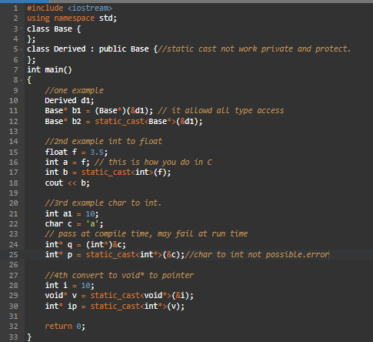

Dynamic Cast:
A cast is an operator that converts data from one type to another type. In C++, dynamic casting is mainly used for safe down casting at run time. To work on dynamic_cast there must be one virtual function in the base class. A dynamic_cast works only polymorphic base class because it uses this information to decide safe down casting.
Syntax: dynamic_cast <new_type>(Expression)
Down casting: Casting a base class pointer (or reference) to a derived class pointer (or reference) is known as down casting
Upcasting: Casting a derived class pointer (or reference) to a base class pointer (or reference) is known as upcasting.
Let’s see example of dynamic_cast:
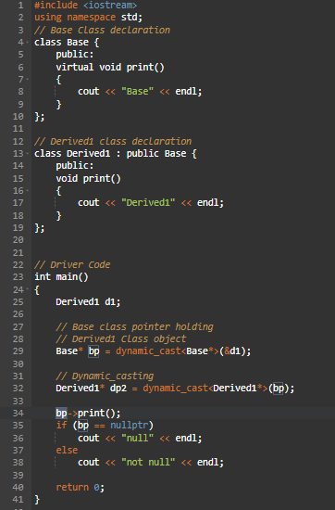

Let’s see example of downcast and up cast:
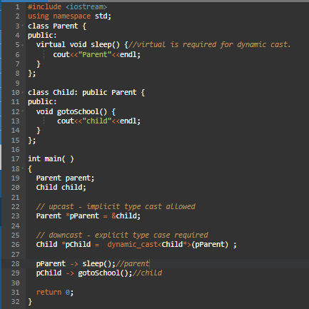
Const_cast:
The const_cast is used to change or manipulate the const behaviour of the source pointer. It means we can perform the const in two ways: setting a const pointer to a non-const pointer or deleting or removing the const from a const pointer.
Syntax: const_cast <type> exp;
Let's write a program to cast a source pointer to a non-cast pointer using the const_cast in C++:
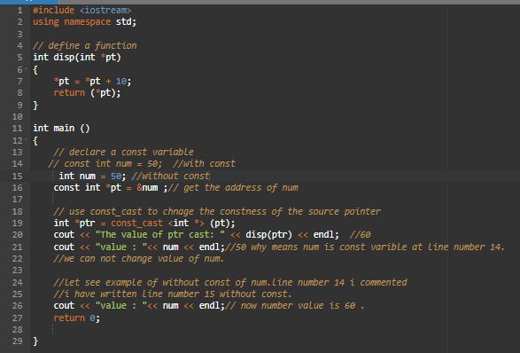
Let's write a program to const function and members modify using const_cast:
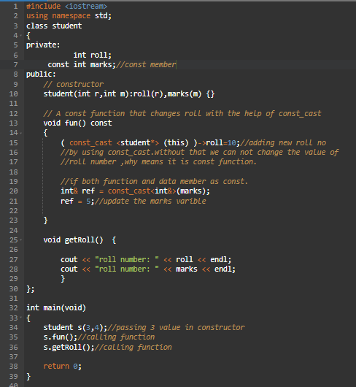
Let’s see example of converting int* to char* using cast operator:
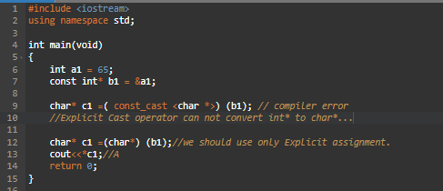
reinterpret_cast:
- It is used to convert a pointer of some data type into a pointer of another data type, even if the data types before and after conversion are different.
- It does not check if the pointer type and data pointed by the pointer is same or not.
- It doesn’t have any return type. It simply converts the pointer type.
- It takes only one parameter.
- reinterpret_cast is a very special and dangerous type of casting operator. And is suggested to use it using proper data type i.e., (pointer data type should be same as original data type).
- It can typecast any pointer to any other data type.
- It is used when we want to work with bits.
- If we use this type of cast then it becomes a non-portable product. So, it is suggested not to use this concept unless required.
- It is only used to typecast any pointer to its original type.
- Boolean value will be converted into integer value i.e., 0 for false and 1 for true.
Syntax: data_type *var_name = reinterpret_cast <data_type *>(pointer_variable);
Let’s see example of reinterpret_cast operator:
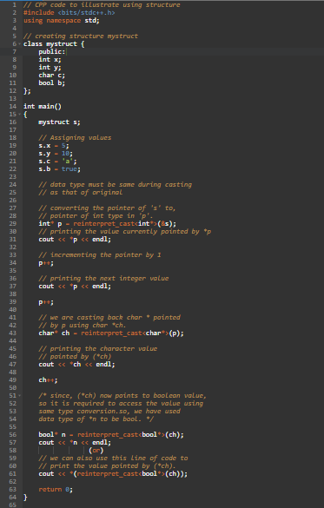

Section 9: Exception Handling
Exception Handling in C++ is a process to handle runtime errors. We perform exception handling, so the normal flow of the application can be maintained even after runtime errors.
In C++, exception is an event or object which is thrown at runtime. All exceptions are derived from std::exception class. It is a runtime error which can be handled. If we don't handle the exception, it prints exception message and terminates the program.
Advantages:
It maintains the normal flow of the application. In such case, rest of the code is executed even after exception.
C++ Exception Handling Keywords
In C++, we use 3 keywords to perform exception handling:
- The try statement allows you to define a block of code to be tested for errors while it is being executed.
- The throw keyword throws an exception when a problem is detected, which lets us create a custom error.
- The catch statement allows you to define a block of code to be executed if an error occurs in the try block.
Let’s see examples of try/throw/catch:
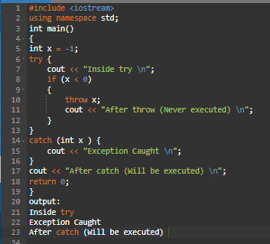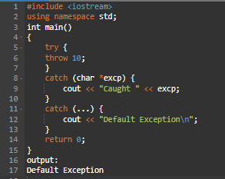
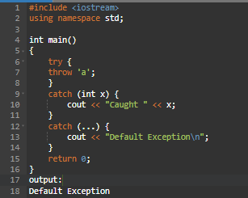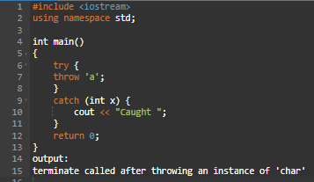
Let’s see examples of try/throw/catch using functions:
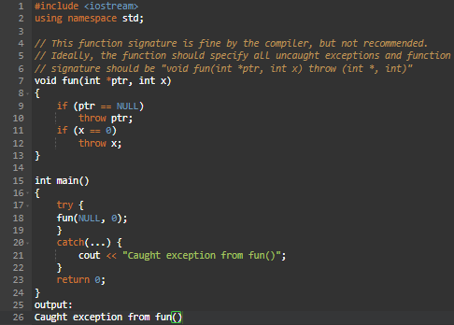
Let’s see examples of try/throw/catch using class:
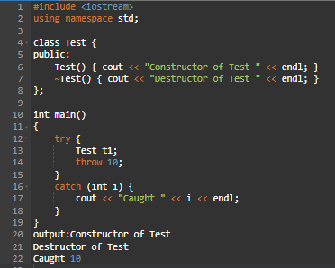
C++ User-Defined Exception Classes:
In C++ standard exceptions are defined in <exception> class that we can use inside our programs.
The arrangement of parent-child class hierarchy is shown below:
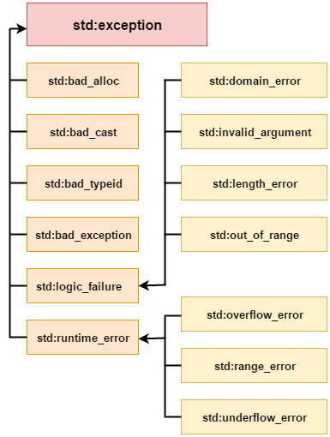
All the exception classes in C++ are derived from std::exception class. Let's see the list of C++ common exception classes.
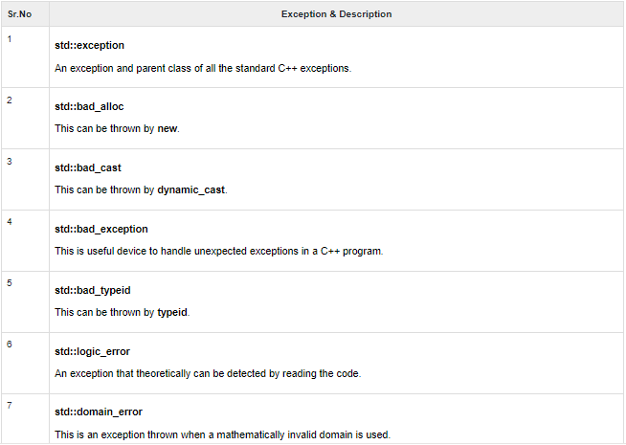
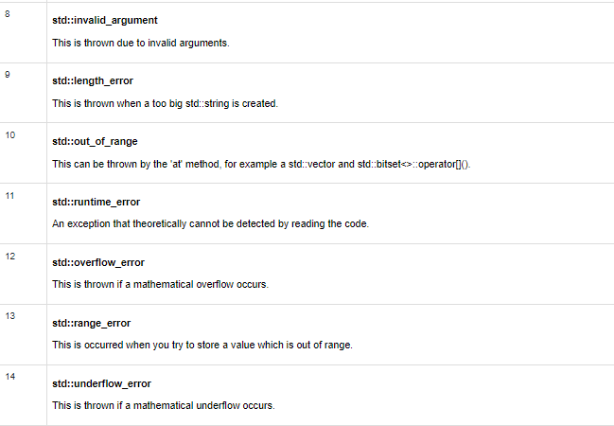
Std::exception:
The C++ Standard library provides a base class specifically designed to declare objects to be thrown as exceptions. It is called std::exception and is defined in the <exception> header. This class has a virtual member function called what that returns a null-terminated character sequence (of type char *) and that can be overwritten in derived classes to contain some sort of description of the exception.
Let’s see example of std::exception:
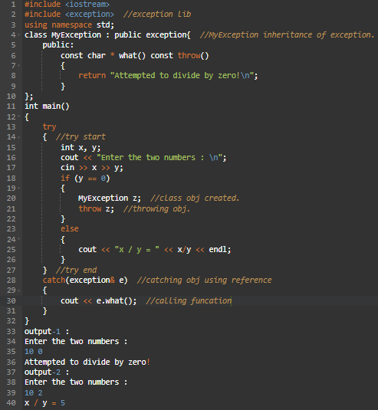
Std::bad_alloc:
Type of the exceptions thrown by the standard definitions of operator new and operator new[] when they fail to allocate the requested storage space.
Let’s see example of std:: bad_alloc:
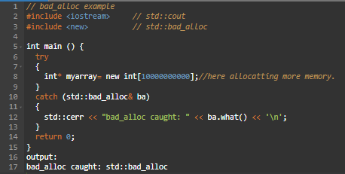
Std::bad_cast:
Type of the exceptions thrown by dynamic_cast when it fails the run-time check performed on references to polymorphic class types.
Let’s see example of std:: bad_cast:
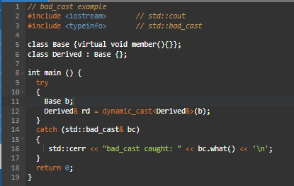
Std::bad_exception:
This is a special type of exception specifically designed to be listed in the dynamic-exception-specifier of a function (i.e., in its throw specifier).
If a function with bad_exception listed in its dynamic-exception-specifier throws an exception not listed in it and unexpected rethrows it (or throws any other exception also not in the dynamic-exception-specifier), a bad_exception is automatically thrown.

Let’s see example of std:: bad_ exception:
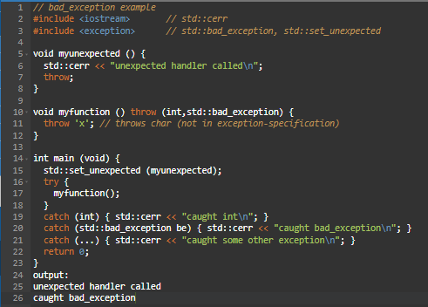
Std::bad_typeid:
Type of the exceptions thrown by typeid when applied on a pointer to a polymorphic type which has a null pointer value.
Let’s see example of std:: bad_ typeid:
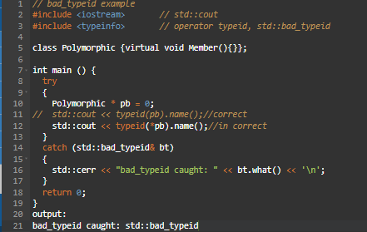
Std:bad_function_call:
Type thrown by empty function objects when their functional call is invoked.Empty function objects are function objects with no target callable object.

Let’s see example of std:: bad_ function_call:
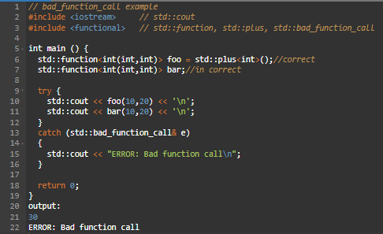
std::bad_weak_ptr :
std::bad_weak_ptr is the type of the object thrown as exceptions by the constructors of std::shared_ptr that take std::weak_ptr as the argument, when the std::weak_ptr refers to an already deleted object.
Let’s see example of std:: bad_ weak_ptr:
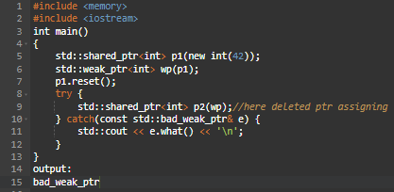
std::logic_failure:
The class serves as the base class for all exceptions thrown to report errors presumably detectable before the program executes, such as violations of logical preconditions.
Syntax:
class logic_error : public exception {
public:
explicit logic_error(const string& message);
explicit logic_error(const char *message);
};
Let’s see example of std:: logic_failure:
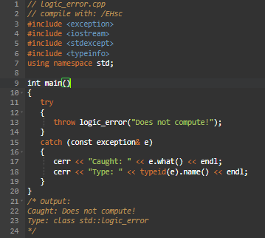
Std:domain_error:
The class serves as the base class for all exceptions thrown to report a domain error (as in mathematics, not networking).
Syntax:
class domain_error : public logic_error {
public:
explicit domain_error(const string& message);
explicit domain_error(const char *message);
};
Let’s see example of std:: domain_error:
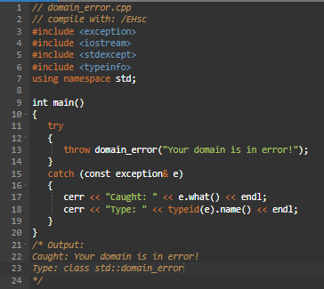
std::invalid_argument:
The class serves as the base class for all exceptions thrown to report an invalid argument.

Syntax:
class invalid_argument : public logic_error {
public:
explicit invalid_argument(const string& message);
explicit invalid_argument(const char *message);
};
Let’s see example of std:: invalid_argument:
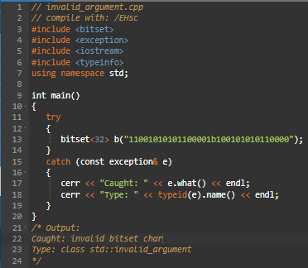
std::length_error:
The class serves as the base class for all exceptions thrown to report an attempt to generate an object too long to be specified.
syntax:
class length_error : public logic_error {
public:
explicit length_error(const string& message);
explicit length_error(const char *message);
};
Let’s see example of std:: length_error:
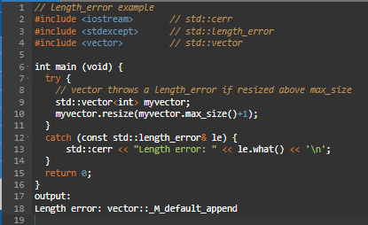
std::out_of_range:
The class serves as the base class for all exceptions thrown to report an argument that is out of its valid range.
syntax:
class out_of_range : public logic_error {
public:
explicit out_of_range (const string& message);
explicit out_of_range (const char *message);
};
Let’s see example of std:: out_of_range:
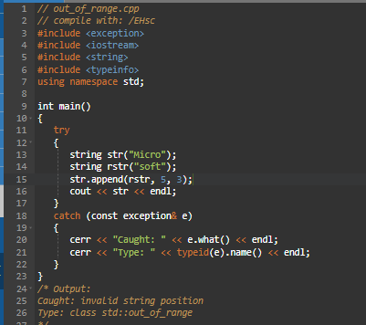
std::future_error:
This class defines the type of objects thrown as exceptions to report invalid operations on future objects or other elements of the library that may access a future's shared state.
Let’s see example of std:: future_error:
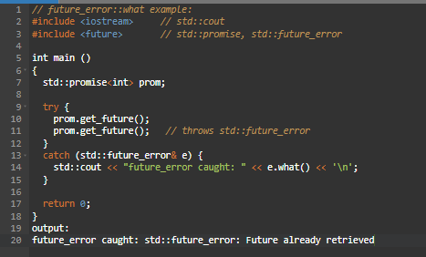
std::runtime_error:
This class defines the type of objects thrown as exceptions to report errors that can only be detected during runtime.
syntax:
class runtime_error : public exception {
public:
explicit runtime_error (const string& message);
explicit runtime_error (const char *message);
};
Let’s see example of std::runtime_error:
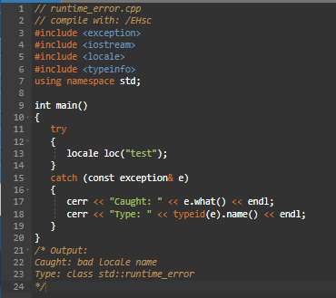

Section 10: C++ STL concepts

10.1 About STL (Standard Template Library)
- The C++ Standard Template Library (STL) is a collection of algorithms, data structures, and other components that can be used to simplify the development of C++ programs. The STL provides a range of containers, such as vectors, lists, and maps, as well as algorithms for searching, sorting, and manipulating data.
- One of the key benefits of the STL is that it provides a way to write generic, reusable code that can be applied to different data types. This means that you can write an algorithm once, and then use it with different types of data without having to write separate code for each type.
- The STL also provides a way to write efficient code. Many of the algorithms and data structures in the STL are implemented using optimized algorithms, which can result in faster execution times compared to custom code.

STL has 4 components:
- Containers
- Iterators
- Functions
- Algorithms
Advantages of the C++ Standard Template Library (STL):
- Reusability: One of the key advantages of the STL is that it provides a way to write generic, reusable code that can be applied to different data types. This can lead to more efficient and maintainable code.
- Efficient algorithms: Many of the algorithms and data structures in the STL are implemented using optimized algorithms, which can result in faster execution times compared to custom code.
- Improved code readability: The STL provides a consistent and well-documented way of working with data, which can make your code easier to understand and maintain.
- Large community of users: The STL is widely used, which means that there is a large community of developers who can provide support and resources, such as tutorials and forums.
Disadvantages of the C++ Standard Template Library (STL):
Learning curve: The STL can be difficult to learn, especially for beginners, due to its complex syntax and use of advanced features like iterators and function objects.
Lack of control: When using the STL, you have to rely on the implementation provided by the library, which can limit your control over certain aspects of your code.
Performance: In some cases, using the STL can result in slower execution times compared to custom code, especially when dealing with small amounts of data.

10.2 Containers
Containers can be described as the objects that hold the data of the same type. Containers are used to implement different data structures for example arrays, list, trees, etc.
Classification of containers:
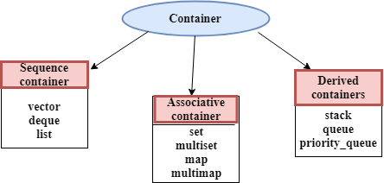

Sequence containers
Implement data structures that can be accessed in a sequential manner.

Std::vector
A vector is a sequence container class that implements dynamic array, means size automatically changes when appending elements. A vector stores the elements in contiguous memory locations and allocates the memory as needed at run time.

Difference between vector and array
An array follows static approach, means its size cannot be changed during run time while vector implements dynamic array means it automatically resizes itself when appending elements.
Syntax: vector<object_type> v1;

Different Functions of Set in C++ STL
C++ Vector Basic Functions:
- begin():It points the first element of the vector.
- end():It refers to the past-last-element in the vector.
- rbegin():It points the last element of the vector.
- rend():It points the element preceding the first element of the vector.
- cbegin():It refers to the first element of the vector.
- cend():It refers to the past-last-element in the vector.
- crbegin():It refers to the last character of the vector.
- crend():It refers to the element preceding the first element of the vector.
Let’s see example of above basic functions:
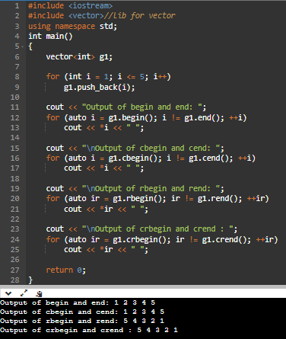
C++ Vector Capacity Functions:
- size():It determines a number of elements in the vector.
- max_size():It determines the maximum size that vector can hold.
- capacity():It determines the current capacity of the vector.
- resize(n):It modifies the size of the vector.
- empty():It determines whether the vector is empty or not.
- shrink_to_fit():It reduces the capacity and makes it equal to the size of the vector.
- reserve() : Requests that the vector capacity be at least enough to contain n elements.
Let’s see example of above capacity functions:
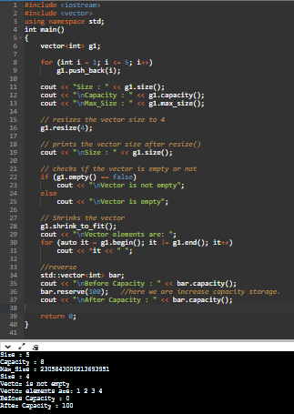

C++ Vector Element Access Functions:
- reference operator [g]: Returns a reference to the element at position ‘g’ in the vector
- at(g):It provides a reference to an element.
- front():It gives a reference to the first element.
- back():It gives a reference to the last element.
- data():It writes the data of the vector into an array.
Let’s see example of above element access functions:
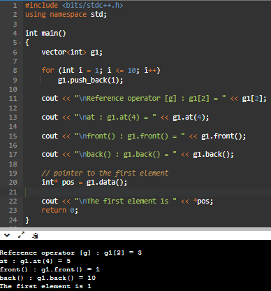
C++ Vector Modifiers Functions:
- assign() : It assigns new value to the vector elements by replacing old ones
- push_back() : It push the elements into a vector from the back
- pop_back() : It is used to pop or remove elements from a vector from the back.
- insert() : It inserts new elements before the element at the specified position
- erase() : It is used to remove elements from a container from the specified position or range.
- swap() : It is used to swap the contents of one vector with another vector of same type. Sizes may differ.
- clear() : It is used to remove all the elements of the vector container
- emplace() : It extends the container by inserting new element at position
- emplace_back() : It is used to insert a new element into the vector container, the new element is added to the end of the vector
Let’s see example of above modifiers functions:
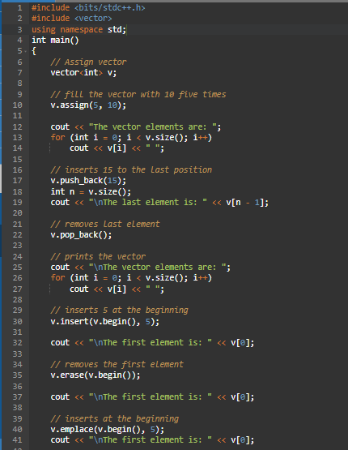
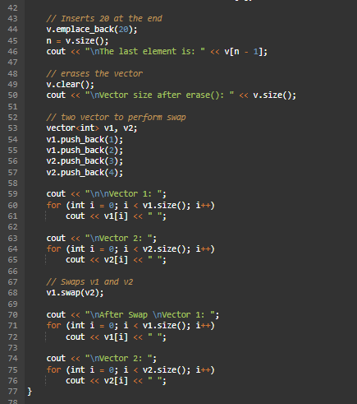
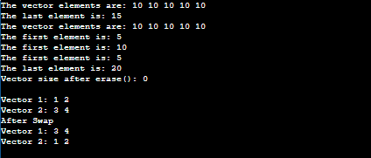

Advantages of Vector
- Size of the vector can be changed
- Multiple objects can be stored
- Elements can be deleted from a vector

Disadvantages of Vector
- A vector is an object, memory consumption is more.

Std::vector Implementation
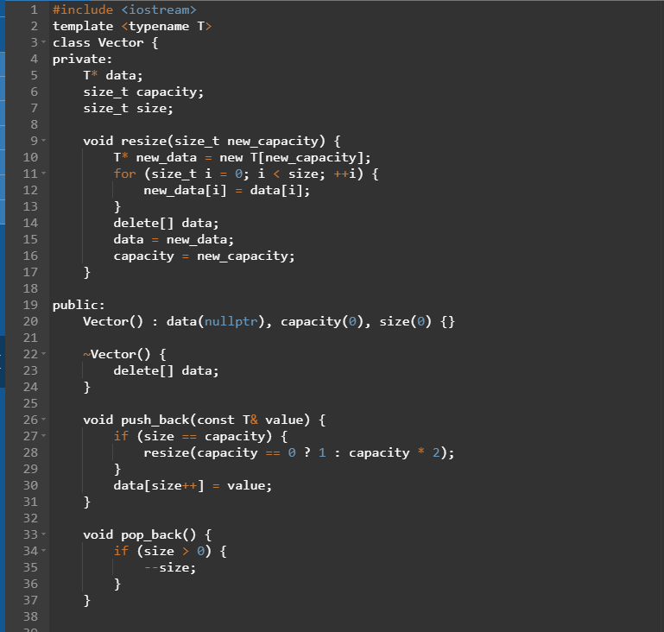
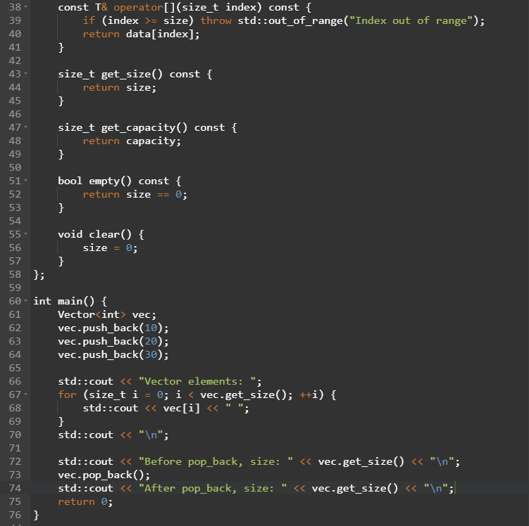
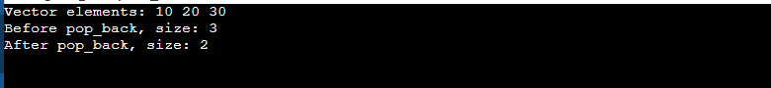

Std::list
- Lists are one of the sequence containers available in C++ STL that store elements in a non-contiguous manner.
- Insertion and deletion in the middle of the vector is very costly as it takes lot of time in shifting all the elements. Link list overcome this problem and it is implemented using list container.
- List supports a bidirectional and provides an efficient way for insertion and deletion operations.
- Traversal is slow in list as list elements are accessed sequentially while vector supports a random access.
Why use std::list:
- In comparison to other sequence containers such as array and vector, std::list performs better due to its non-contiguous storage.
- They perform better while inserting, moving, and removing items from any location. Insertion and deletion of elements from the list take O (1) time.
- The std::list also performs better with algorithms that execute a lot of these operations.
Syntax: list<int> new_list{1,2,3,4}; (OR) list<int> new_list = {1,2,3,4};

Different Functions of List in C++ STL
C++ list Basic Functions:
- begin():It points the first element of the list.
- end():It refers to the past-last-element in the list.
- rbegin():It points the last element of the list.
- rend():It points the element preceding the first element of the list.
- cbegin():It refers to the first element of the list.
- cend():It refers to the past-last-element in the list.
- crbegin():It refers to the last character of the list.
- crend():It refers to the element preceding the first element of the list.

Let’s see example of above basic functions:
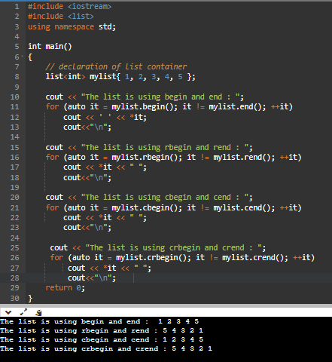

C++ list Capacity Functions:
- size():It determines a number of elements in the list.
- max_size():It determines the maximum size that list can hold.
- resize(n):It modifies the size of the list.
- empty():It determines whether the list is empty or not.
- reserve():Reverses the list.

Let’s see example of above capacity functions:
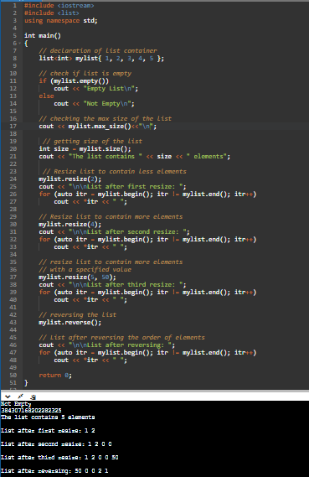
C++ list Element Access Functions:
- list::operator=:This operator is used to assign new contents to the container by replacing the existing contents.
- front():It gives a reference to the first element.
- back():It gives a reference to the last element.

Let’s see example of above element access functions:
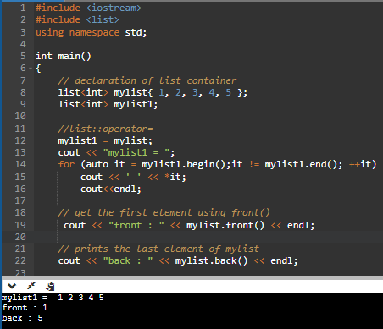
C++ list Modifiers Functions:
- push_front(g):Adds a new element ‘g’ at the beginning of the list.
- push_back(g):Adds a new element ‘g’ at the end of the list.
- pop_front():Removes the first element of the list, and reduces size of the list by 1.
- pop_back():Removes the last element of the list, and reduces size of the list by 1.
- list::swap():This function is used to swap the contents of one list with another list of same type and size.
- list splice():Used to transfer elements from one list to another.
- list merge():Merges two sorted lists into one.
- list unique():Removes all duplicate consecutive elements from the list.
- list emplace():Extends list by inserting new element at a given position.
- list::emplace_front():emplace_front function is used to insert a new element into the list container, the new element is added to the beginning of the list.
- list::emplace_back():emplace_back function is used to insert a new element into the list container, the new element is added to the end of the list.
- sort():Sorts the list in increasing order.
- insert():Inserts new elements in the list before the element at a specified position.
- assign():Assigns new elements to list by replacing current elements and resizes the list.
- remove():Removes all the elements from the list, which are equal to given element.
- list::remove_if():Used to remove all the values from the list that correspond true to the predicate or condition given as parameter to the function.
- list::clear():clear() function is used to remove all the elements of the list container, thus making it size 0.
- erase():Removes a single element or a range of elements from the list.
Let’s see example 1 of above modifiers functions:
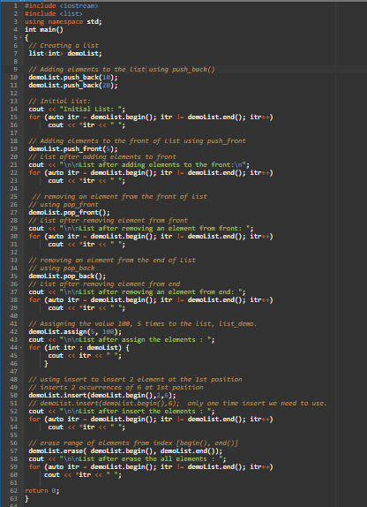
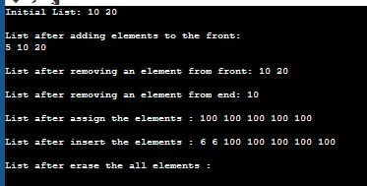
Let’s see example 2 of above modifiers functions:
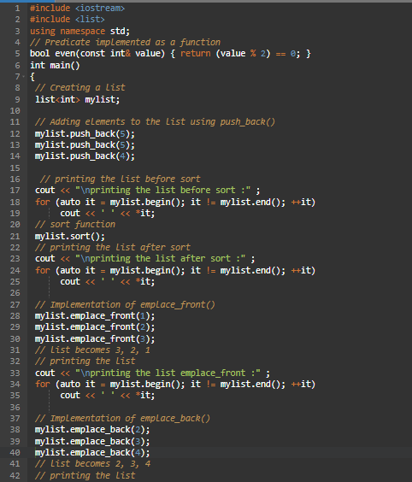
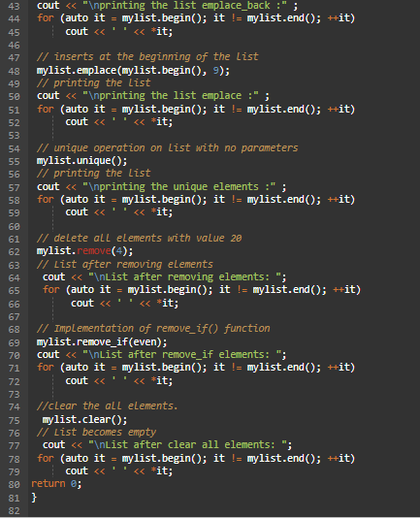
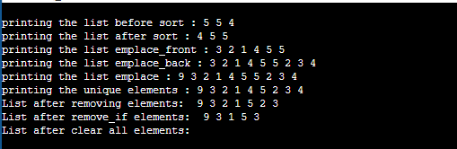
Let’s see example 3 of above modifiers functions:
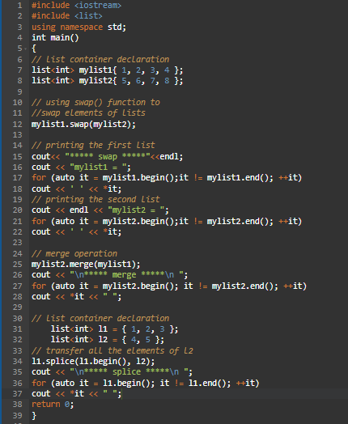
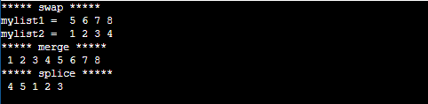

Std::deque
Deque stands for (double ended queue). It generalizes the queue data structure i.e insertion and deletion can be performed from both the ends either front or back.
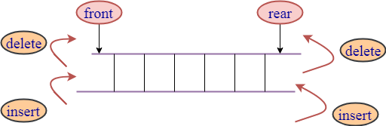
Syntax: deque<object_type> deque_name;
Let’s see example of basic functions of deque:
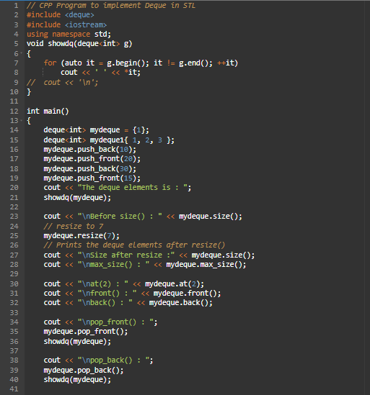
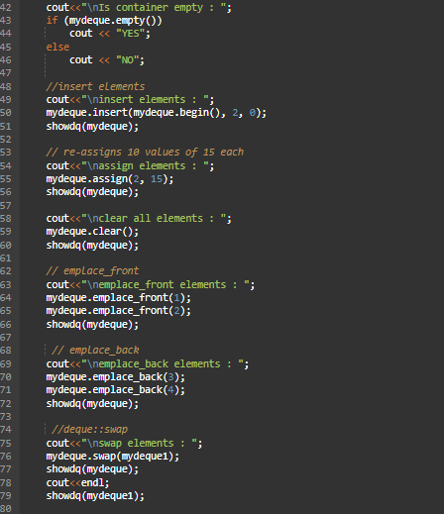
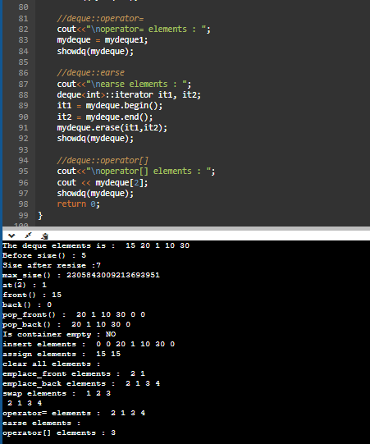

Applications of Deque
- It is used in job scheduling algorithms.
- It supports both stack and queue operations.
- The clockwise and anti-clockwise rotation operations in deque are performed in O(1) time which is helpful in many problems.

Advantages of Deque
- You are able to add and remove items from the both front and back of the queue.
- Deques are faster in adding and removing the elements to the end or beginning.
- The clockwise and anti-clockwise rotation operations are faster in a deque.
- Dynamic Size: Deques can grow or shrink dynamically.
- Efficient Operations: Deques provide efficient O (1) time complexity for inserting and removing elements from both ends.
- Versatile: Deques can be used as stacks (LIFO) or queues (FIFO), or as a combination of both.
- No Reallocation: Deques do not require reallocation of memory when elements are inserted or removed.
- Thread Safe: Deques can be thread-safe if used with proper synchronization.
- Cache-Friendly: Deques have a contiguous underlying storage structure which makes them cache-friendly.

Disadvantages of Deque
- Deque has no fixed limitations for the number of elements they may contain. This interface supports capacity-restricted deques as well as the deques with no fixed size limit.
- They are less memory efficient than a normal queue.
- Memory Overhead: Deques have higher memory overhead compared to other data structures due to the extra pointers used to maintain the double-ended structure.
- Synchronization: Deques can cause synchronization issues if not used carefully in multi-threaded environments.
- Complex Implementation: Implementing a deque can be complex and error-prone, especially if implementing it manually.
- Not All Platforms: Deques may not be supported by all platforms and may need to be implemented manually.
- Not Suitable for Sorting: Deques are not designed for sorting or searching, as these operations require linear time.
- Limited Functionality: Deques have limited functionality compared to other data structures such as arrays, lists, or trees.

Associative containers
Implement sorted data structures that can be quickly searched.

Std::set
Sets are a type of associative container in which each element has to be unique because the value of the element identifies it. The values are stored in a specific sorted order i.e. either ascending or descending. Duplicates are not allowed in set. cannot change the value once it gets inserted.
The std::set class is the part of C++ Standard Template Library (STL) and it is defined inside the <set> header file.
Syntax: std::set <data_type> set_name;
Datatype: Set can take any data type depending on the values, e.g. int, char, float, etc.

Different Functions of Set in C++ STL
Basic Iterators functions in set:
- Begin:Returns an iterator pointing to the first element in the set.
- cbegin:Returns a const iterator pointing to the first element in the set.
- end:Returns an iterator pointing to the past-end.
- cend:Returns a constant iterator pointing to the past-end.
- rbegin Returns a reverse iterator pointing to the end.
- rend:Returns a reverse iterator pointing to the beginning.
- crbegin:Returns a constant reverse iterator pointing to the end.
- crend:Returns a constant reverse iterator pointing to the beginning.
- empty:Returns true if set is empty.
- Size : Returns the number of elements in the set.
- max_size : Returns the maximum size of the set.

Let’s see example of Basic Iterators functions.
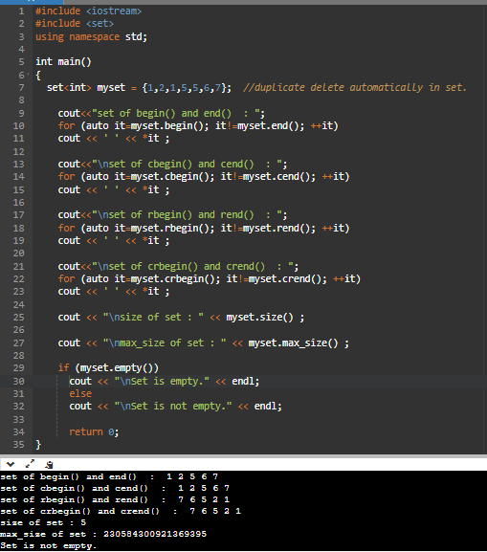
Basic modifiers functions in set:
- insert:Insert element in the set.
- erase:Erase elements from the set.
- swap:Exchange the content of the set.
- clear:Delete all the elements of the set.
- emplace:Construct and insert the new elements into the set.
- emplace_hint:Construct and insert new elements into the set by hint

Let’s see example of modifier functions.
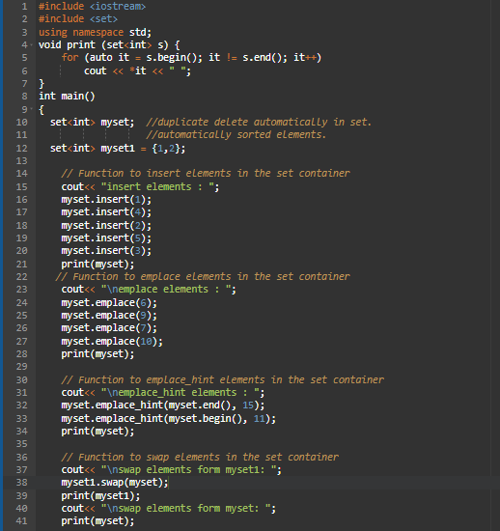
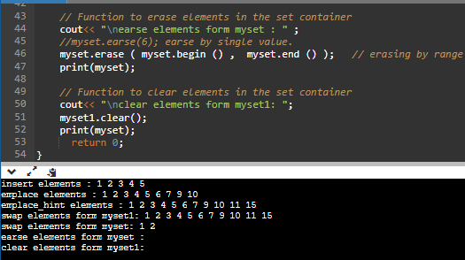
Basic operations functions in set:
- Find:Search for an element with given key.
- count:Gets the number of elements matching with given key.
- lower_bound:Returns an iterator to lower bound.
- upper_bound:Returns an iterator to upper bound.
- equal_range:Returns the range of elements matches with given key.
- key_comp:Return a copy of key comparison object.
- value_comp Return a copy of value comparison object.
- get_allocator Returns an allocator object that is used to construct the set.
- swap():Exchanges the element of two sets.
Let’s see example 1 of operations functions.
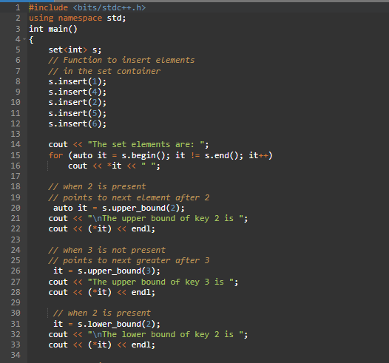
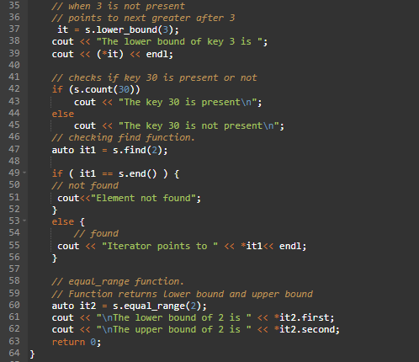
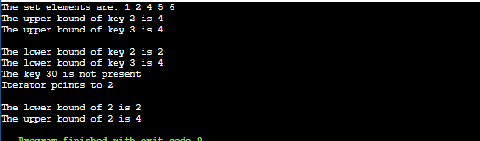
Let’s see example 2 of operations functions:
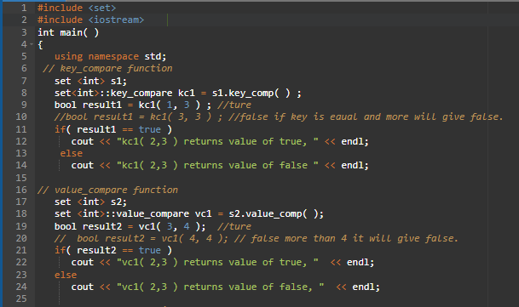
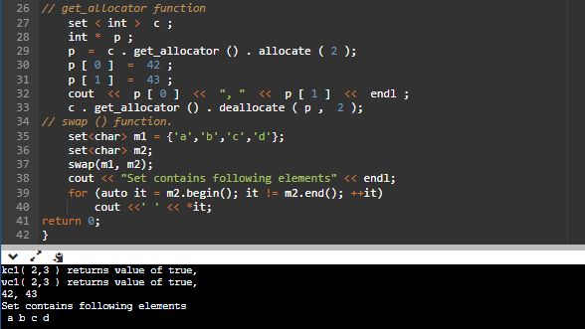

Realtime Applications of Set
- Set are used in the music player app to list all the songs in proper order.
- Set are used to determine the distinct values in an array.
- Set are used to detect cycles in a Linked List.
- Sets are used in various database operations such as performing joins.

Advantages of Set
- Set can be used to store unique values in order to avoid duplications of elements present in the set.
- Elements in a set are stored in a sorted fashion which makes it efficient.
- Set are dynamic, so there is no error of overflowing of the set.
- Searching operation takes O(logN) time complexity.
- Sets provide fast and efficient operations for checking if an element is present in the set or not.
- set can be implemented using different data structures, such as Hash Sets and Tree Sets, each with its own advantages and use cases.
- Sets can be used in a variety of applications, including algorithms, data analysis, and databases.
- Sets can be used to improve performance in many algorithms by providing fast lookups.

Disadvantages of Set
- Elements in a set can only be accessed with pointers, there is no indexing in set like arrays.
- Set is very complex to implement because of its structure and properties.
- A set takes O(logN) time complexity for basic operations like insertion and deletion.
- Not suitable for large data sets.
- Sets can only store elements of a specific data type.
- Sets can use more memory than other data structures, such as arrays or lists, because they store each element in a separate location.

Std::multiset
- Multisets are associative containers that store multiple elements having equivalent values.
- Multisets are Stores elements in sorted order.
- In multisets we can erase more than 1 element by giving the start iterator and end iterator.
- multiset can have duplicate keys.
- The value of the elements in a multiset can be inserted or deleted but cannot be altered (The elements are always const).
Syntax: std::multiset <data_type> multiset_name;
Note: All other properties are similar to the set.
Let’s see example of multiset.
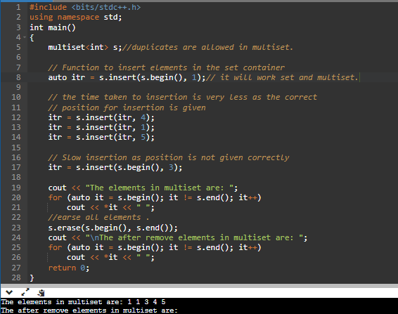

Std::map
Maps are part of the C++ STL (Standard Template Library). Maps are the associative containers that store sorted key-value pair, in which each key is unique, and it can be inserted or deleted but cannot be altered. Values associated with keys can be changed. No two mapped values can have the same key values. Duplicates are not allowed in map.
Syntax: std::map <data_type1,data_type2> map_name;
Some basic functions associated with Map:
- begin() : Returns an iterator to the first element in the map.
- end() : Returns an iterator to the theoretical element that follows the last element in the map.
- size() : Returns the number of elements in the map.
- max_size() : Returns the maximum number of elements that the map can hold.
- empty() : Returns whether the map is empty.
- pair insert(keyvalue, mapvalue) : Adds a new element to the map.
- erase(iterator position) : Removes the element at the position pointed by the iterator.
- erase(const g) : Removes the key-value ‘g’ from the map.
- erase() : Used to erase elements from the container –> O(log n)
- clear() : Removes all the elements from the map.
- insert() : Insert elements with a particular key in the map container –> O(log n)
- count() : Returns the number of matches to element with key-value ‘g’ in the map. –> O(log n)
- equal_range() : Returns an iterator of pairs. The pair refers to the bounds of a range that includes all the elements in the container which have a key equivalent to k.
- rend() : Returns a reverse iterator pointing to the theoretical element right before the first key-value pair in the map(which is considered its reverse end).
- rbegin() : Returns a reverse iterator which points to the last element of the map.
- find() : Returns an iterator to the element with key-value ‘g’ in the map if found, else returns the iterator to end.
- crbegin() and crend() : crbegin() returns a constant reverse iterator referring to the last element in the map container. crend() returns a constant reverse iterator pointing to the theoretical element before the first element in the map.
- cbegin() and cend() : cbegin() returns a constant iterator referring to the first element in the map container. cend() returns a constant iterator pointing to the theoretical element that follows the last element in the multimap.
- emplace() : Inserts the key and its element in the map container.
- upper_bound() : Returns an iterator to the first element that is equivalent to mapped value with key-value ‘g’ or definitely will go after the element with key-value ‘g’ in the map
- operator= : Assigns contents of a container to a different container, replacing its current content.
- lower_bound() : Returns an iterator to the first element that is equivalent to the mapped value with key-value ‘g’ or definitely will not go before the element with key-value ‘g’ in the map –> O(log n)
- emplace_hint() : Inserts the key and its element in the map container with a given hint.
- value_comp() : Returns the object that determines how the elements in the map are ordered (‘<‘ by default).
- key_comp() : Returns the object that determines how the elements in the map are ordered (‘<‘ by default).
- operator[] : This operator is used to reference the element present at the position given inside the operator.
- at() and map::swap() : at() function is used to return the reference to the element associated with the key k. swap() function is used to exchange the contents of two maps but the maps must be of the same type, although sizes may differ.
Let’s see example of map:
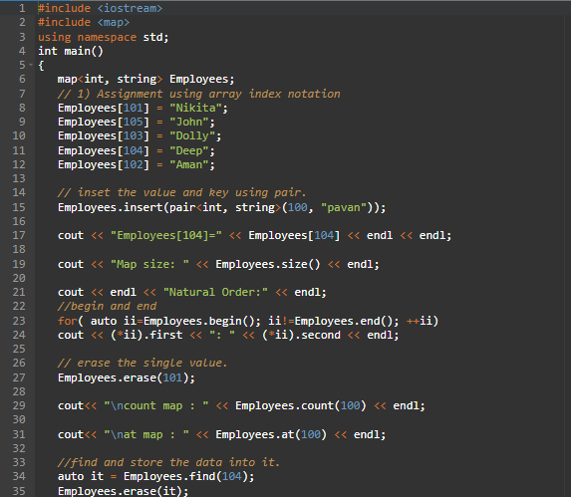
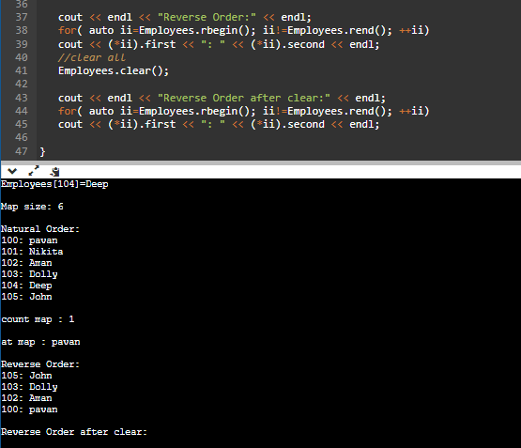

Advantages of map
- Map allows fast access to the value using the key. This property is useful when building any kind of index or reference.
- The map ensures that a key is unique across the entire data structure, which is an excellent technique for avoiding duplication of data.

Disadvantages of map
- In the case of a large number of elements stored in the map, traversing to every element is more time-consuming.

Std::multimap
Multimap is similar to a map with the addition that multiple elements can have the same keys. Also, it is NOT required that the key-value and mapped value pair have to be unique in this case. One important thing to note about multimap is that multimap keeps all the keys in sorted order always. These properties of multimap make it very much useful in competitive programming. Duplicates are allowed in multimap.
Syntax: std::multimap <data_type1,data_type2> multimap_name;
Note: All other properties are similar to the map.

Let’s see example of multimap:
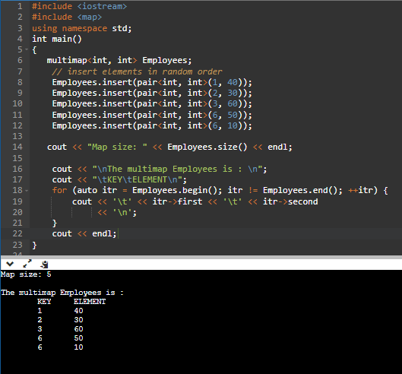

Derived containers
Derived containers provide a different interface for sequential containers

std::queue
queues are a type of container adaptors that operate in a first in first out (FIFO) type of arrangement. Elements are inserted at the back (end) and are deleted from the front. Queues use an encapsulated object of deque or list (sequential container class) as its underlying container, providing a specific set of member functions to access its elements.
Syntax: std::queue <data_type> queue_name;

Different Functions of queue in C++ STL
- queue::empty():Returns whether the queue is empty. It returns true if the queue is empty otherwise returns false.
- queue::size():Returns the size of the queue.
- queue::swap():Exchange the contents of two queues but the queues must be of the same data type, although sizes may differ.
- queue::emplace():Insert a new element into the queue container, the new element is added to the end of the queue.
- queue::front():Returns a reference to the first element of the queue.
- queue::back():Returns a reference to the last element of the queue.
- queue::push(g):Adds the element ‘g’ at the end of the queue.
- queue::pop():Deletes the first element of the queue.
Let’s see example of std::queue.
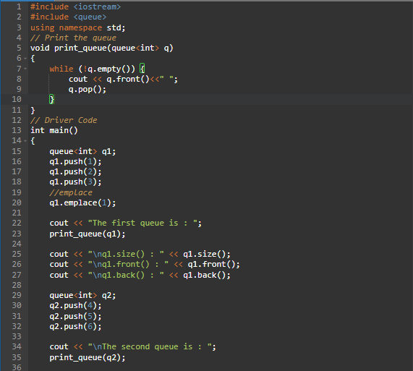
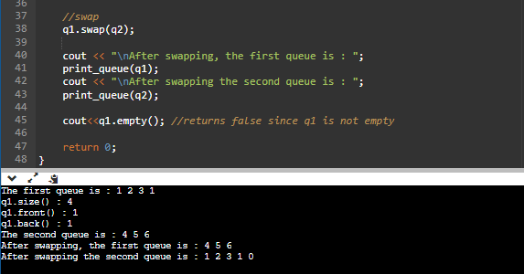

Applications of Queue
- Multi programming: Multi programming means when multiple programs are running in the main memory. It is essential to organize these multiple programs and these multiple programs are organized as queues.
- Network: In a network, a queue is used in devices such as a router or a switch. another application of a queue is a mail queue which is a directory that stores data and controls files for mail messages.
- Job Scheduling: The computer has a task to execute a particular number of jobs that are scheduled to be executed one after another. These jobs are assigned to the processor one by one which is organized using a queue.
- Shared resources: Queues are used as waiting lists for a single shared resource.

Real-time application of Queue
- ATM Booth Line
- Ticket Counter Line
- Key press sequence on the keyboard
- CPU task scheduling
- Waiting time of each customer at call centres.

Advantages of Queue
- A large amount of data can be managed efficiently with ease.
- Operations such as insertion and deletion can be performed with ease as it follows the first in first out rule.
- Queues are useful when a particular service is used by multiple consumers.
- Queues are fast in speed for data inter-process communication.
- Queues can be used in the implementation of other data structures.

Disadvantages of Queue
- The operations such as insertion and deletion of elements from the middle are time consuming.
- Limited Space.
- In a classical queue, a new element can only be inserted when the existing elements are deleted from the queue.
- Searching an element takes O(N) time.
- Maximum size of a queue must be defined prior.

std:: priority queue
The priority queue in C++ is a derived container in STL that considers only the highest priority element. The queue follows the FIFO policy while priority queue pops the elements based on the priority, i.e., the highest priority element is popped first.
It is similar to the ordinary queue in certain aspects but differs in the following ways:
- In a priority queue, every element in the queue is associated with some priority, but priority does not exist in a queue data structure.
- The element with the highest priority in a priority queue will be removed first while queue follows the FIFO(First-In-First-Out) policy means the element which is inserted first will be deleted first.
- If more than one element exists with the same priority, then the order of the element in a queue will be taken into consideration.
Syntax: std:: priority _queue <data_type> priority_queue_name;

Different Functions of priority_queue in C++ STL
- push(): It inserts a new element in a priority queue.
- pop(): It removes the top element from the queue, which has the highest priority.
- top(): This function is used to address the topmost element of a priority queue.
- size():It determines the size of a priority queue.
- empty():It verifies whether the queue is empty or not. Based on the verification, it returns the status.
- swap():It swaps the elements of a priority queue with another queue having the same type and size.
- emplace():It inserts a new element at the top of the priority queue.
- value_type:Represents the type of object stored as an element in a priority_queue. It acts as a synonym for the template parameter.
Let’s see example of std:: priority_queue:
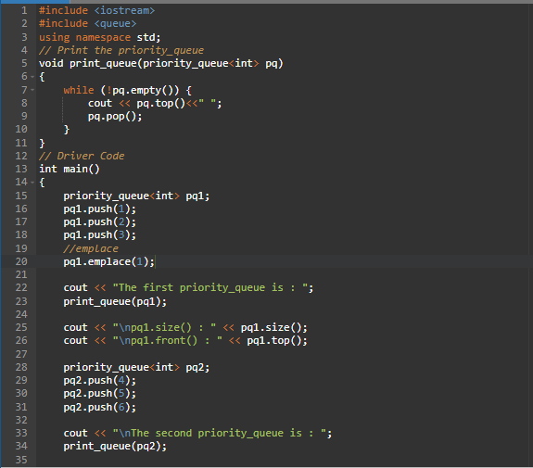
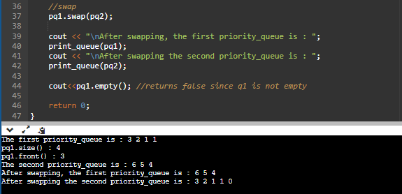

Advantages and Disadvantages of priority _queue
- The major advantage of using a priority queue is that you will be able to quickly access the highest priority item with a time complexity of just O(1).
- The only disadvantage of using Priority Queues are that the enqueue and dequeue operations are slow and have a time complexity of O(log n).

std::stack
Stacks are a type of container adaptors with LIFO (Last In First Out) type of working, where a new element is added at one end (top) and an element is removed from that end only. Stack uses an encapsulated object of either vector or deque (by default) or list (sequential container class) as its underlying container, providing a specific set of member functions to access its elements.
If there is confusion in remembering the basic difference between stack and queue, then just have a real life example for this differentiation, for stack, stacking of books we can take the top book easily and for queue remember when you have to stand in queue front of ATM for taking out the cash, then first person near to ATM has the first chance to take out the money from ATM. So, queue is the FIFO (First In First Out) type working.
Syntax: std:: stack <data_type> stack_name;

Different Functions of stack in C++ STL
- push():It inserts a new element in a stack.
- pop():It removes the top element from the stack.
- top():This function is used to address the topmost element of a stack.
- size():It determines the size of a stack.
- empty():It verifies whether the stack is empty or not. Based on the verification, it returns the status.
- emplace():It inserts a new element at the top of the stack.
Let’s see example of std::stack :
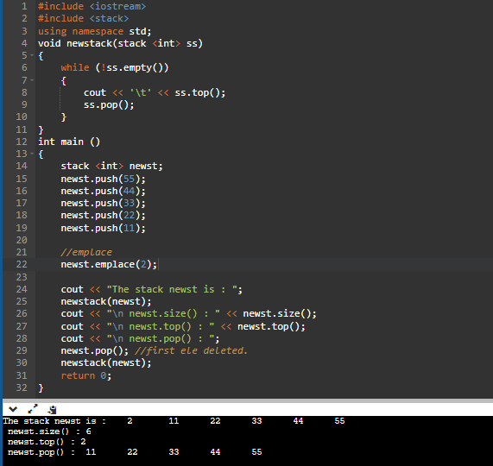

Application of Stack in real life
- CD/DVD stand.
- Stack of books in a book shop.
- Call centre systems.
- Undo and Redo mechanism in text editors.
- The history of a web browser is stored in the form of a stack.
- Call logs, E-mails, and Google photos in any gallery are also stored in form of a stack.
- YouTube downloads and Notifications are also shown in LIFO format (the latest appears firs).
- Allocation of memory by an operating system while executing a process.

Advantages of Stack
- Easy implementation: Stack data structure is easy to implement using arrays or linked lists, and its operations are simple to understand and implement.
- Efficient memory utilization: Stack uses a contiguous block of memory, making it more efficient in memory utilization as compared to other data structures.
- Fast access time: Stack data structure provides fast access time for adding and removing elements as the elements are added and removed from the top of the stack.
- Supports backtracking: Stack data structure supports backtracking algorithms, which are used in problem-solving to explore all possible solutions by storing the previous states.
- Enables undo/redo operations: Stack data structure is used to enable undo and redo operations in various applications like text editors, graphic design tools, and software development environments.

Disadvantages of Stack
- Limited capacity: Stack data structure has a limited capacity as it can only hold a fixed number of elements. If the stack becomes full, adding new elements may result in stack overflow, leading to the loss of data.
- No random access: Stack data structure does not allow for random access to its elements, and it only allows for adding and removing elements from the top of the stack. To access an element in the middle of the stack, all the elements above it must be removed.
- Memory management: Stack data structure uses a contiguous block of memory, which can result in memory fragmentation if elements are added and removed frequently.
- Not suitable for certain applications: Stack data structure is not suitable for applications that require accessing elements in the middle of the stack, like searching or sorting algorithms.
- Stack overflow and underflow: Stack data structure can result in stack overflow if too many elements are pushed onto the stack, and it can result in stack underflow if too many elements are popped from the stack.
- Recursive function calls limitations: While stack data structure supports recursive function calls, too many recursive function calls can lead to stack overflow, resulting in the termination of the program.

10.3 Iterators
Iterators are just like pointers used to access the container elements. Iterators are used to point at the memory addresses of STL containers. They are primarily used in sequences of numbers, characters etc. They reduce the complexity and execution time of the program.
Important Points:
- Iterators are used to traverse from one element to another element, a process is known as iterating through the container.
- The main advantage of an iterator is to provide a common interface for all the containers type.
- Iterators make the algorithm independent of the type of the container used.
- Iterators provide a generic approach to navigate through the elements of a container.
Syntax : <ContainerType> :: iterator;
<ContainerType> :: const_iterator;
Operations Performed on the Iterators:
- Operator (*)
- Operator (++)
- Operator (==)
- Operator (!=)
- Operator (=)
Operations of iterators:
1. begin (): - This function is used to return the beginning position of the container.
2. end ():- This function is used to return the after end position of the container.
3. advance () :- This function is used to increment the iterator position till the specified number mentioned in its arguments.
4. next() :- This function returns the new iterator that the iterator would point after advancing the positions mentioned in its arguments.
5. prev() :- This function returns the new iterator that the iterator would point after decrementing the positions mentioned in its arguments.
6. inserter() :- This function is used to insert the elements at any position in the container.
Let’s see example of operations of iterators:
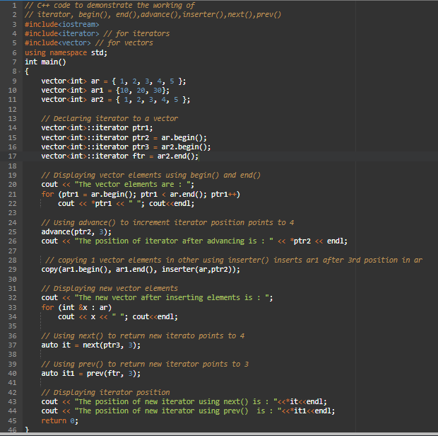
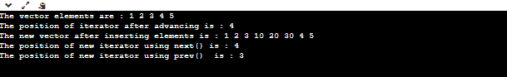
Iterator Categories:
- Input Iterator
- Output Iterator
- Forward Iterator
- Bidirectional Iterator
- Random Access Iterator
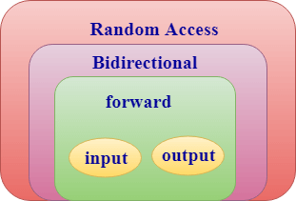

Input Iterator
An input iterator is an iterator used to access the elements from the container, but it does not modify the value of a container.
Operators used for an input iterator are:
- Increment operator(++)
- Equal operator(==)
- Not equal operator(!=)
- Dereference operator(*)
Let’s see example of input iterator:
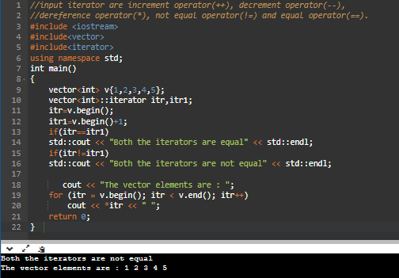

Output Iterator
An output iterator is an iterator used to modify the value of a container, but it does not read the value from a container. Therefore, we can say that an output iterator is a write-only iterator.
Operators used for an output iterator are:
- Increment operator (++)
- Assignment operator (=)
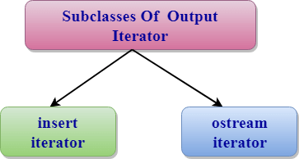
Ostream iterator:
- An ostream iterators are the output iterators used to write to the output stream such as cout successively.
- An ostream iterator is created using a basic_ostream object.
- When an assigenment operator is used on the ostream iterator, it inserts a new element into the output stream.
Syntax: ostream_iterator<data_type> varible_name;
Let’s see example of output iterator:
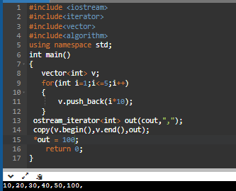
Features of Output Iterator:
Invalid:
- X==Y;
- X!=Y;
- x = *A;
- A++;
- ++A;
- A = =B;
- A = =B;
- A + 2;
- A + 5;
Valid:
- *X=7;
- X++;
- ++X;
- *A = x;

Forward Iterator
A forward iterator is an iterator used to read and write to a container. It is a multi-pass iterator.
Operators used for a Forward iterator are:
- Increment operator (++)
- Assignment operator (=)
- Equal operator (=)
- Not equal operator (!=)

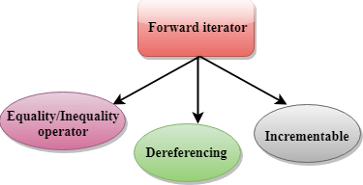
Let’s see example of forward iterator:
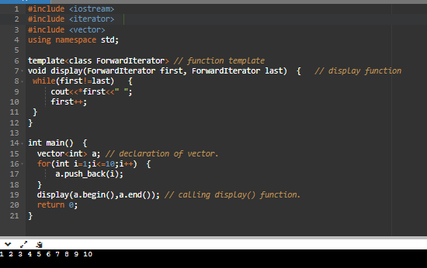
Features of the Forward Iterator:
Valid:
- A==B;
- A!=B;
- *A = t;
- t = *A;
- A++;
- ++A;
Invalid:
- A--;
- A>=B;
- A+2;
- A+3;

Bidirectional iterator
A bidirectional iterator is an iterator supports all the features of a forward iterator plus it adds one more feature, i.e., decrement operator (--). We can move backward by decrementing an iterator.
Operators used for a Bidirectional iterator are:
- Increment operator (++)
- Assignment operator (=)
- Equal operator (=)
- Not equal operator (!=)
- Decrement operator (--)
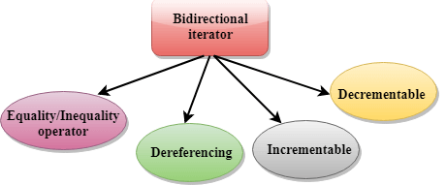
Let’s see example of bidirectional iterator:
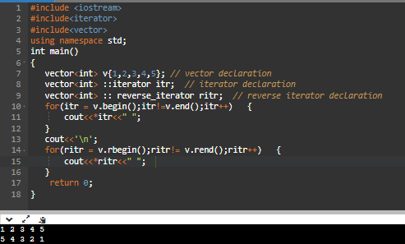
Features of the Bidirectional iterator
Invalid:
- A+2;
- A+1;
- A<=B;
Valid:
- A==B;
- A!=B;
- *A = t;
- t = *A
- A++;
- ++A;
- A--;
- --A;

Random Access Iterator
A Random-Access iterator is an iterator provides random access of an element at an arbitrary location. It has all the features of a bidirectional iterator plus it adds one more feature, i.e., pointer addition and pointer subtraction to provide random access to an element.
Difference b/w Random Access Iterator and Other Iterators
The most important difference between the Random-access iterator and other iterators is that random access iterator requires '1' step to access an element while other iterators require 'n' steps.
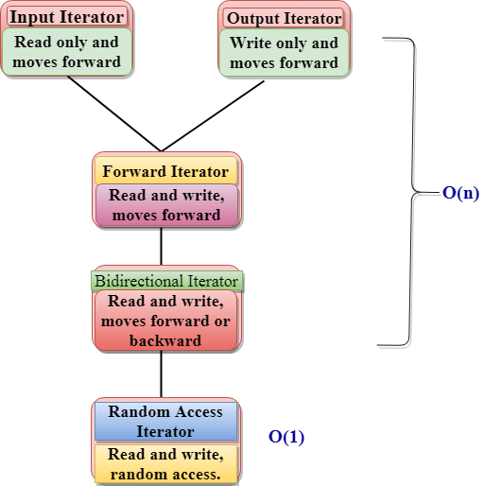

Providers of Iterators
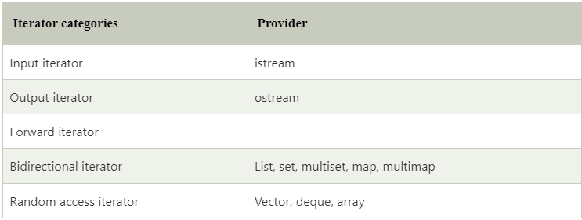

Iterators and their Characteristics
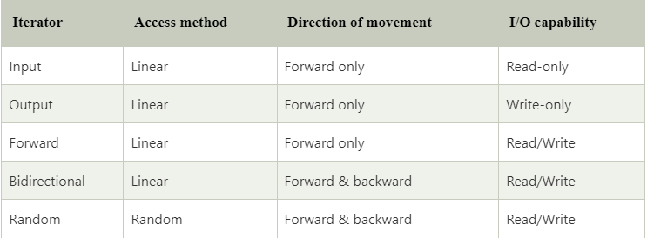

Advantages of iterator
- Ease in programming
- Code Reusability
- Dynamic Processing

Disadvantages of iterator
- If we want to move from one data structure to another at the same time, iterators won't work.
- If we want to update the structure which is being iterated, an iterator won’t allow us to do because of the way it stores the position.
- If we want to backtrack while processing through a list, the iterator will not work in this case.

10.4 Algorithms
- Algorithms in C++ help in writing cleaner, more maintainable code by leveraging tested and optimized implementations of common operations on STL.
- Here are some of the most commonly used algorithms in C++ from the Standard Template Library (STL), along with brief explanations and examples for each:

1. sort
Sorts elements in a range
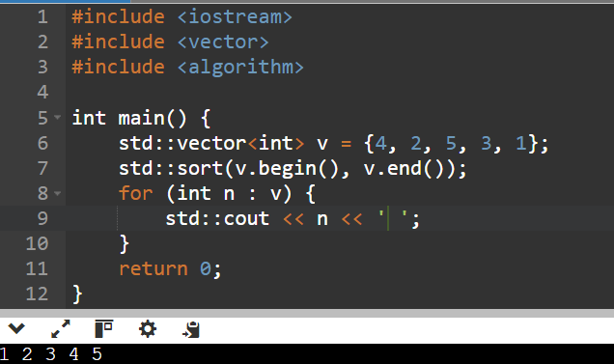
Implementation of sort:
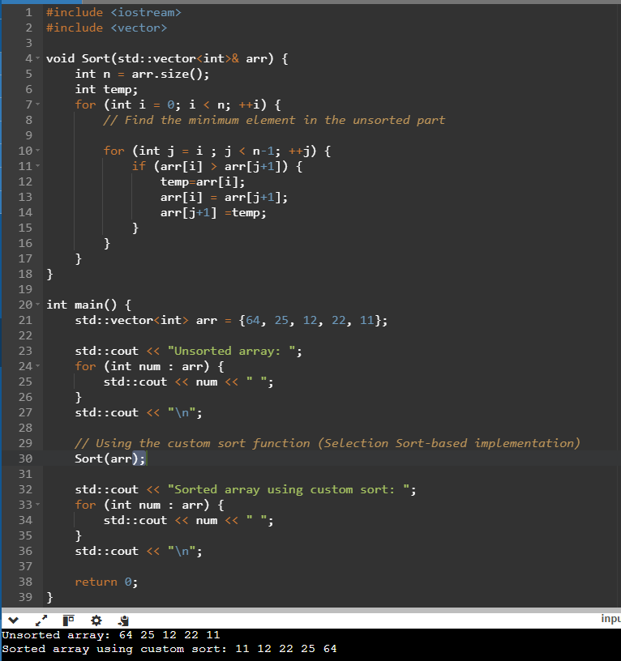
Implementation of Bubble Sort:
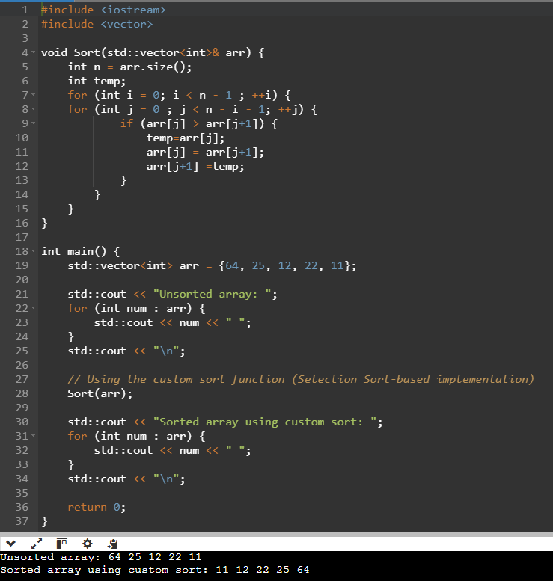

2. find
Searches for an element equal to a given value.
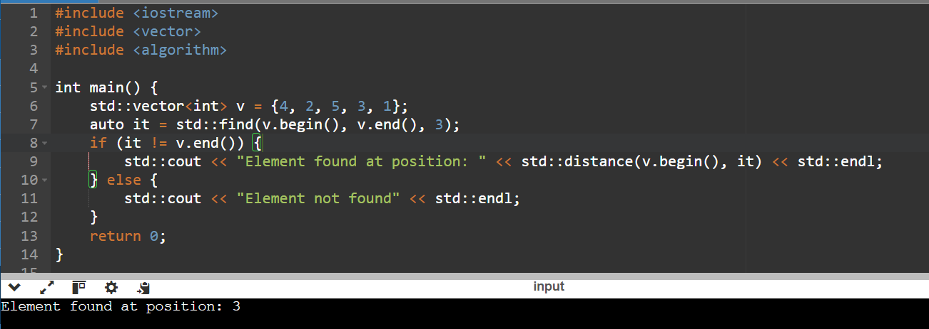

3. count
Counts occurrences of a value.
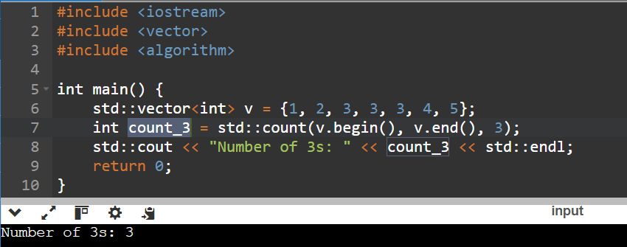

4. accumulate (from <numeric>)
Calculates the sum of elements in a range.
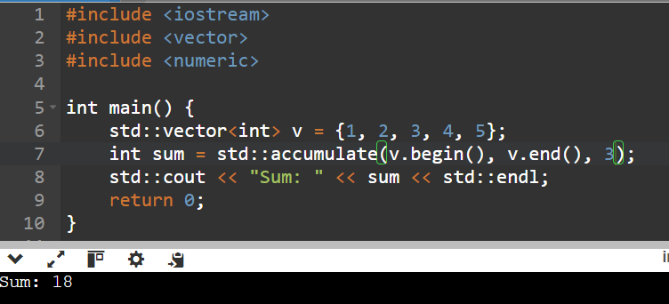
Here, first calculate the sum of elements 1+2+3+4+5 = 15 and at the end 3 will add 15+3 =18.

5. copy
Copies elements from one range to another.
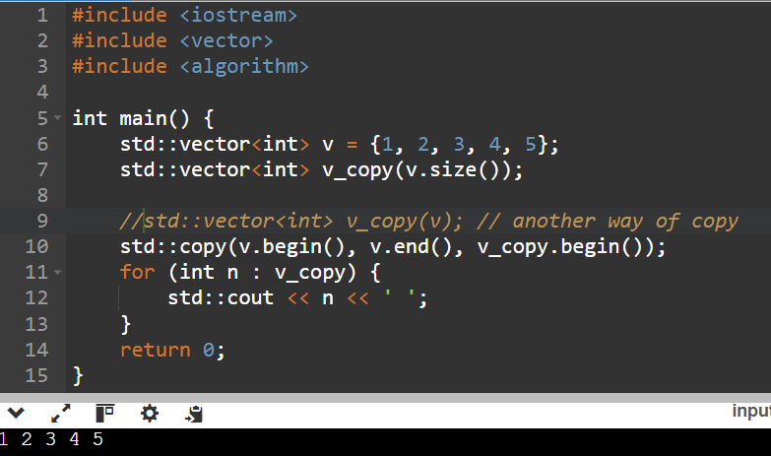

6. remove
Removes elements equal to a value.
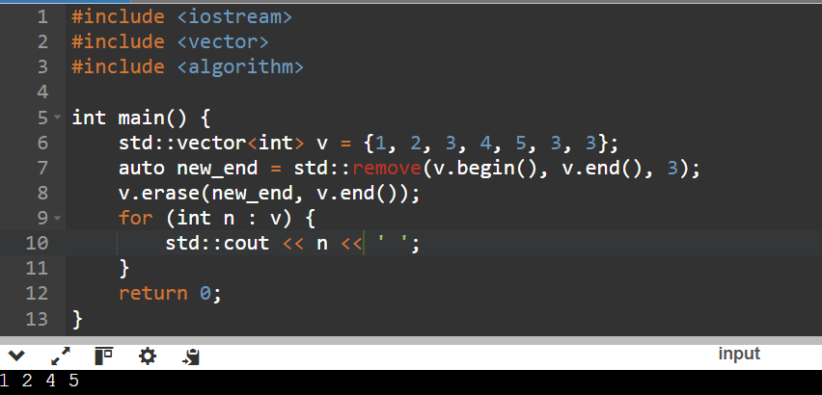

7. reverse
Reverses the order of elements in a range.
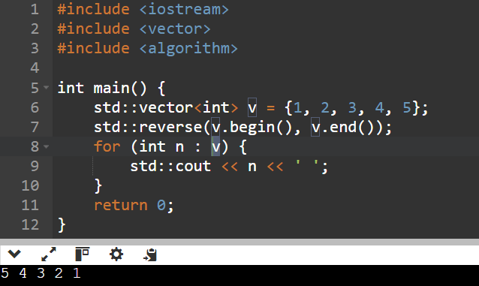

8. transform
Applies a function to a range and stores the result in another range.
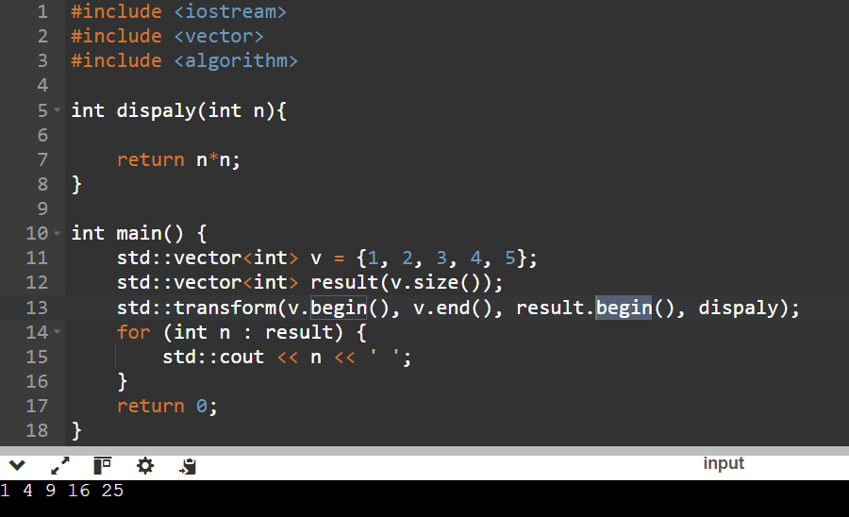

9. unique
Removes consecutive duplicate elements.
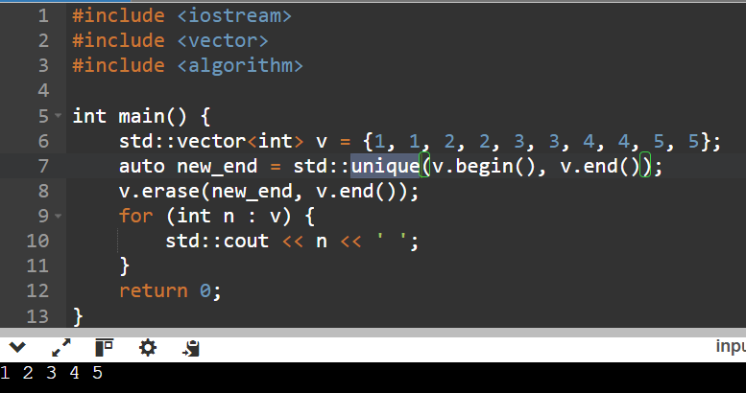

10. partition
Rearranges elements based on a condition.
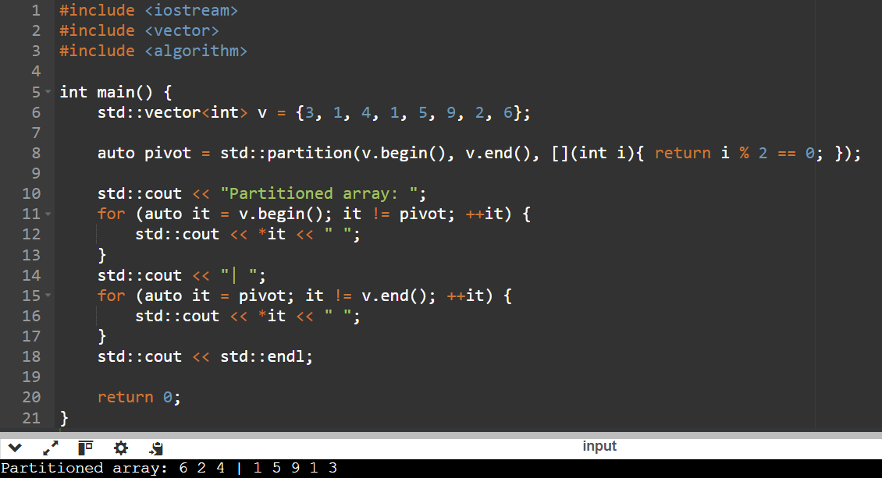

11. for_each
Applies a function to each element in a range.
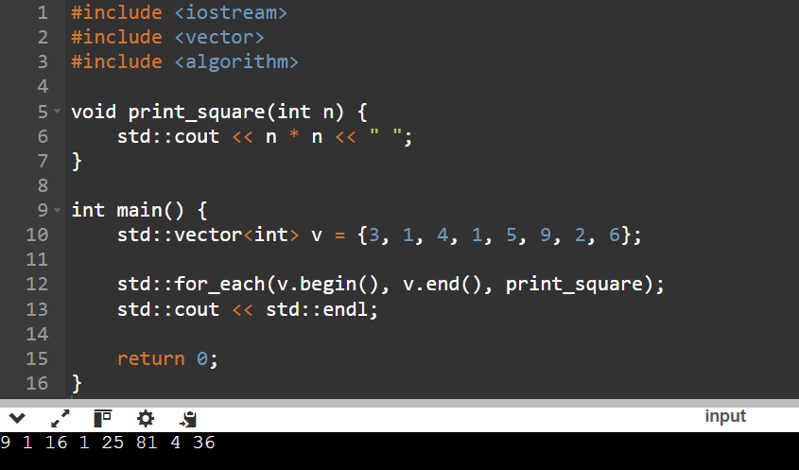

12. replace
Replaces occurrences of a value in a range.
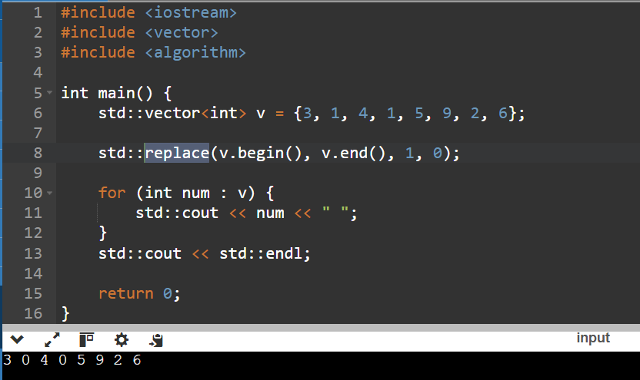

13. fill
Assigns a value to all elements in a range.
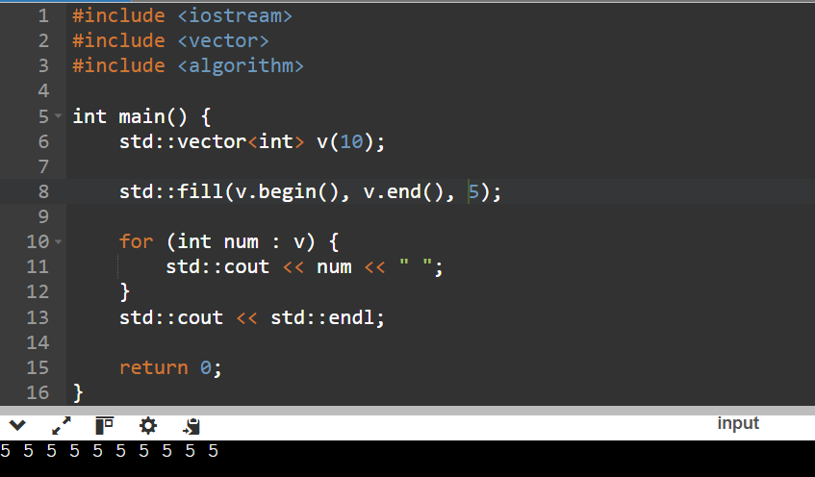

14. max_element
Finds the largest element in a range.
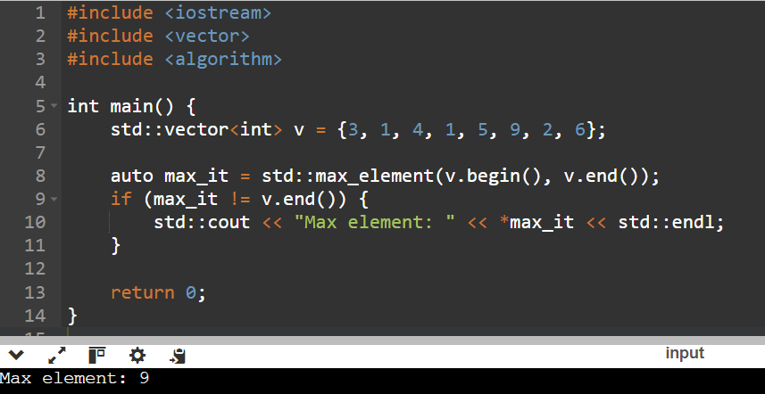

15. min_element
Finds the smallest element in a range.
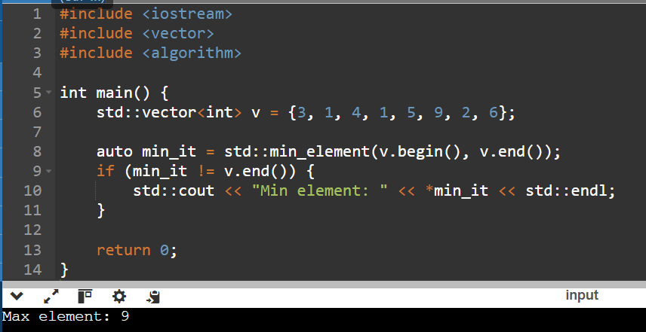

16. next_permutation
Generates the next lexicographical permutation of a range.
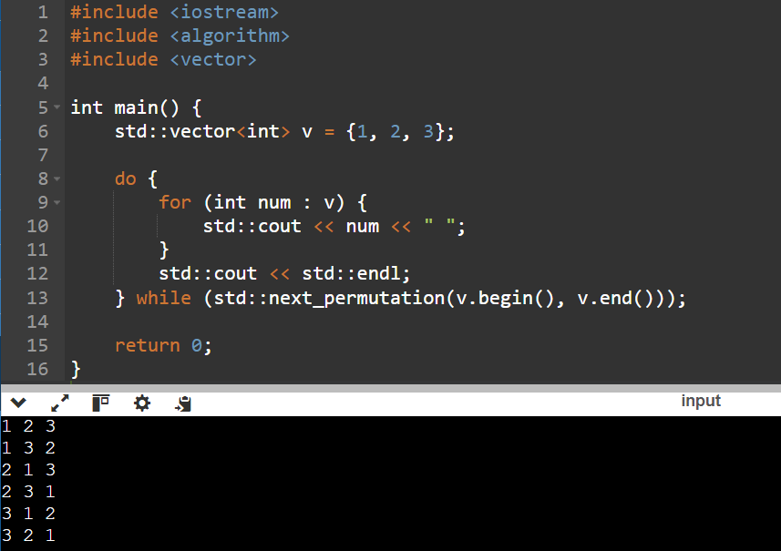

17. prev_permutation
Generates the previous lexicographical permutation of a range.
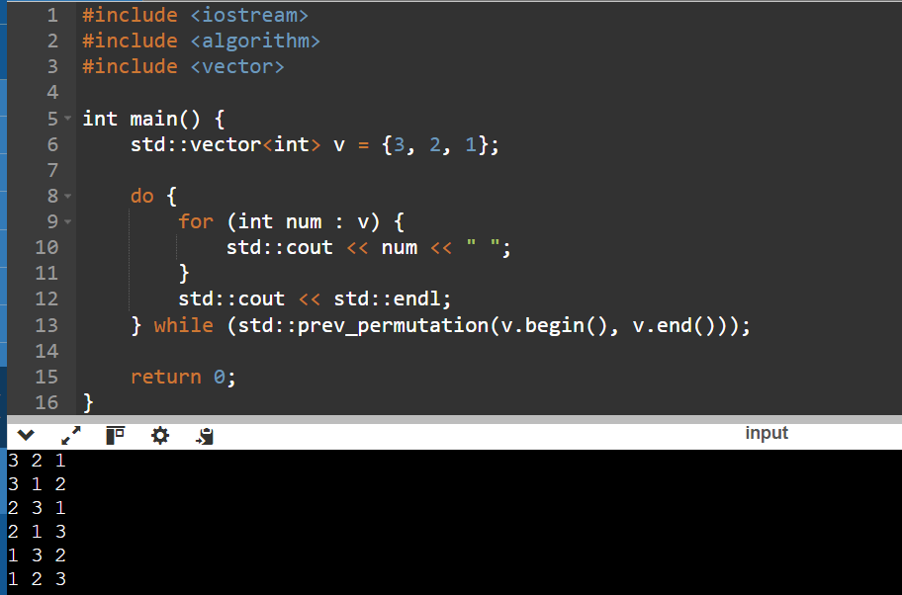
18. Rabdom_shuffle
(deprecated in C++17, use shuffle with a random number generator) Randomly shuffles elements in a range.
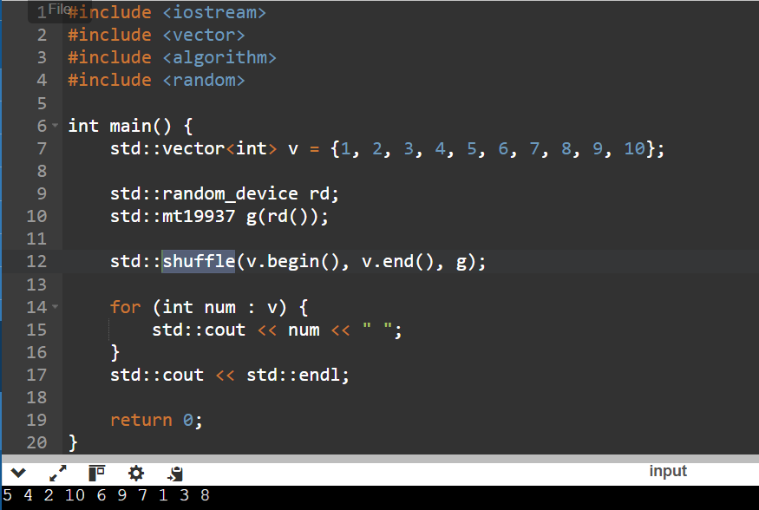

19. lower_bound
Finds the first position where a value could be inserted without disrupting the order in a sorted range.
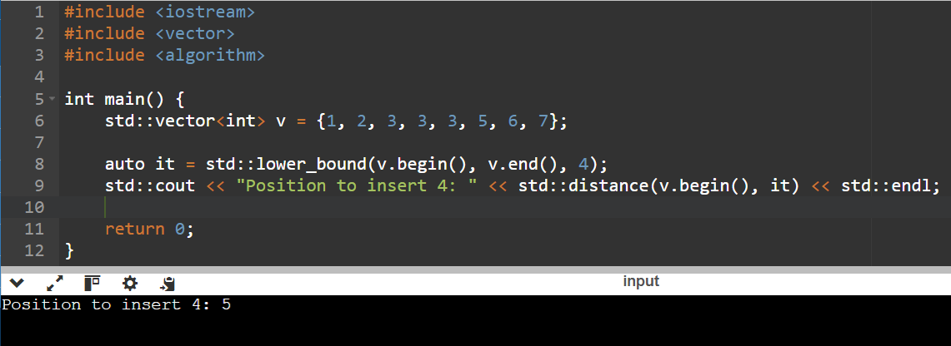

20. upper_bound
Finds the last position where a value could be inserted without disrupting the order in a sorted range.
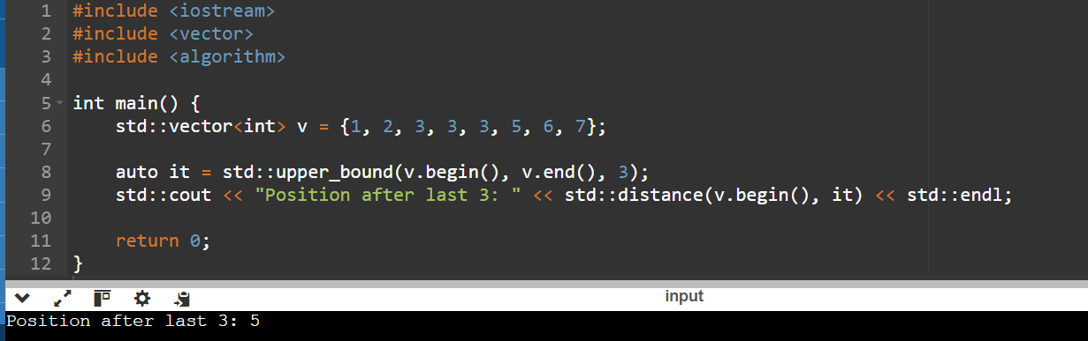

21. binary_search
Checks if a value exists in a sorted range.
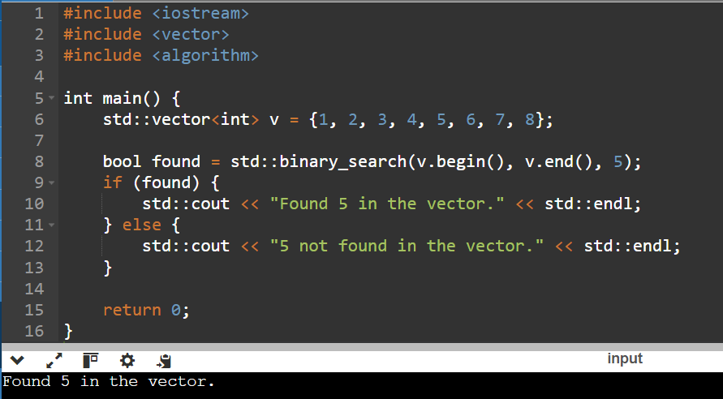

Section 11: C++ Advance concepts

C++11

C++11 includes the following new language features

Move Semantics
- move constructors work on the R - value references and move semantics (move semantics involves pointing to the already existing object in the memory).
- On declaring the new object and assigning it with the R - value, firstly a temporary object is created, and then that temporary object is used to assign the values to the object.
- Due to this the copy constructor is called several times and increases the overhead and decreases the computational power of the code.
- To avoid this overhead and make the code more efficient we use move constructors.
Syntax of the Move Constructor:
class_name(class_name&& obj) : data{ obj.data } {
// Nulling out the pointer to the temporary data
obj.data = nullptr;
}
Let’s see example of move semantics:
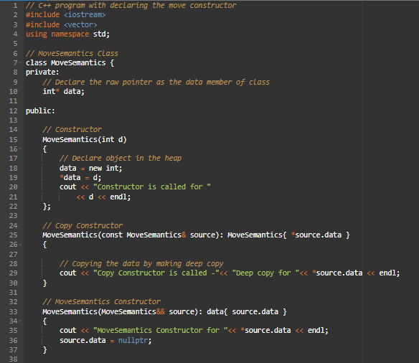
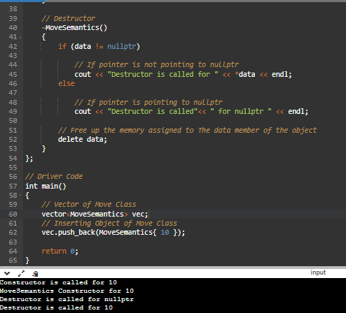
Advantages of move semantic:
Move semantics allows you to avoid unnecessary copies when working with temporary objects that are about to evaporate, and whose resources can safely be taken from that temporary object and used by another.

Variadic Templates
Variadic templates are class or function templates, that can take any variable (zero or more) number of arguments. In C++, templates can have a fixed number of parameters only that have to be specified at the time of declaration. However, variadic templates help to overcome this issue.
Syntax of variadic template:
template (typename arg, typename... args)
return_type function_name(arg var1, args... var2)

let’s see example of variadic function template:
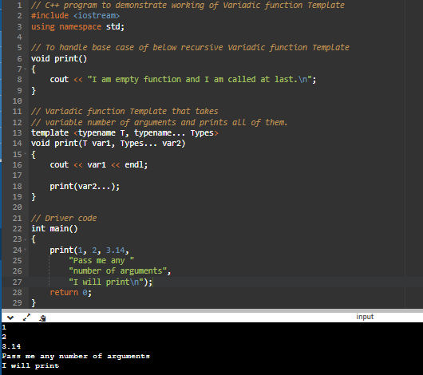

l - value & R - value references
l–value:
“l-value” refers to a memory location that identifies an object.
syntax of l-value reference:
int a = 10;
int& lref = a;
Uses of the l-value references:
- l-value references can be used to alias an existing object.
- They can also be used to implement pass-by-reference semantics.

Let’s see example of l - value reference
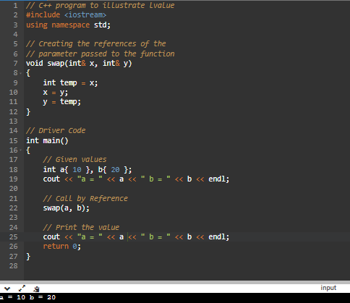
R-value:
“r - value” refers to the data value that is stored at some address in memory.
syntax of r-value reference:
int&& rref = 20;
Uses of r-value references:
- They are used in working with the move constructor and move assignment.
- cannot bind non-const l - value reference of type ‘int&‘ to an r - value of type ‘int’.
- cannot bind r - value references of type ‘int&&‘ to l - value of type ‘int’.
- One of the most significant uses of r - values in C++ is to enable move semantics. Move semantics allow efficient transfer of resources (e.g., memory, ownership) from one object to another without making a copy. This is particularly useful for large or expensive-to-copy objects like dynamic arrays or objects managing system resources (e.g., file handles).

Let’s see example of r-value reference:
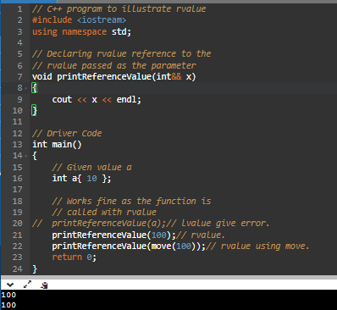
Note: The different between the l-value and R-value are l-value is an object reference and an r-value is a value reference.

Forwarding References
std::forward is a utility function in the C++ Standard Library, introduced in C++11, that is used to enable perfect forwarding in template programming.They allow functions to accept arguments of any type (lvalue, rvalue, const, non-const) and forward them to another function, maintain the argument's type and value category.
Syntax of forwarding reference:
template <typename T>
void forwardingFunction(T&& arg) {
otherFunction(std::forward<T>(arg));
}

Let’s see example of forwarding reference:
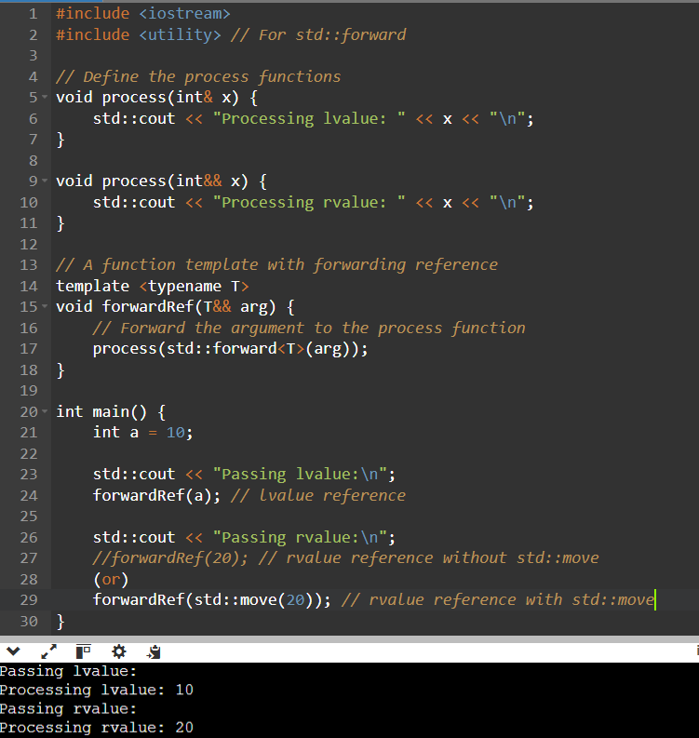
Advantages of forward reference:
- Perfect forwarding.
- Avoid unnecessary copies/moves.
- Support for move semantics.
- Flexible argument passing.
- Support for variadic templates.
- Improved code reusability.

initializer lists
Using initializer lists can be more efficient than assigning values in the constructor body because it avoids an extra default construction and subsequent assignment. This is especially relevant for complex objects that might have non-trivial default constructors.
Initializer lists are specified within curly braces {} and are used in the constructor's initialization list.

Syntax of the initializer lists:
ClassName::ClassName(parameters) : member1(value1), member2(value2), ... {
// constructor body
}
Let’s see example of initializer lists:
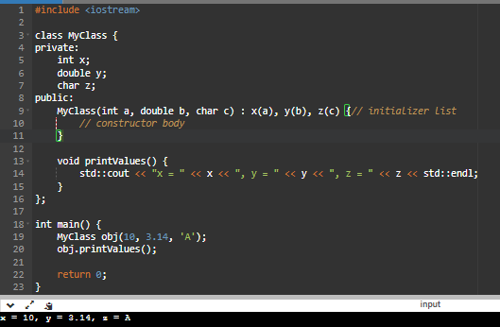
Example with std::initializer_list:
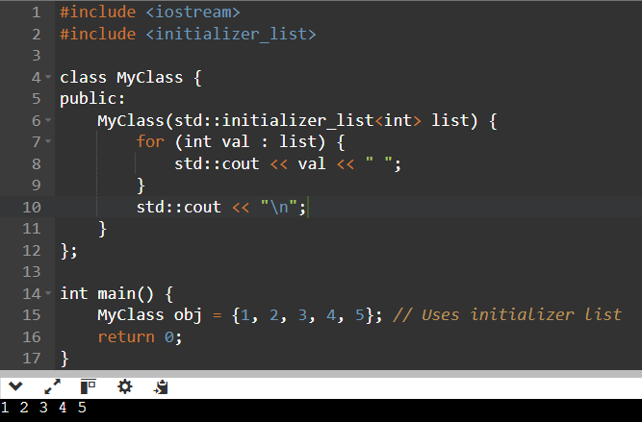
Advantages of initializer lists
- Initialization of const and reference members.
- Avoiding extra default construction and assignment.
- Initialization of base class.
- Order of initialization.
- Initialization of array elements.
Limitations
- Once created, an std::initializer_list is immutable (its elements cannot be modified).
- It can only be used where an initializer list is explicitly defined.
- Does not work directly with dynamically sized arrays.
When to Use Initializer Lists
- Initializing containers with a predefined set of values.
- Simplifying constructor code for classes.
- Constructing objects with multiple values.

static assertions
Static assertions are a way to check if a condition is true when the code is compiled. If it isn’t, the compiler is required to issue an error message and stop the compiling process. The condition that needs to be checked is a constant expression. constant expression will work only compile time.
Syntax of the static assertion:
static_assert( constant_expression, string_literal );
Let’s see example of static assertion:
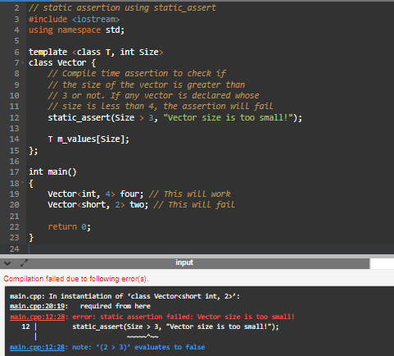
Advantages of static assertion
- Compile-time error detection
- Improved code quality
- Informative error messages
- Early detection of compatibility issues

auto
In C++, the 'auto' keyword is used for automatic type inference. It allows the compiler to determine the type of a variable based on its initializer expression.
Syntax of auto:
auto variable = value;
Let’s see example of auto keyword:
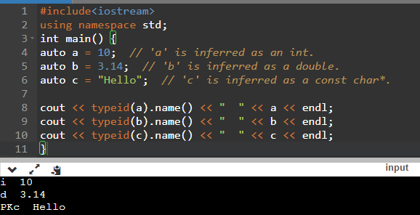

lambda expressions
A lambda expression in C++ is an anonymous function that can be defined in place within the code. It allows developers to create a function without a name, making it concise and suitable for short-lived, reusable functionality, particularly in algorithms and event handling.
Key Features
- Anonymous: Lambdas do not require a name.
- Scope Capture: They can capture variables from their enclosing scope by value or reference.
- Inline Definition: They are defined directly where they are needed.
- First-Class Functions: Lambdas can be stored in variables, passed as arguments, or returned from functions.
Syntax of lambda expressions:
auto name_of_function = [capture list] (parameter list) -> return_type {
// lambda function body
};

Let’s see example of lambda expressions:
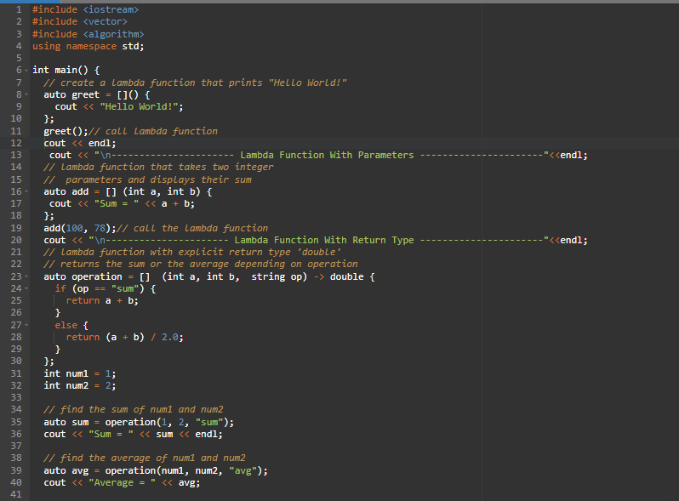
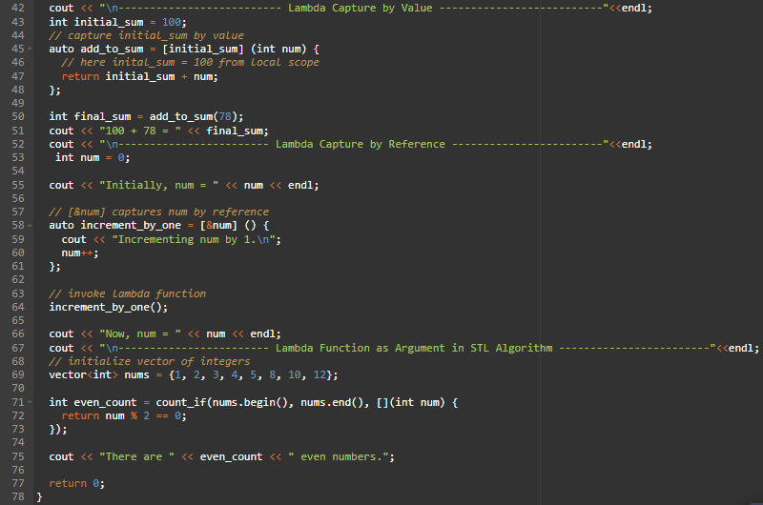
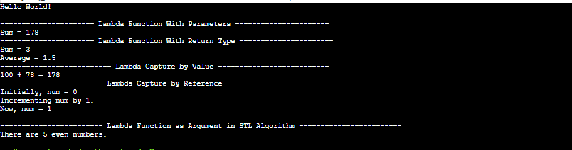
Advantages of lambda expressions:
- Concise and Readable Code
- Local Scope Access
- Flexibility
- Algorithm Customization
- Avoiding Function Overhead
- Capturing by Reference or Value
- Easier Call-backs
The main difference between a function and a lambda expression in C++ is their form and usage:
Function:
- Named: Functions have names and are defined with a specific name in the code.
- Standalone: They are defined separately from their usage and can be called from different parts of the code.
- Typically for Reusability: Functions are used when you want to create a reusable piece of code that can be called multiple times.
Lambda Expression:
- Anonymous: Lambdas are anonymous, meaning they don't have a specific name and are defined inline at the point where they are needed.
- Inline: They are often used for short, one-time operations where defining a separate named function would be less convenient.
- Typically for Conciseness: Lambdas are used when you want a compact and concise way to define a small piece of functionality without the overhead of naming a function.

decltype
In C++, 'decltype' is a keyword that allows you to determine the type of an expression or a variable at compile-time. It returns the type of the expression or variable without actually evaluating it.
Syntax of decltype:
decltype(expression)

Let’s see example of decltype:
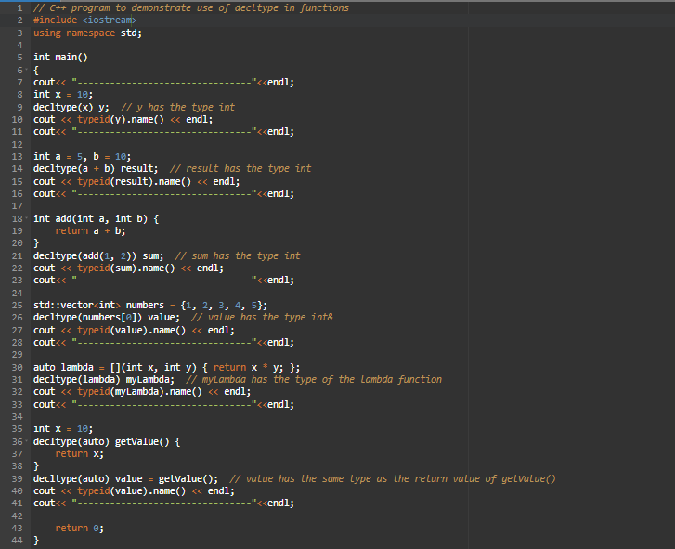
Advantages of decltype:
- Type Deduction
- Preserve Type Information
- Support for Generic Programming
- Automatic Adaptation to Code Changes
- Type Reflection
- Function Pointer and Template Parameter Deduction
Note: Decltype gives the type of information at compile time while typeid gives at runtime.

type aliases
In C++, type aliases allow you to create alternative names for existing types. They can be useful for improving code readability, creating more descriptive type names, and abstracting away complex or long type names. C++ provides two ways to define type aliases: typedef and using.

Syntax of both typedef and using:
typedef existing_type new_type_alias;
using new_type_alias = existing_type;
Let’s see example of typedef:
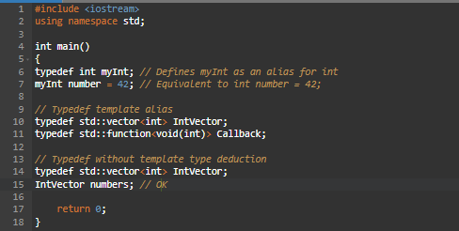
Let’s see example of using:
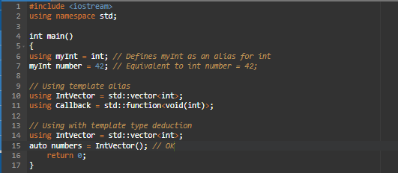
Different between the typedef and using:
- Purpose:
Both typedef and using are used to create type aliases (new names) for existing data types.
Syntax:
typedef: More verbose and less intuitive.
typedef int Integer;
using: Simpler and more modern.
using Integer = int;
- Template Usage:
typedef: Syntax becomes more complex when used with templates.
typedef std::vector<int>::iterator IntIterator;
using: Cleaner and easier to use with templates.
using IntIterator = std::vector<int>::iterator;
- Readability:
typedef: Can be harder to read and understand, especially for complex types.
using: More readable, especially for complex types and templates.
- Compatibility:
typedef: Available in all versions of C++.
using: Introduced in C++11 and preferred for modern C++ code.
- Flexibility:
typedef: Less flexible with advanced type features (e.g., template aliasing).
using: More flexible and supports aliasing for templates better.

nullptr
In C++, nullptr is a keyword introduced in C++11 to represent a null pointer. It is a constant that can be assigned to pointers of any type and is used to indicate that a pointer does not point to any object or function.
Prior to C++11, the macro NULL was commonly used to represent a null pointer. However, nullptr provides a safer and more expressive alternative. It has a distinct type, std::nullptr_t, and can be implicitly converted to any pointer type. This means you can assign nullptr to pointers of different types without explicit casting.
Let’s see example of nullptr:
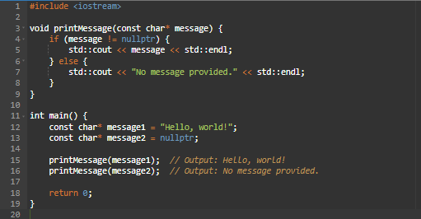
Advantages of nullptr:
- Improved Type Safety
- Avoiding Overloaded Function Ambiguities
- Clarity and Readability
- Enhanced Debugging
- Forward Compatibility

strongly-typed enums
Strongly-typed enums, also known as strongly-typed enumerations or enum classes, are a feature introduced in C++11 to provide a type-safe and scoped alternative to traditional C-style enums. Strongly-typed enums help prevent unintended implicit conversions and namespace pollution that can occur with regular enums.
Syntax of enums:
enum class EnumClassName : UnderlyingType {
Enumerator1,
Enumerator2,
// ...
};
Let’s see example of enum:
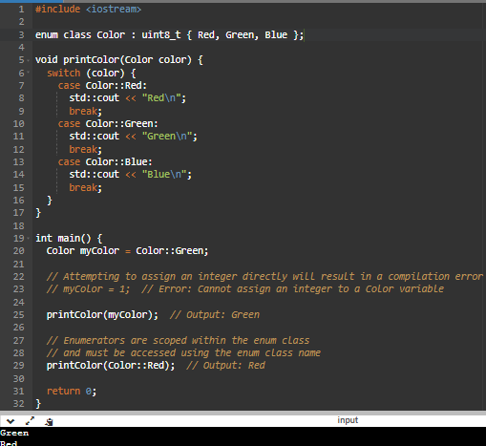

Strongly-typed enums have the following characteristics:
Type safety: The enumerators are strongly associated with the enum class and cannot be implicitly converted to integers or other enumerations. For example, you can't assign an integer value directly to a strongly-typed enum variable.
ex:
Color myColor = 1; // Error: Cannot assign an integer to a Color variable
Scoped: The enumerators are scoped within the enum class, which means you need to qualify them with the enum class name to use them.
ex:
Color myColor = Color::Red; // Correct: Using the enumerator with the enum class name
No implicit conversions: Strongly-typed enums do not implicitly convert to integers, and vice versa. You need to explicitly cast them to perform conversions.
ex:
int myInt = static_cast<int>(myColor); // Explicitly cast the enum to an integer
Enumerators are not part of the enclosing scope: Unlike regular enums, strongly-typed enum enumerators don't pollute the enclosing scope. You need to use the enum class name to access the enumerators.
ex:
// Regular enum
enum ColorLegacy { Red, Green, Blue };
// Strongly-typed enum
enum class Color { Red, Green, Blue };
int Red = 5; // Okay with regular enum, but an error with enum class

attributes
In C++, attributes are annotations or metadata that provide additional information about various program elements like variables, functions, classes, or even the entire translation unit. Attributes are typically enclosed in square brackets ('[]') and placed before the declaration or definition of the element they modify.
C++11 introduced attributes as a standard feature, allowing developers to add implementation-specific or user-defined metadata to their code. Attributes can be used for a variety of purposes, such as optimizing code, enabling or disabling specific compiler features, controlling memory layout, or providing hints to the compiler.
Here are some commonly used attributes in C++:
Let’s see examples of attributes.
- [[nodiscard]]: This attribute indicates that a function's return value should not be ignored. The compiler will emit a warning if the return value is not used.
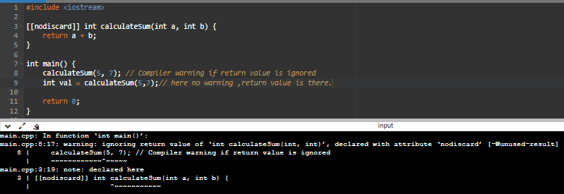
- [[deprecated]]: This attribute marks a declaration as deprecated, indicating that it is no longer recommended to use. The compiler will emit a warning when the deprecated
element is used.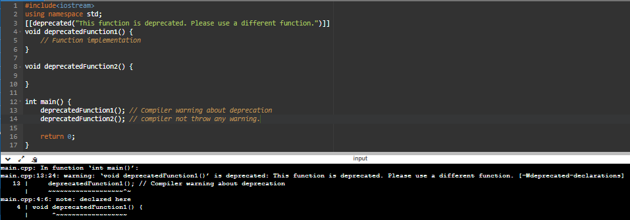
- [[maybe_unused]]: This attribute suppresses compiler warnings for unused variables or entities explicitly marked as "unused."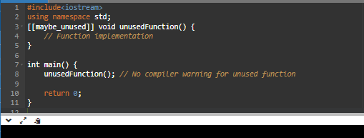

- [[fallthrough]]: This attribute is used in switch statements to indicate intentional fallthrough between case labels. It suppresses compiler warnings about missing break statements.
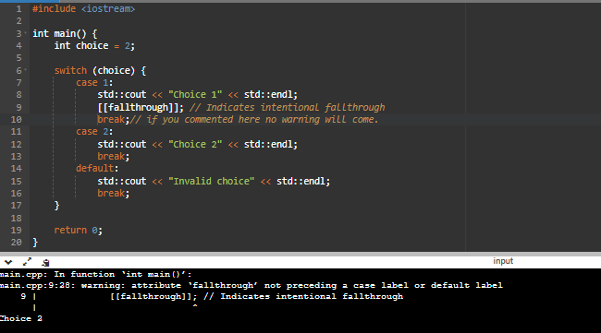
- [[noreturn]]: This attribute specifies that a function does not return to the caller. It is typically used for functions that exit the program, such as std::exit or infinite loops.
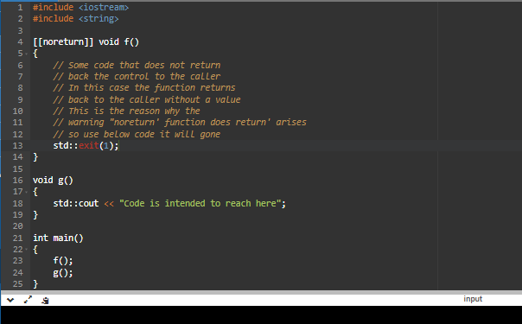
- [[alignas(n)]]: This attribute specifies the alignment of a variable or data structure to a specific byte boundary. 'n' represents the alignment value.
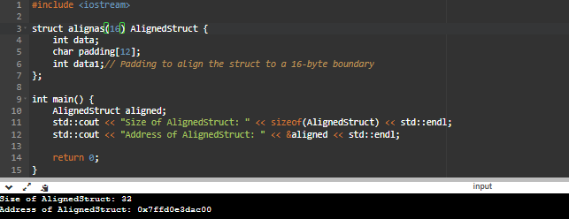
- [[override]]: This attribute indicates that a member function overrides a virtual function from a base class, helping detect errors when overriding functions.
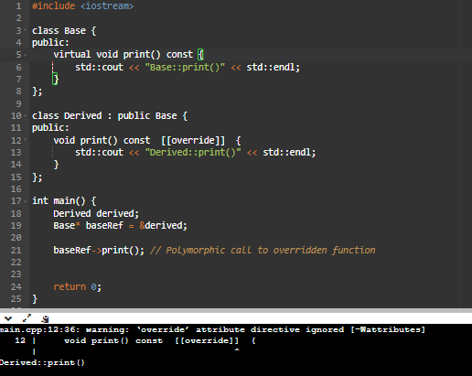
- [[nodiscard("description")]]: This attribute allows providing a custom warning message when a [[nodiscard]] function is ignored. The "description" parameter specifies the warning message.
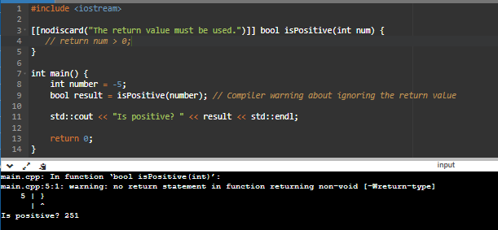

constexpr
"constexpr" is a keyword used in the C++ programming language to declare a constant expression. It is used to indicate that a variable, function, or expression can be evaluated at compile time and its value will not change during the program's execution.
When you declare a variable or function as "constexpr," you are specifying that its value or result can be computed at compile time rather than at runtime. This allows the compiler to optimize the code and potentially eliminate unnecessary runtime computations.
Let’s see example of constexpr:
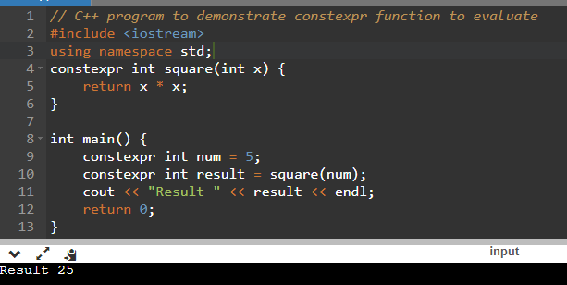

**static** constexpr (C++11): Commonly used inside classes to define compile-time constants without requiring a separate definition outside the class.
Let’s see example of Static constexpr:

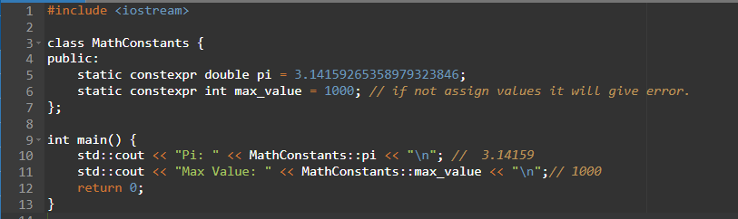

Use static_assert (for compile-time check constexpr):
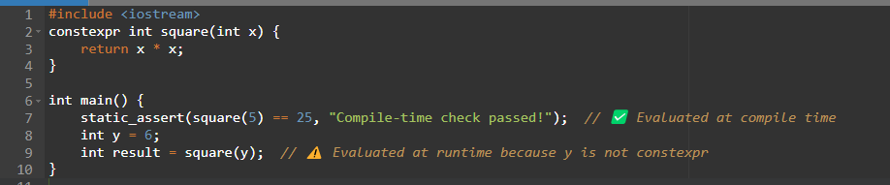
Advantages of constexpr:
- Compile-time evaluation
- Optimization opportunities
- Improved code readability and maintainability
- Enhanced error checking
- Template metaprogramming
- Improved integration with other C++ features
Different B/W the const and constexpr:
- const: The value of a const variable or object is evaluated at runtime. It can be initialized with a value computed at runtime, and its value cannot be modified after initialization.
- constexpr: The value of a constexpr variable or object is evaluated at compile time. It must be initialized with a value that can be computed at compile time using a constant expression. The value of a constexpr entity is known and fixed at compile time and cannot be modified.

delegating constructors
Delegating constructors in C++ allow one constructor to call another constructor of the same class to initialize the object. This feature was introduced in C++11 and provides a convenient way to avoid code duplication when multiple constructors have similar initialization logic.
Let’s see example of delegating contractor:
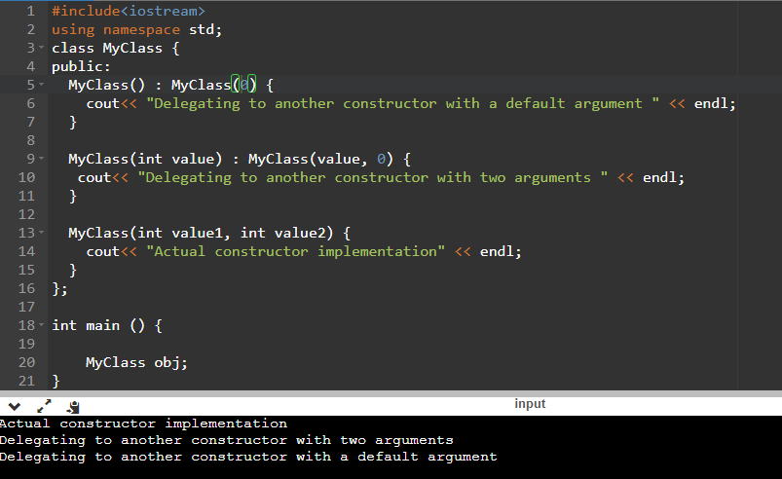

user-defined literals
User-defined literals in C++ are a feature introduced in the C++11 standard that allows you to define your own custom suffixes for literals. In C++, literals are specific values that represent themselves, such as integers, floating-point numbers, strings, and character constants. User-defined literals enable you to extend this concept by defining new literal forms and specifying how they should be interpreted by the compiler.
Syntax of user-defined literals
return_type operator"" suffix(const char_type* str, size_t size) {
// Implementation goes her
}
Let’s see example of user defined literals:
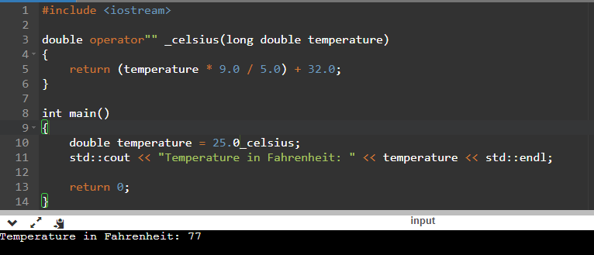

Advantages of user defined literals
User-defined literals allow you to define your own literal syntax that suits the problem domain or improves the readability of your code. This enables you to create more expressive and intuitive representations of values, making your code easier to understand.

Overrides keyword
In C++, when a function is declared as virtual in a base class, it can be overridden in derived classes. However, starting from C++11, you have the option to use the override keyword explicitly when overriding a virtual function. The override keyword serves as a safety mechanism to ensure that you're actually overriding a function and not accidentally creating a new one.
Let’s see example of overrides:
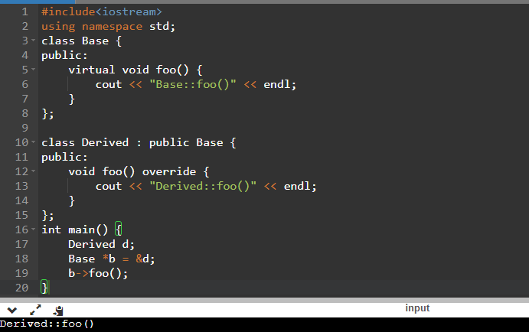
Advantages of overrides:
- Compile-time safety: By using the override keyword, the compiler performs a check to ensure that the function you're intending to override actually exists in the base class. If the function doesn't exist or if the signature doesn't match, the compiler will generate an error. This helps catch errors at compile-time rather than at runtime, making your code more robust and reducing the chances of accidental mistakes.
- Better code maintenance: When a base class is modified to add, remove, or change virtual functions, the explicit use of override in derived classes highlights which functions need to be updated. If a function no longer overrides a virtual function due to changes in the base class, the compiler will generate an error, indicating that the function needs to be reviewed and potentially modified.

default functions
In C++, the default keyword is used in various contexts to specify that the compiler should generate default behavior for certain functions. Here are the main uses of the default keyword in C++:
Default Constructor: The default keyword can be used to explicitly request the compiler to generate the default constructor for a class.

For example:
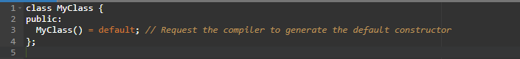
Copy Constructor and Copy Assignment Operator: Similarly, the default keyword can be used to ask the compiler to generate the copy constructor and copy assignment operator.
For example:
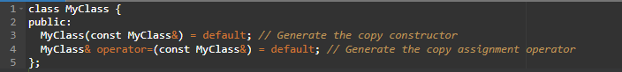
Destructor: By default, the compiler generates a destructor for a class. However, if you want to explicitly request the compiler to generate the destructor, you can use the default keyword.
For example:
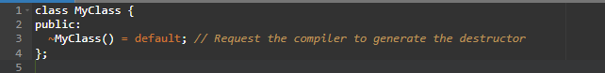
Deleted Functions: In addition to generating default functions, the default keyword can be used to explicitly delete certain functions. This prevents their usage and generates a compilation error if they are called.
For example:
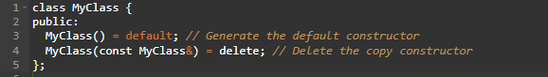
Special Member Functions in Special Cases: The default keyword can also be used in other special cases, such as specifying default behavior for move constructors or move assignment operators in certain scenarios.
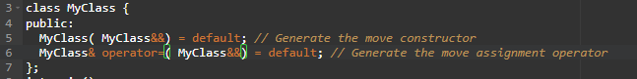
Advantages of default keyword:
Concise Code: The default keyword allows you to express the default behaviour of functions in a concise and clear manner. By using = default, you indicate that you want the compiler to automatically generate the default implementation, reducing the need for writing boilerplate code.
Implicit Generation: By explicitly requesting the generation of default functions, such as default constructor, copy constructor, copy assignment operator, or destructor, you ensure that these functions are automatically generated by the compiler when needed. This eliminates the need for writing them manually and reduces the chances of errors or omissions.

deleted functions
In C++, the delete keyword is used to explicitly disable the implicit generation of special member functions (constructor, copy constructor, move constructor, copy assignment operator, move assignment operator, and destructor) for a class. It is not used for deleting objects or variables.
Let’s see example of delete functions:
Disabling the Default Constructor:
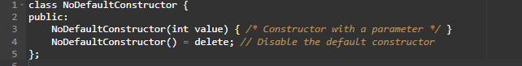
Disabling the Copy Constructor:
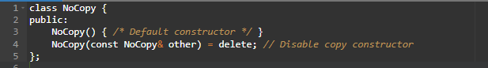
Disabling the Copy Assignment Operator:
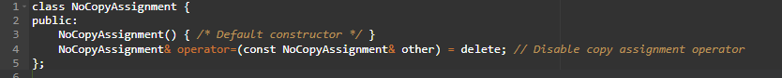
Disabling the Move Constructor and Move Assignment Operator:
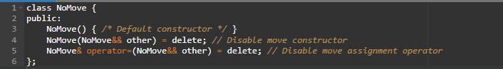
Disable the un used function.
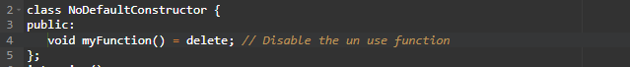
Advantages of delete keyword
Deleting of special member functions provides a cleaner way of preventing the compiler from generating special member functions that we don’t want. (As demonstrated in ‘Disabling copy constructors’ example).
Deleting of normal member function or non-member functions prevents problematic type promotions from causing an unintended function to be called (As demonstrated in ‘Disabling undesirable argument conversion’ example).

range-based for loops
Range-based for loops, also known as foreach loops, are a convenient way to iterate over elements in a sequence or container in C++. They were introduced in C++11 to simplify the process of iterating through collections, such as arrays, vectors, or other containers that support the range-based for loop syntax.
Syntax of range-based for loop:
for (element_type element : collection) {
// Loop body
}
Let’s see examples of range-based for loop:
Example 1: Iterating over an array
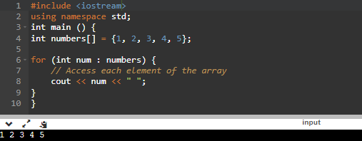
Example 2: Iterating over a vector
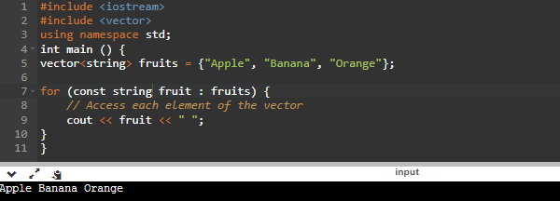
Example 3: Modifying elements using references
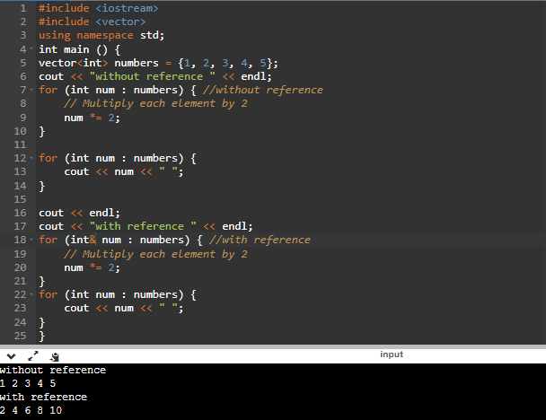
Example 4: Using Range-Based For Loop with std::cin
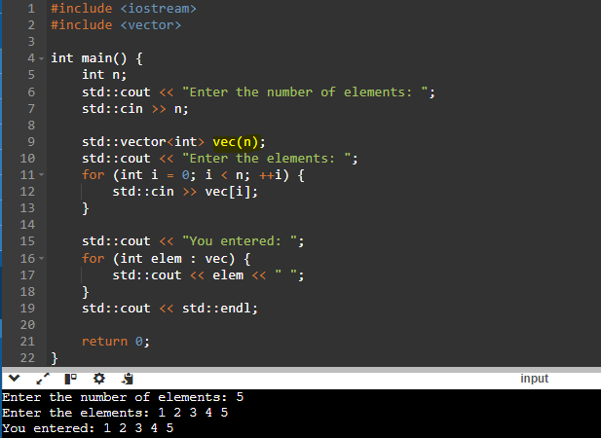
Advantages of range-based for loop:
- Simplicity and Readability
- Automatic Element Access
- Support for Different Containers
- Improved Safety
- Integration with Auto Keyword
- Performance Optimization

converting constructors
In C++, a converting constructor is a special constructor that can be used to implicitly convert one type to another. It allows you to create an object of a class using a single argument that has a different type than the class itself. Converting constructors are sometimes also referred to as single-argument constructors or implicit constructors.

Let’s see example of converting constructors:
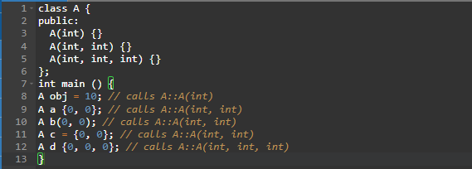
Note:
- Extended initializer lists are available in C++11 and on.
- We can directly try assigning an extended initializer list to an object when it is being created.
- An implicit class-type conversion feature of a constructor doesn’t affect its normal behavior.
- Using the explicit function-specifier for a constructor removes the implicit conversions using that constructor.

explicit keyword
In C++, explicit conversion functions are used to define conversions between different types explicitly. They are also known as conversion operators. By using explicit conversion functions, you can control how objects of one type are converted to another type.
Syntax of explicit conversion functions:
class MyClass {
public:
explicit operator TargetType() {
// Conversion logic here
} };
Let’s see example of explicit conversion function:
Example 1:
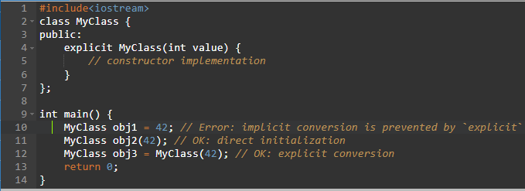
Example 2:
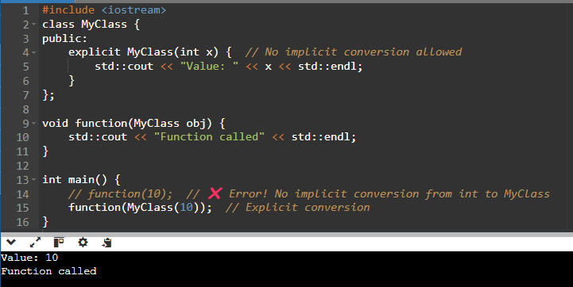
Advantages of explicit conversion function
By using explicit conversion functions, you have explicit control over how objects of one type are converted to another type. This helps avoid unintended conversions and provides clarity in the code.

inline-namespaces
In C++, an inline namespace is a feature introduced in C++11 that allows you to define a nested namespace that behaves as if its members were directly declared in the enclosing namespace. This feature is useful when you want to introduce a new version of a namespace without breaking existing code that uses the previous version.
Syntax of lnline namespace:
inline namespace namespace_name;
Let’s see example of inline-namespace:
Example 1:
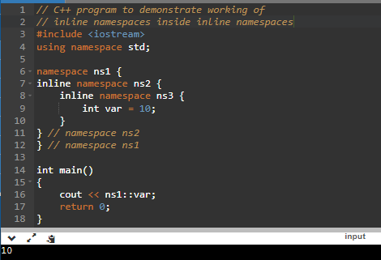
Example 2:
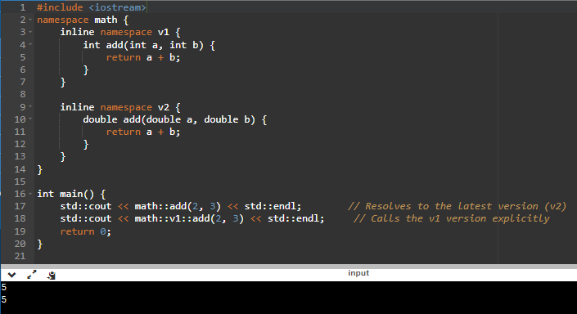
“Using” directive:
This same behavior (same as inline namespaces) can also be achieved by using the “using” declarative inside namespaces. A using-directive that names the inline namespace is implicitly inserted in the enclosing namespace (similar to the implicit using-directive for the unnamed namespace).
Syntax of using directive namespace:
using namespace namespace_name;
Let’s see example of using directive namespace:
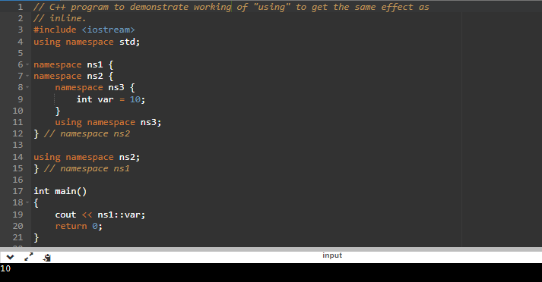
Advantages of inline-namespace
Avoid verbose: Consider the above code, if you want to print “var”, you write:
cout << ns1::ns2::ns3::var;
This looks good only if the namespace’s names are short as in the above example. But by using inline with namespaces there is no need to type the entire namespace as given above or use the “using” directive.

non-static data member initializers
Non-static data member initializers in C++ are a feature introduced in C++11 that allows you to initialize non-static data members directly within the class definition. This feature provides a concise and convenient way to assign default values to class members without having to explicitly initialize them in every constructor.
Syntax of non-static data member initializers:
class ClassName {
dataType memberName = initializer; // Non-static data member initializer
public:
// Constructors and other member functions
};
Let’s see example of Non-static data member initializer:
Example 1:
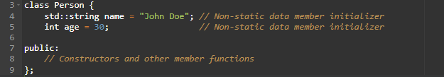
Example 2:
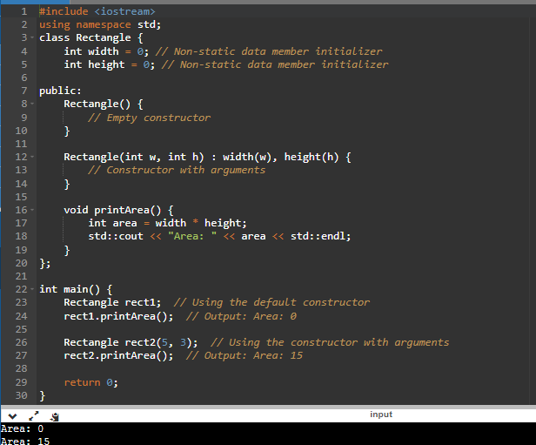
Advantages of non-static data member initializer:
- It’s easy to write.
- You can be sure that each member is initialized correctly.
- The declaration and the default value are in the same place, so it’s easier to maintain.
- It’s much easier to conform to the rule that every variable should be initialized.

right angle brackets
The angle bracket hack resolves a lexing ambiguity when a templated name ending in ">" is used as the template parameter of another class template or function template. Prior to C++11, when two consecutive angle brackets appeared, many lexers would interpret these as the right shift operator instead according to the language grammar. As a workaround, a space would need to be inserted between the two angle brackets so a lexer could interpret them as individual angle bracket tokens.
In C++, right angle brackets (>) are used in several contexts, primarily related to template parameters and template specialization.
Let's explore some of the common uses:
Template Declarations: Right angle brackets are used to specify template parameters in C++ templates. For example:
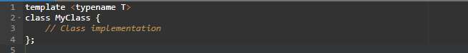
Template Instantiation: When instantiating a template class or function, you use right angle brackets to provide the specific types or values for the template parameters. For instance:
Nested Templates: When using nested templates, you may encounter multiple right angle brackets. It is essential to disambiguate them properly. One common technique is to add whitespace between the angle brackets to avoid parsing issues:
Template Specialization: Right angle brackets are also used in template specialization to provide a specialized implementation for a specific template argument.
For example:
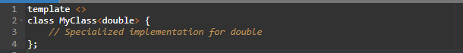
Let’s see example of right angle brackets:
Example 1:
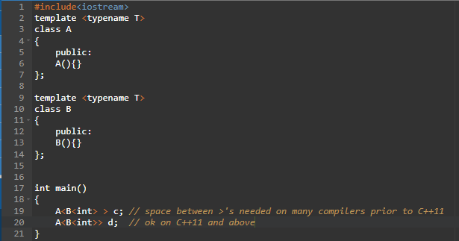
Example 2:
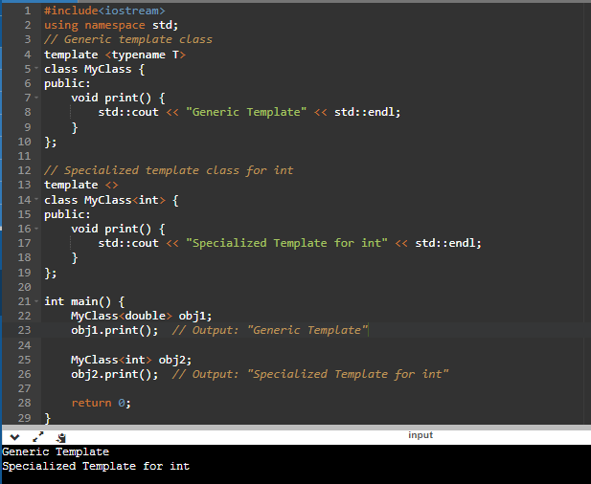

ref-qualified member functions
In C++, a member function can be declared as "ref-qualified" using the & and && specifiers. This feature was introduced in C++11 and allows you to define different behavior for member functions depending on whether the object they are called on is an l - value or an r - value.
The & specifier denotes that the member function can be called on both l - values and r - values, whereas the && specifier restricts the member function to be called only on r - values. These specifiers are added at the end of the function declaration, after the parameter list and before the const/volatile qualifiers (if any).
Syntax of ref-qualified:
class MyClass {
public:
void myFunction() const & {
// Code for const l - value version
}
void myFunction() const && {
// Code for const r - value version
}
};
Let’s see example of ref-qualified:
Example 1:
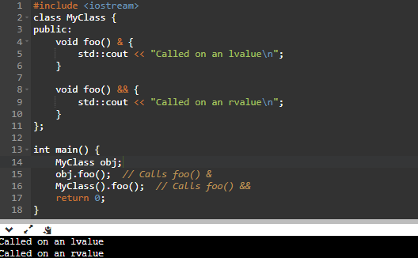

Example 2 :
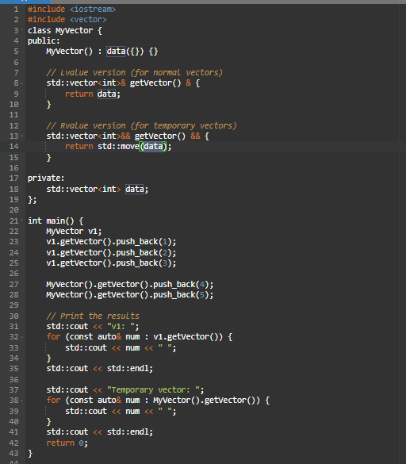

trailing return types
In C++, trailing return types allow you to specify the return type of a function after its parameter list. This feature was introduced in C++11 and is commonly used in modern C++ programming.
The syntax for trailing return types uses the auto keyword as a placeholder for the return type, followed by the -> token and the actual return type.
Syntax of trailing return types:
auto function_name(parameters) -> return_type {
// Function body
}
Let’s see example of trailing return types:
Example 1:
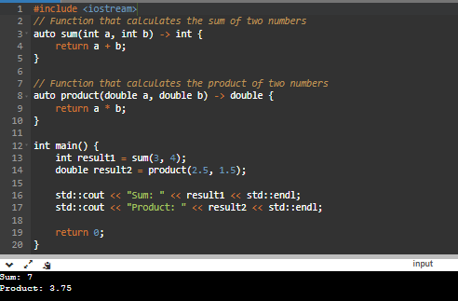
Example 2:
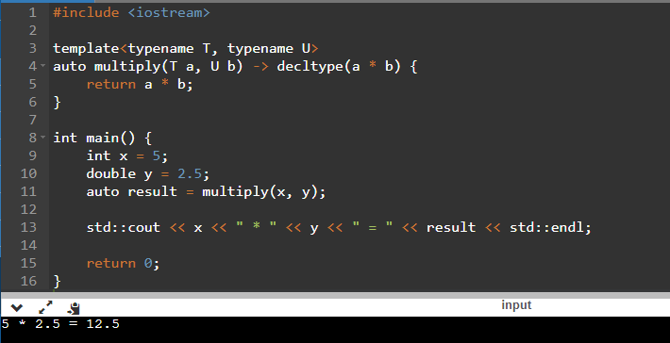
Advantages of trailing return type
The trailing return type feature removes a C++ limitation where the return type of a function template cannot be generalized if the return type depends on the types of the function arguments

noexcept specifier
In C++, the noexcept specifier is used to declare that a function will not throw any exceptions. It is a part of exception specification mechanism, which allows you to specify the exception handling behavior of a function.
The noexcept specifier can be used in two ways:
noexcept without any argument:
When used at the end of a function declaration or definition, it indicates that the function will not throw any exceptions.

For example:
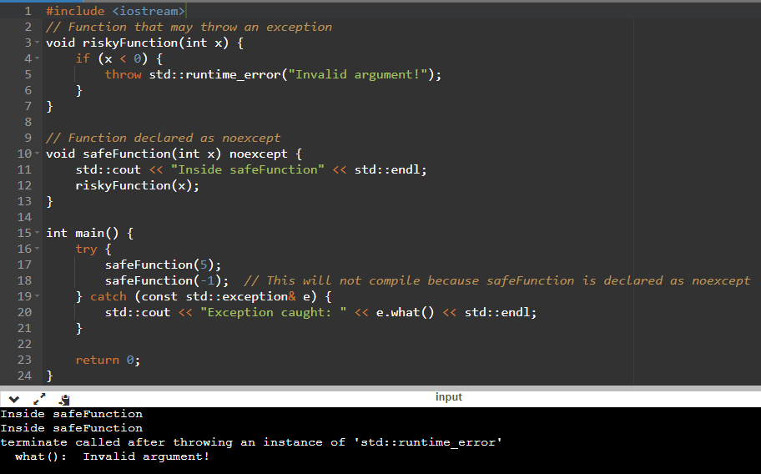
noexcept with a boolean expression:
You can also specify a boolean expression inside the noexcept specifier, which determines whether the function can throw exceptions or not based on the result of the expression.
If the expression evaluates to true, it indicates that the function will not throw exceptions. If it evaluates to false, it means the function may throw exceptions.
For example:
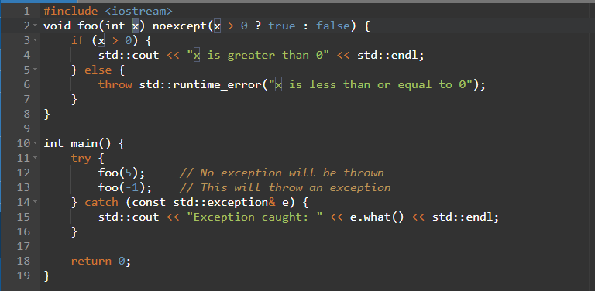

Advantages of noexcept
There are two good reasons for using noexcept:
- First, an exception specifier documents the function's behavior. If a function is specified as noexcept, it can be safely used in a non-throwing function.
- Second, it is an optimization opportunity for the compiler.

char32_t and char16_t
In C++, char32_t and char16_t are character types introduced in the C++11 standard to support Unicode characters and provide a way to represent characters with extended character sets.
Let’s see examples of character types:
Example 1: Using char32_t
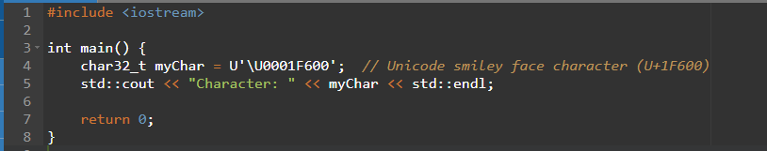
Example 1: Using char16_t
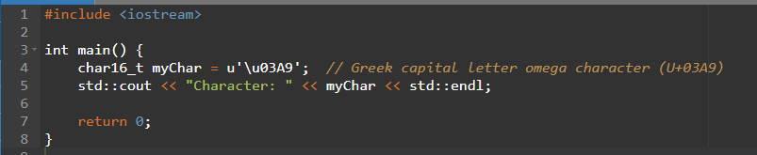
Example 2: Using std::u32string
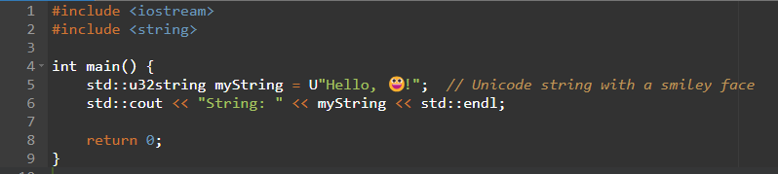
Example 3: Using std::u16string
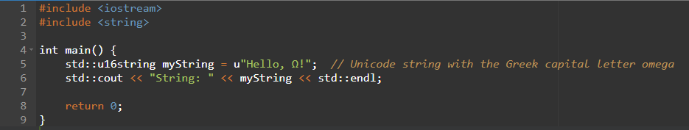

raw string literals
Raw string literals are a feature introduced in C++11 that allow you to define string literals without escape sequences and special character processing. In a raw string literal, you can include newlines, backslashes, and quotes directly in the string without any special handling. This makes it convenient for representing strings that contain lots of special characters or formatting.
Syntax of raw string literals:
R"delimiter(raw_characters) delimiter"
Let’s see example of raw string literals:
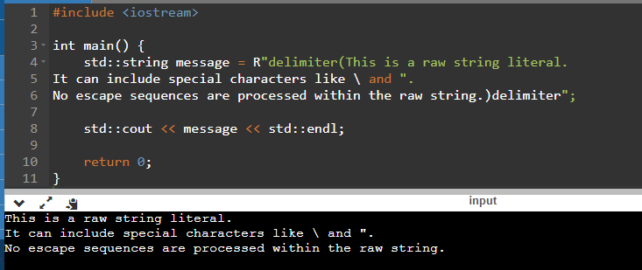

Final
The final keyword is used with classes or functions to prevent inheritance or overriding.
1. final with Classes
If you write final after a class, it cannot be inherited by other classes.

Example:
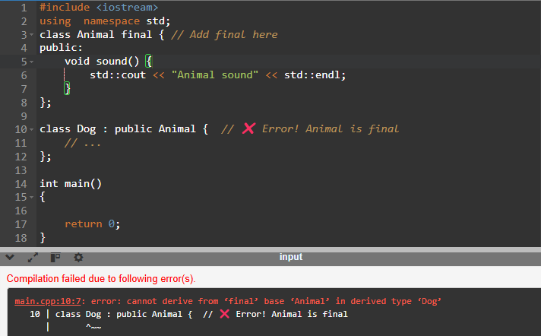
❌ Dog can't inherit from Animal because Animal is marked as final.
2. final with Functions
If you mark a function as final, it cannot be overridden in derived classes.
Example:
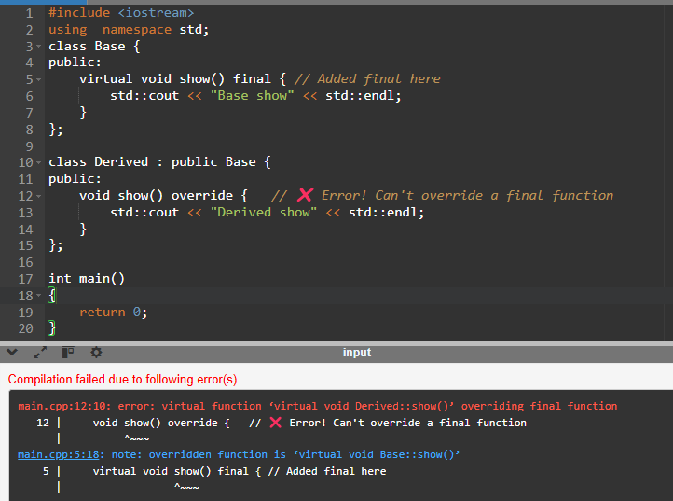
Advantages:
The final specifier makes code clearer and safer by preventing unintended modifications or overrides.

C++11 includes the following new library features

std::move
std::move is a utility function provided in the <utility> header, introduced in C++11. It is used to enable move semantics by converting an object into an rvalue reference, allowing resources to be transferred from one object to another without unnecessary copying.
Let’s see example of std::move:
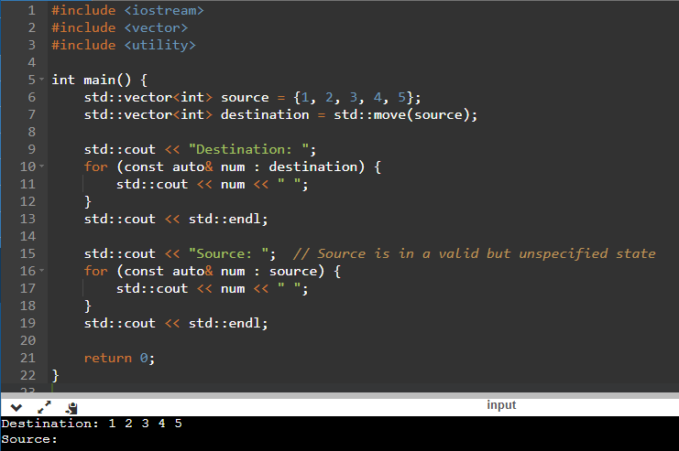

std::forward
std::forward is a utility function in the C++ Standard Library, introduced in C++11, that is used to enable perfect forwarding in template programming.They allow functions to accept arguments of any type (lvalue, rvalue, const, non-const) and forward them to another function, maintain the argument's type and value category.
Syntax of forwarding reference:
std::forward<T>(arg)
Let’s see example of std::forward:
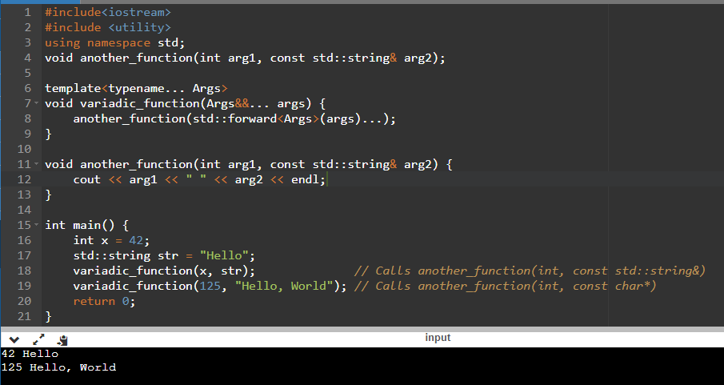

std::to_string
In C++, the std::to_string function is used to convert numerical values or other types to their string representation. It is part of the <string> header and is available in the C++11 standard and later versions.
Syntax of std::to_string:
std::string to_string(Argument value);
let’s see examples of std::to_string:
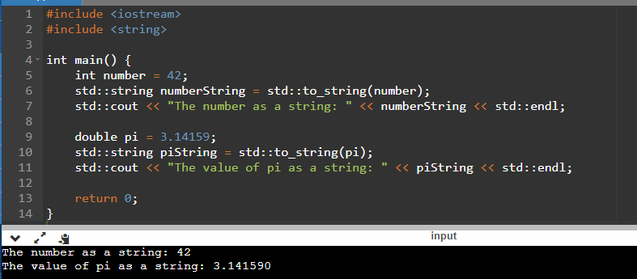

type traits
In C++, type traits are a set of template classes and functions that provide compile-time information about types. They are part of the C++ Standard Library and can be found in the <type_traits> header.
Here are some commonly used type traits in C++:
std::is_same<T, U>: Checks if types T and U are the same:
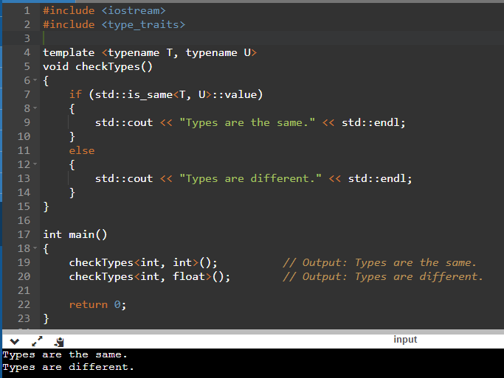
std::is_integral<T>: Checks if type T is an integral type:
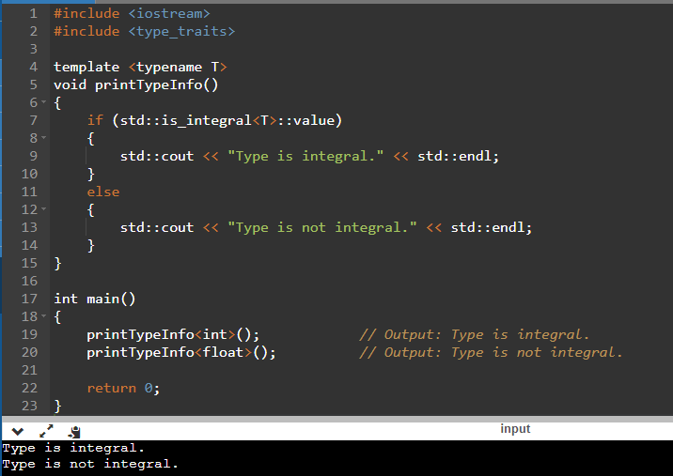
Example of compilation error stage:
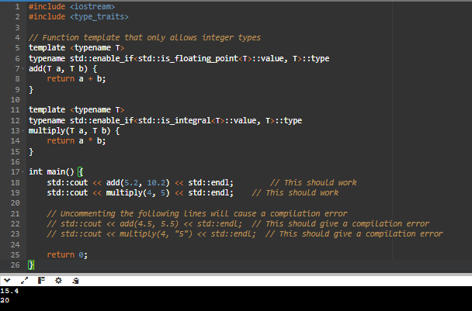

std::is_floating_point<T>: Checks if type T is a floating-point type:
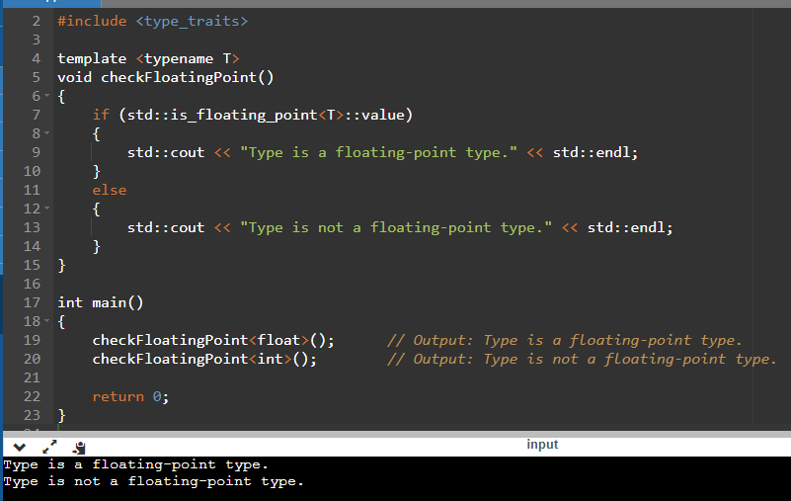
std::is_pointer<T>: Checks if type T is a pointer:
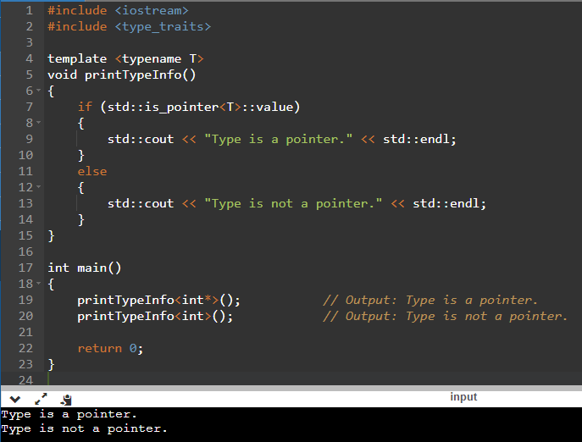
std::is_reference<T>: Checks if type T is a reference type:
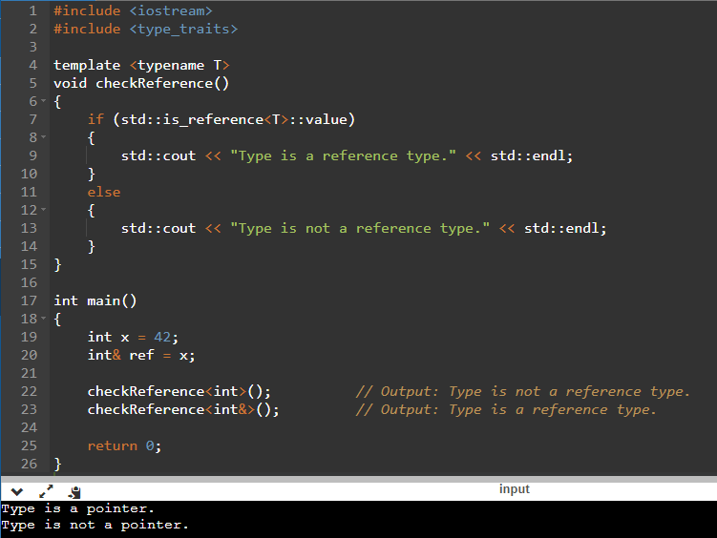
std::is_array<T>: Checks if type T is an array type:
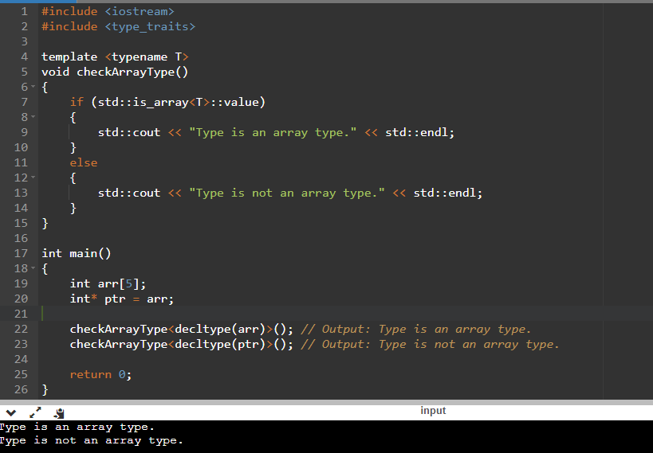

std::is_class<T>: Checks if type T is a class type:
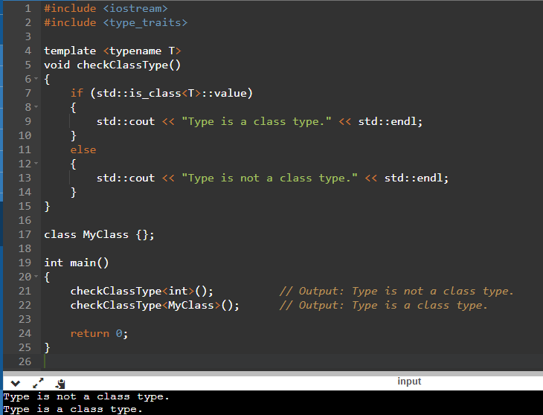
std::is_enum<T>: Checks if type T is an enumeration type:
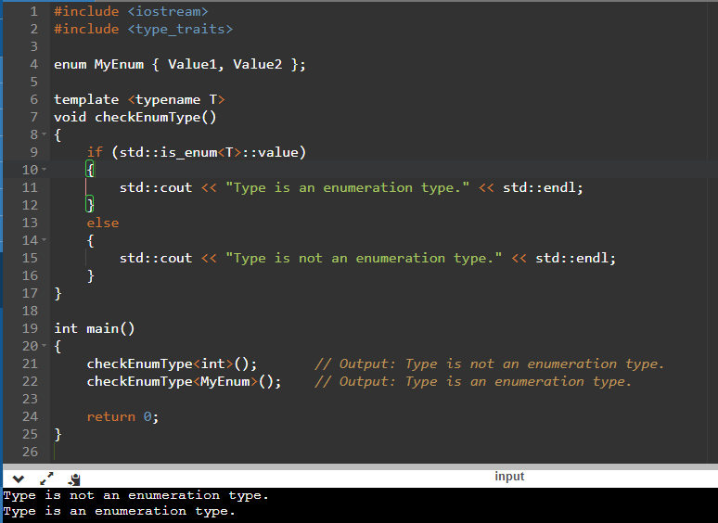

std::is_function<T>: Checks if type T is a function type:
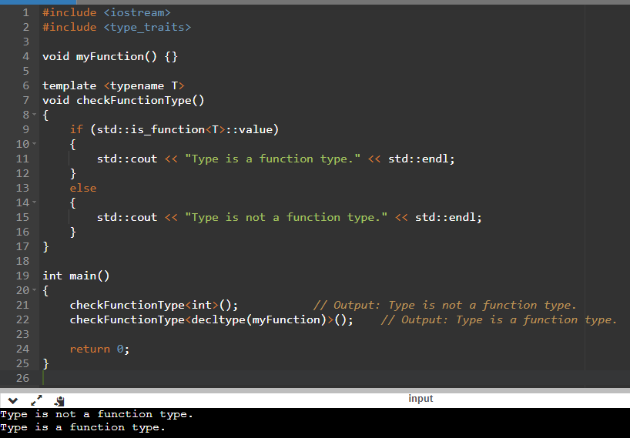
std::is_const<T>: Checks if type T is a const-qualified type:
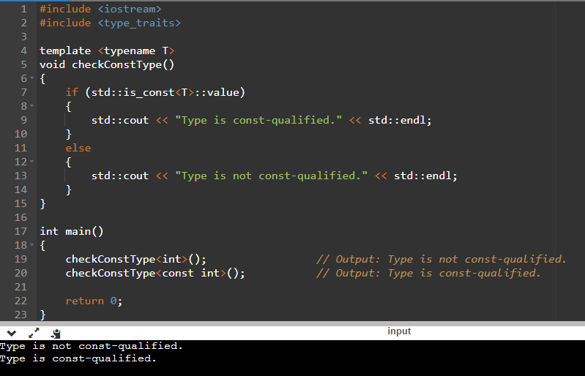

std::is_volatile<T>: Checks if type T is a volatile-qualified type:
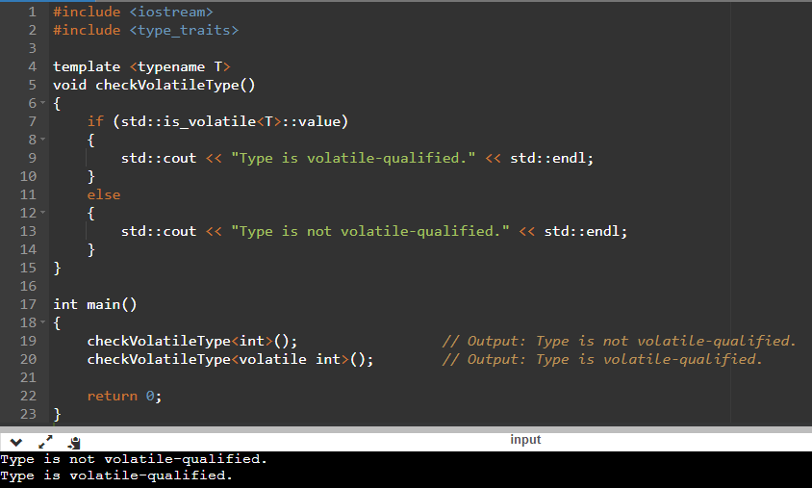
std::is_trivial<T>: Checks if type T is a trivial type:
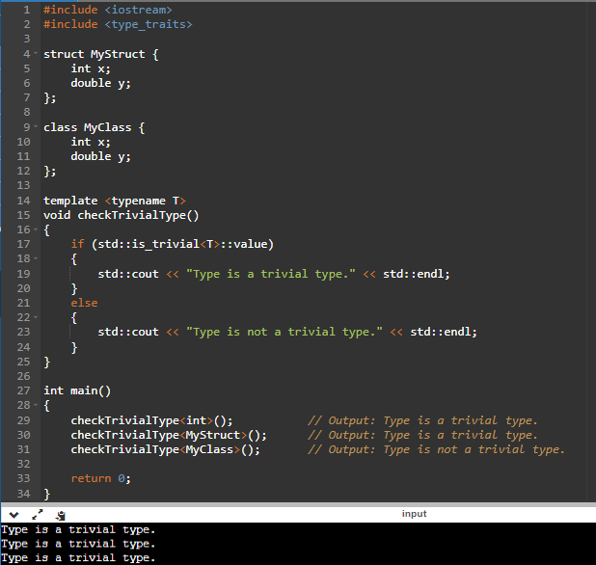

std::is_pod<T>: Checks if type T is a plain old data (POD) type:
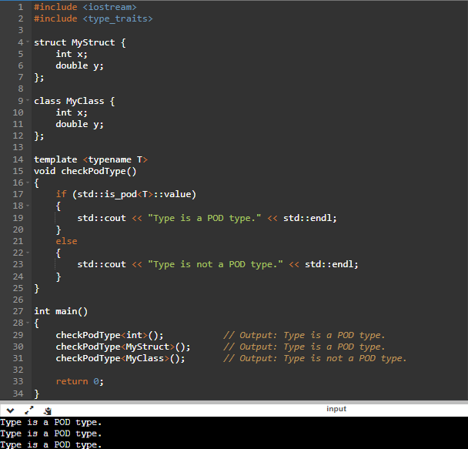
std::is_abstract<T>: Checks if type T is an abstract class type:
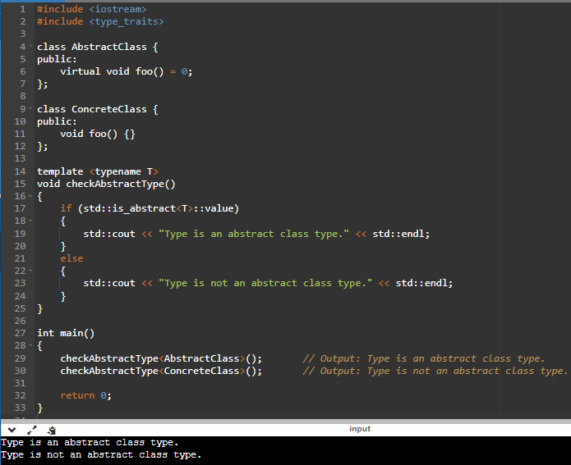

std::is_base_of<Base, Derived>: Checks if Base is a base class of Derived:
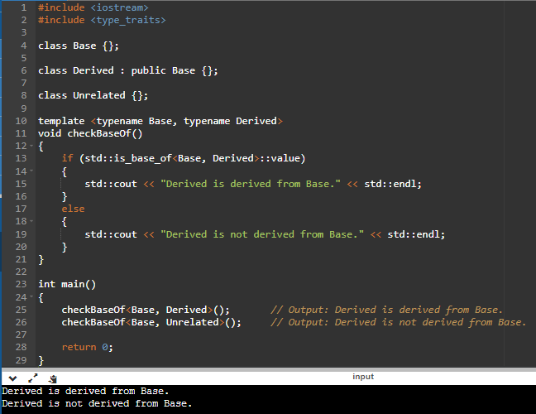

smart pointers

std::make_unque
- std::make_unique is a utility function template introduced in C++11.
- It is used to create an instance of a dynamically allocated object wrapped in a std::unique_ptr.
- std::make_unique simplifies the process of creating a std::unique_ptr by automatically deducing the type and forwarding the constructor arguments to construct the object.
- It returns a std::unique_ptr owning the newly created object.
- std::make_unique provides exception safety guarantees. If an exception is thrown during the object creation, it ensures that the memory is correctly deallocated, and no memory leaks occur.
- It is generally recommended to use std::make_unique instead of creating a std::unique_ptr directly with new due to its exception safety and code clarity advantages.
- Using make_unique No need to delete myObject explicitly but If you use new need to delete myObject.

Syntax of std::make_unque:
std::unique_ptr<T> make_unique<Args>(Args&&... args);
Let’s see example of make_unque:
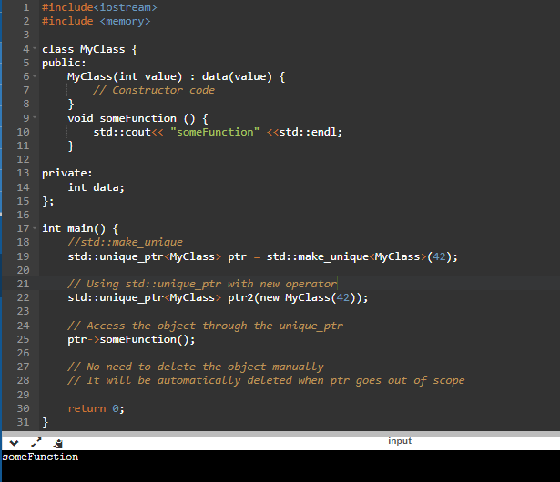

std::make_shared
std::make_shared is a function template in C++ that is used to create a std::shared_ptr object. It combines the allocation and construction of an object into a single step, making memory management easier and safer.
Syntax of std::make_shared:
template<typename T, typename... Args>
std::shared_ptr<T> make_shared(Args&&... args);

Let’s see example of std::make_shared:
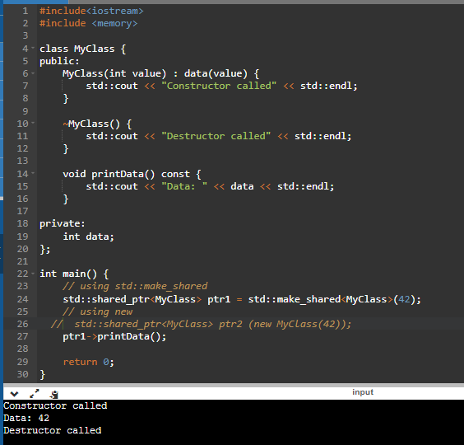
Note: Using std::make_unique instead of new ensures safer, cleaner, and more modern C++ code. It eliminates the risks of memory leaks, improves code readability, and aligns with modern best practices for smart pointers and memory management.

std::chrono
The <chrono> library in C++ provides a set of standardized components for handling time-related operations, including durations, clocks, and time points. It was introduced in C++11 and offers a more robust and flexible alternative to the previously available <ctime> library.

Let’s see example of std::chrono:
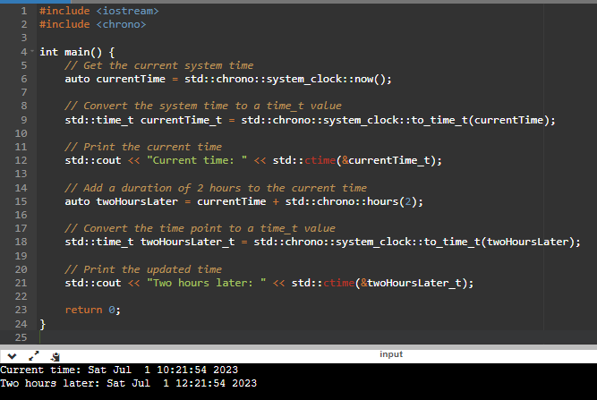

tuples
In C++, a tuple is an object that can hold a collection of values of different types. It is similar to an array or a struct, but unlike arrays, the types of the values in a tuple can be different. Tuples provide a convenient way to group multiple values together into a single object.
To use tuples in C++, you need to include the <tuple> header file.
Syntax of tuple:
std::tuple<T1, T2, ..., Tn> myTuple(value1, value2, ..., valueN);

let’s see example of tuple:
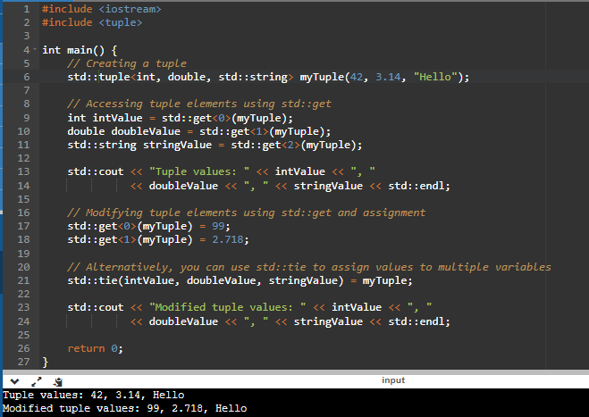
Advantages of tuple
By using a tuple, you can bundle multiple values together and return them as a single object. This allows you to effectively return multiple values from a function without needing to define a custom data structure explicitly.
std::make_tuple?
It's a function that creates a std::tuple object by deducing the types of its arguments automatically.
You don’t need to specify the types manually.
It returns std::tuple<int, double, const char*> in this case.

let’s see example of make_tuple:
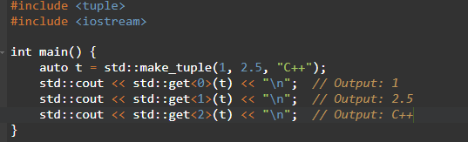

std::tie
std::tie is a function template in C++ that creates a tuple of l - value references to its arguments. It allows you to group multiple variables or values together into a tuple, providing a convenient way to unpack and assign values from different variables or expressions simultaneously.
The std::tie function is part of the <tuple> header in the C++ Standard Library and is defined in the std namespace.
Syntax of std::tie:
template <typename... Types>
tuple<Types&...> tie(Types&... args);
Let’s see example of std::tie:
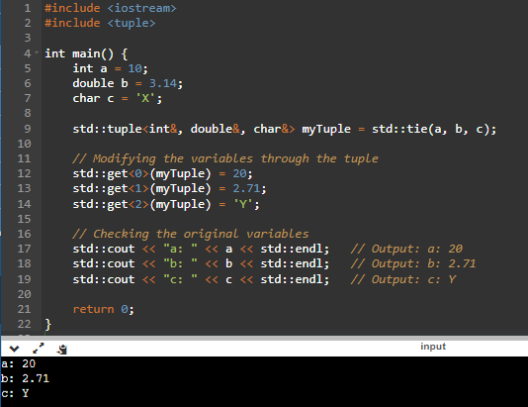
Advantages of std::tie:
One of the main uses of std::tie in C++ is in combination with std::tuple to perform structured binding or multiple value assignment. It allows you to conveniently assign values from different variables or expressions simultaneously.

std::array
In C++, std::array is a container class template that provides a fixed-size array. It is defined in the <array> header and is part of the Standard Library.
Syntax of std::array:
#include <array>
std::array<type, size> array_name;
let’s see example of std::array:
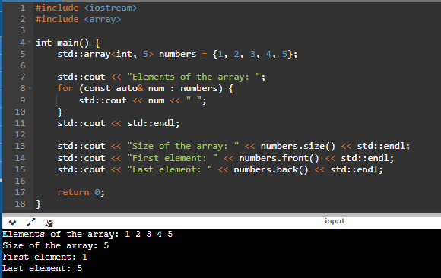
Advantages of std::array
- Storing a fixed number of elements in a container with a known size at compile time.
- Providing a safer alternative to traditional C-style arrays, as std::array performs bounds checking.
- Compatibility with standard algorithms and functions that expect containers, allowing you to easily integrate with other parts of the Standard Library.

<functional>

Std::functional
In C++, std::function is a general-purpose polymorphic function wrapper provided by the <functional> header. It can store and invoke callable objects such as functions, function pointers, lambda expressions, and even member functions. std::function provides a unified interface for working with different types of callable objects.
Syntax of std::functional:
std::function<return_type(parameter_types)> function_name;
Let’s see example of std::functional.
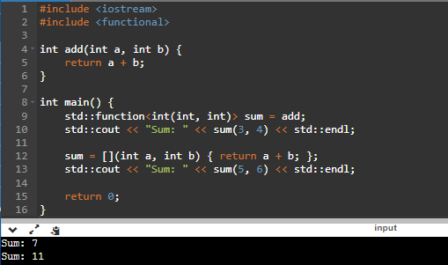
Advantages of std::function
Type Erasure:
You don’t need to know the exact type of the callable object.
For example, lambdas with different captures can still be assigned to std::function.
Flexibility:
Can store different types of callables in a single variable, as long as they match the specified signature.
Runtime Polymorphism:
Allows storing and invoking different callable objects at runtime.
Callback Mechanisms:
Commonly used for event handling or callbacks.
Disadvantages
Overhead:
std::function introduces a small runtime overhead compared to directly invoking a function or callable.
Requires Matching Signatures:
The stored callable must match the exact signature specified by std::function.

Std::bind
In C++, std::bind is a function provided by the <functional> header that allows you to create a new callable object by binding arguments to a function or callable object. It enables partial function application and function composition.
Syntax of std::bind:
template<class Fn, class... Args>
std::bind(Fn&& fn, Args&&... args);
Let’s see example of std::bind:
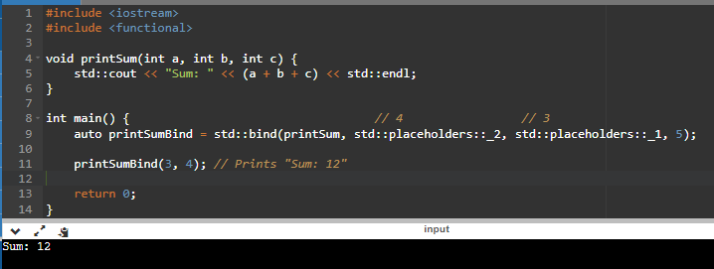

Std::ref
In C++, std::ref is a utility function provided by the <functional> header that allows passing objects by reference when using them as arguments in functions or function templates that expect object parameters. It is primarily used to bind reference wrappers to the actual objects.
Syntax of std::ref:
template<class T>
reference_wrapper<T> ref(T& t);
Let’s see example of std::ref:
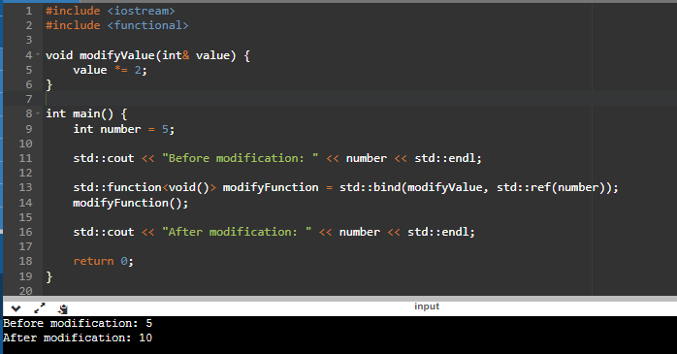

Std::mem_fun
In C++, std::mem_fn is a function template provided by the <functional> header that allows you to create function objects that can invoke member functions or member function pointers on objects. It is particularly useful when working with member function pointers or when you need to store and call member functions polymorphically.
Syntax of std::mem_fun:
template<class R, class T>
std::mem_fn(R T::* pm);
Let’s see example of std::mem_fun:
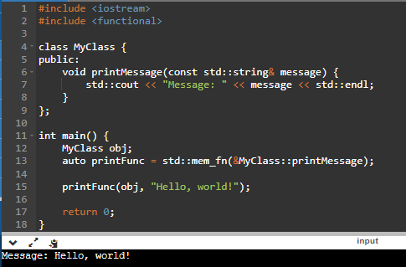

Std::reference_wrarpper
The primary use case for std::reference_wrapper is when you need to store references in containers like std::vector or pass them as arguments to algorithms or function templates that expect copyable types. Since references themselves are not copyable, std::reference_wrapper serves as a wrapper that can be copied, assigned, and stored like any other regular object.
Let’s see example of std::reference_wrapper:
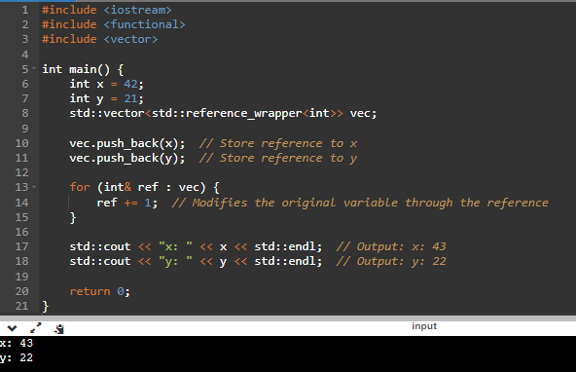

std::begin/end/next/prev
In C++11, the std::begin and std::end functions were introduced as part of the Standard Library to provide a consistent and generic way to obtain iterators representing the beginning and end of a range.
In C++, the std::next and std::prev functions are part of the <iterator> header and provide a convenient way to obtain iterators to elements in a container relative to a given iterator.
Let’s see example of std::begin/end/next/prev:
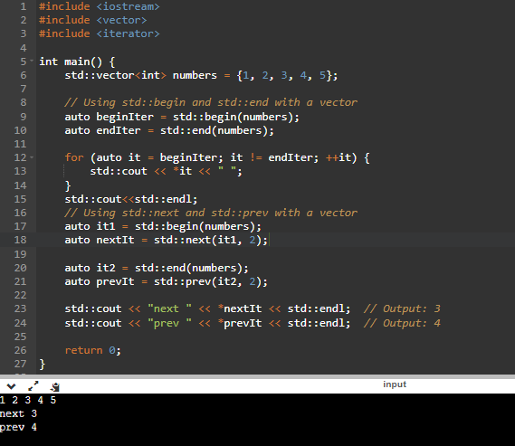

unordered containers
In C++, unordered containers are a set of data structures provided by the Standard Template Library (STL) that store elements in an unordered manner, typically implemented using hash tables. These containers offer efficient lookup, insertion, and deletion operations, providing constant-time average complexity for these operations.
There are four main unordered containers in C++:

unordered_set
In C++, std::unordered_set is a container class provided by the Standard Template Library (STL) that represents a collection of unique elements. It is implemented using a hash table, which allows for efficient insertion, deletion, and retrieval of elements. The elements in an unordered_set are not stored in any particular order.
Syntax of unordered_set container:
std::unordered_set<DataType> set_name;
Let’s see example of unordered_set container:
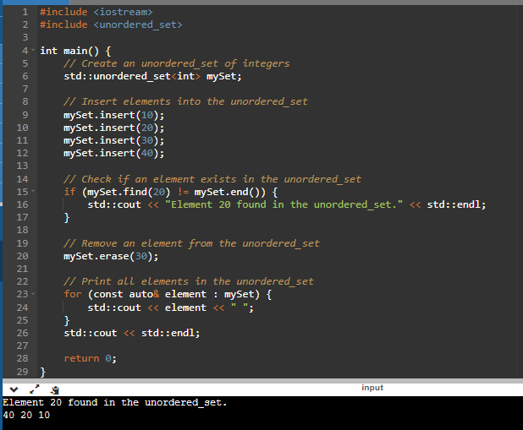
Different between the std::set and std::unordered_set containers:
Underlying Data Structure:
std::set: It is implemented as a balanced binary search tree (usually a red-black tree). The elements in the set are sorted in ascending order.
std::unordered_set: It is implemented as a hash table. The elements in the unordered set are not stored in any particular order.
Order of Elements:
std::set: The elements in the set are automatically sorted based on the comparison operator for the element type.
std::unordered_set: The elements in the unordered set are not sorted. They are organized based on their hash values.
Performance:
std::set: The insertion, deletion, and search operations in a set have a time complexity of O(log n), where n is the number of elements in the set.
std::unordered_set: The average time complexity for insertion, deletion, and search operations in an unordered set is O(1). However, in the worst case, it can be O(n).

unordered_map
In C++, std::unordered_map is a container class template from the Standard Template Library (STL) that provides an associative array data structure. It is an implementation of a hash table, which allows for efficient insertion, retrieval, and deletion of elements based on their keys. The elements in an unordered_map are not stored in any particular order.
Syntax of unordered_map container:
std::unordered_map<DataType> map_name;
Let’s see example of unordered_map container:
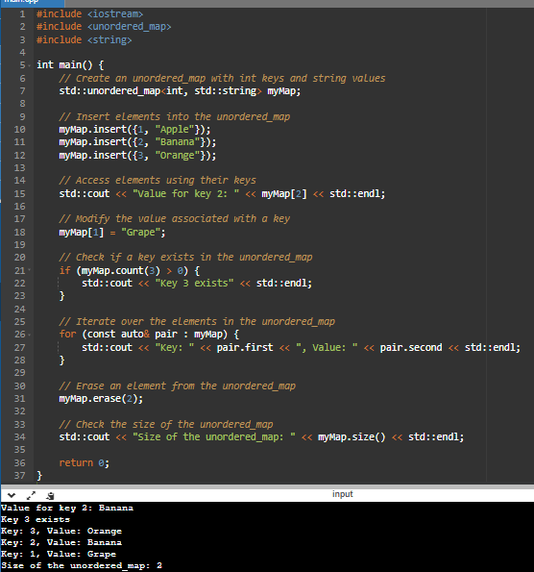

Differents between the std::map and std::unorder_map containers:
std::map: It is implemented as a self-balancing binary search tree (usually a red-black tree). The elements in the map are stored in a based on the keys. This enables efficient searching, insertion, and deletion operations with a time complexity of O(log n). sorted order
std::unordered_map: It is implemented as a hash table. The elements in the unordered map are not sorted and the order of elements may vary. It provides fast average-case performance for searching, insertion, and deletion operations, with a time complexity of O(1) on average. However, in the worst-case scenario, the time complexity can be O(n).

unordered_multiset
In C++, std::unordered_multiset is a container class template that represents an unordered collection of unique elements. It is defined in the <unordered_set> header file and is part of the Standard Template Library (STL).
An std::unordered_multiset is similar to std::unordered_set with the main difference being that it allows duplicate elements. It provides efficient insertion, deletion, and search operations on its elements.
Syntax of unordered_multiset container:
std::unordered_ multiset <DataType> multiset _name;
Let’s see example of unordered_ multiset container:
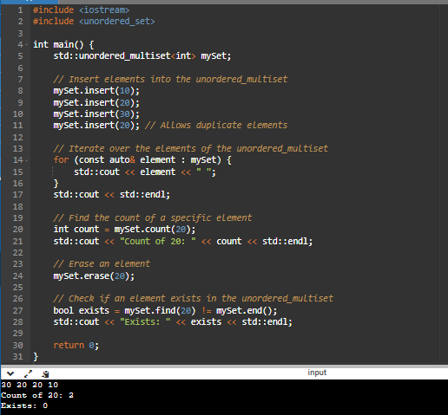

unordered_multimap
std::unordered_multimap is a container class in C++ Standard Library that represents an associative container with multiple values assigned to the same key. It is defined in the <unordered_map> header and is part of the C++11 standard.
An unordered_multimap is similar to std::unordered_map, but it allows duplicate keys. The elements in an unordered_multimap are not sorted, and the order of elements may vary between different implementations or even between different runs of the same program.
Syntax of unordered_multimap container:
std::unordered_ multimap <DataType> multimap _name;
Let’s see example of unordered_ multimap container:
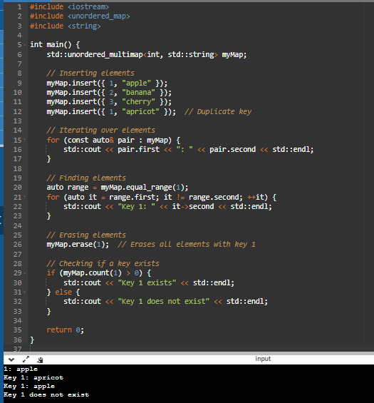

muti-threading
In C++, multithreading allows you to create concurrent execution flows within a single program. It enables you to divide your program's tasks into multiple threads that can execute concurrently, potentially improving performance and responsiveness.
Here are some important concepts related to multithreading in C++:

std::thread
In C++, the <thread> header provides a thread support library that allows you to create and manage concurrent execution of multiple threads within a single program. The std::thread class is the main component of this library and provides several functions for thread management.
Let's go through each of these functions with examples:
std::thread::thread(): This is the constructor function that creates a new thread object. It takes a callable object (a function, functor, or lambda expression) and optional arguments to pass to the callable object.
Here's an example:
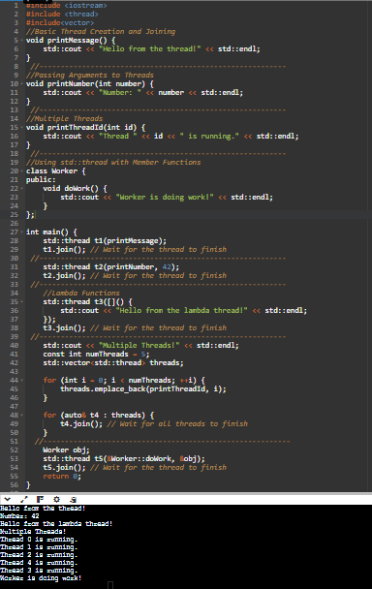
std::thread::join(): This function blocks the execution of the calling thread until the thread represented by the std::thread object has completed its execution. It's typically used to synchronize the main thread with the spawned thread. Here's an example:
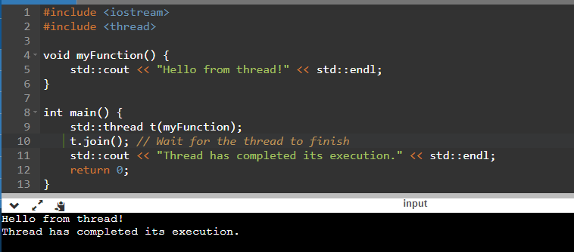
std::thread::detach(): Detaches the thread from the main thread, allowing it to execute independently. Once detached, the thread can't be joined again. It's typically used when you don't need to synchronize with the detached thread. Here's an example:
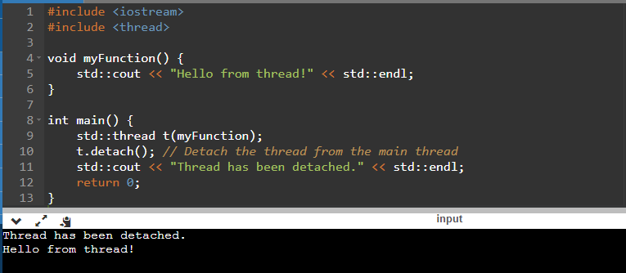
std::thread::get_id(): This function returns the identifier of the thread represented by the std::thread object. The identifier is of type std::thread::id. Here's an example:
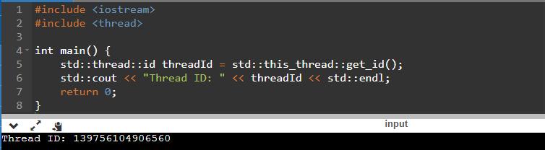
std::thread::joinable() : This function is used to check if a thread is joinable or not. A joinable thread is a thread that can be joined or detached, while a non-joinable thread is one that has already been joined or detached. Here's an example:
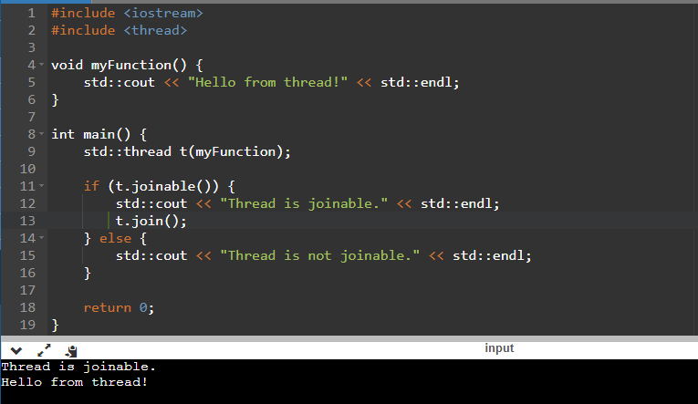
Advantage of std::thread:
Threads allow multiple functions to execute concurrently.

std::mutex
- A mutex (mutual exclusion) is used to provide exclusive(full) access to a shared resource.
- Only one thread can lock a mutex at a time, which helps prevent race conditions when multiple threads try to read/write a shared resource.
- A std::mutex is typically used in critical sections where data needs to be modified by only one thread at a time.
- In C++, mutexes are implemented as a synchronization primitive provided by the <mutex> header. They are used to protect shared resources or critical sections of code from simultaneous access by multiple threads.
- Used to protect shared data by allowing only one thread to access a critical section at a time.
Here are some important functions provided by the std::mutex class:
- lock(): Acquires the mutex lock. If the lock is not available, the calling thread will be blocked until it can acquire the lock.
- try_lock(): Attempts to acquire the mutex lock without blocking. If the lock is not available, this function will return immediately, allowing the thread to continue execution. It returns true if the lock is acquired successfully and false otherwise.
- unlock(): Releases the mutex lock, allowing other threads to acquire it.

Let’s see example of std::mutex:
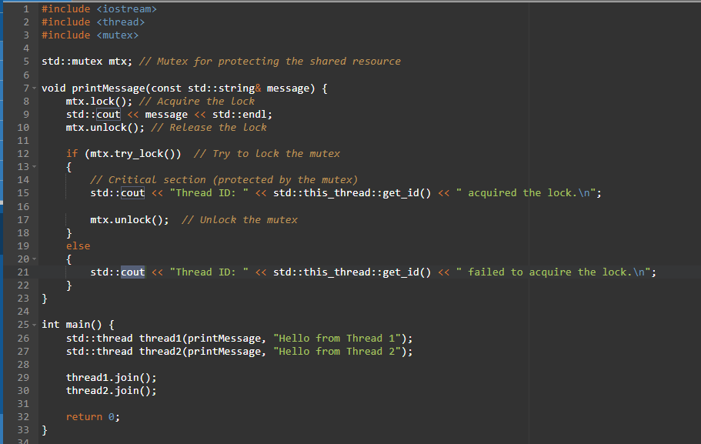
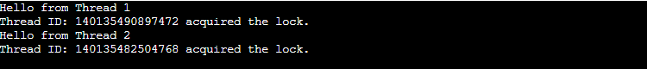

std::future
In C++, the std::future class provides a way to represent a future result of an asynchronous operation. It allows you to launch a task asynchronously and obtain its result when it becomes available.
Here are some important member functions of std::future:
- get(): This function blocks the calling thread until the future's result becomes available. Once the result is available, it returns the value or throws an exception if an exception was stored as the result.
- valid(): Checks if the std::future object is associated with a shared state. It returns true if the std::future is valid (i.e., it has a shared state) or false otherwise.
- wait(): This function blocks the calling thread until the future's result becomes available. It does not return any value and can be used in combination with other synchronization mechanisms.
- wait_for(): This function blocks the calling thread for a specified duration or until the future's result becomes available, whichever comes first. It returns a std::future_status indicating the status of the future after the timeout.
- wait_until(): This function blocks the calling thread until a specified time point is reached or until the future's result becomes available, whichever comes first. It returns a std::future_status indicating the status of the future after the timeout.
- std::async in C++ is a function template that allows you to run tasks asynchronously. It starts a task in a new thread (or delays execution depending on the launch policy) and returns a std::future that will hold the result of the task when it’s ready.
Let’s see example of std::future:
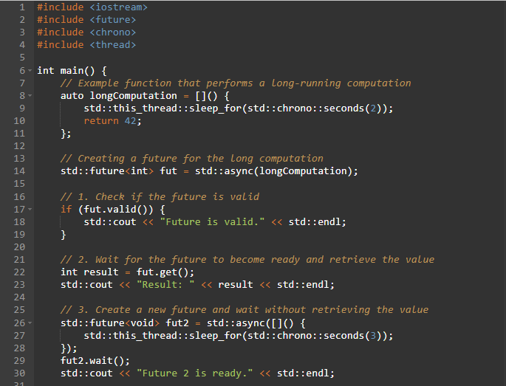
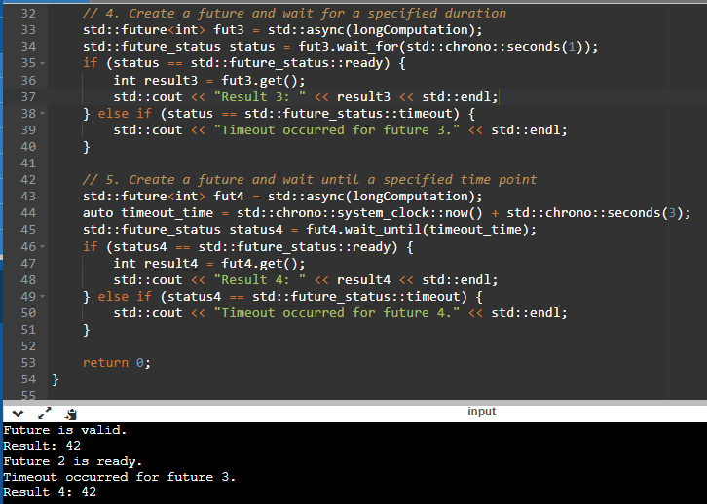
Advantages of std::future:
std::future is an object used in multithreaded programming to receive data or an exception from a different thread.

std::promise
std::promise is a class template in C++ that provides a mechanism for asynchronous communication between two threads. It is used in conjunction with std::future to pass a value or an exception from one thread to another.
Here are the main member functions of std::promise:
- std::promise::promise(): Constructs a new std::promise object.
- std::promise::get_future(): Returns a std::future object that is associated with the promise. The future can be used to retrieve the value or exception set by the promise.
- std::promise::set_value(): Sets the value of the associated std::future object. This function is used to fulfill the promise, making the associated future ready with the provided value.
- std::promise::set_exception(): Sets the exception of the associated std::future object. This function is used to fulfill the promise with an exception, making the associated future ready with the provided exception.
Let’s see example of std::promise:
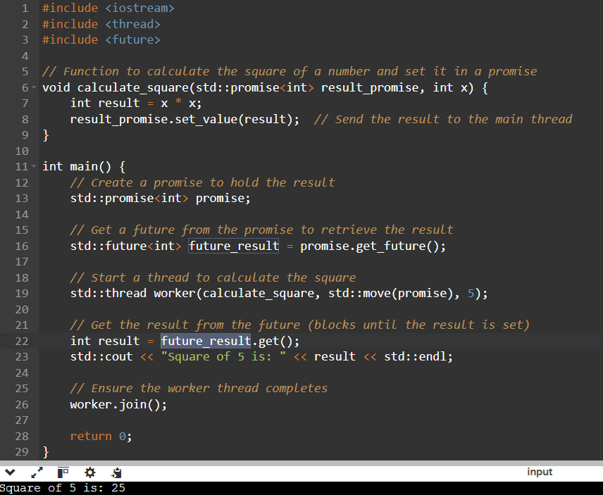
Advantage of std::promise:
std::promise is used to set a value that is later retrieved through a std::future object.

std::condition_variable
The std::condition_variable class provides a mechanism for threads to block until notified. It allows threads to efficiently wait for a condition to be met without continuously checking a flag or using CPU cycles. When a thread waits on a condition variable, it releases the associated mutex and enters a blocked state until another thread notifies the condition variable.
Here are the main member functions of std::condition_variable:
- wait(lock): This method is used by a thread to wait for a notification on the condition variable. It releases the associated lock (typically a std::unique_lock<std::mutex>) and puts the thread to sleep until it is awakened by a call to notify_one() or notify_all() on the same condition variable. The lock is reacquired by the thread once it wakes up.
- notify_one(): This method notifies one waiting thread that the condition may have changed. If multiple threads are waiting, only one of them is chosen to be awakened. The awakened thread will reacquire the lock and continue execution.
- notify_all(): This method notifies all waiting threads that the condition may have changed. All the waiting threads are awakened and they will compete to acquire the lock and continue execution.
Let’s see example of std::condition_variable:
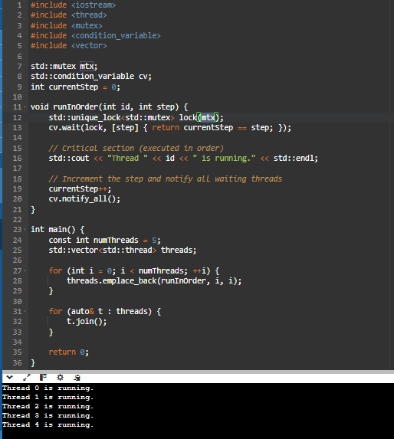
Advantage of std::condition_variable:
One of the main uses of std::condition_variable in C++ is to synchronize the execution of multiple threads based on certain conditions. It allows threads to wait for a specific condition to become true before proceeding with their execution.

std::atomic
std::atomic is a C++ feature that provides atomic operations on variables, making it safe for concurrent access by multiple threads. It ensures that a variable is updated atomically (without interruptions), preventing data races in multi-threaded applications.
Here are some important member functions of std::atomic:
- load(): This function atomically reads the current value of the std::atomic variable and returns it. It ensures that the read operation is atomic and provides the most up-to-date value.
- store(): This function atomically assigns a new value to the std::atomic variable. It guarantees that the assignment is atomic and provides a synchronized store operation.
- exchange(): This function atomically assigns a new value to the std::atomic variable and returns the previous value. It guarantees that the exchange operation is atomic and provides a synchronized exchange operation.
- compare_exchange_weak() and compare_exchange_strong(): These functions perform an atomic compare-and-exchange operation on the std::atomic variable. They compare the current value with an expected value and if they match, replace the current value with a new value. These functions return true if the exchange is successful and false otherwise.
- fetch_add(), fetch_sub(), fetch_and(), fetch_or(), fetch_xor(): These functions perform atomic arithmetic or bitwise operations on the std::atomic variable and return the previous value.
Let’s see example of std::atomic:
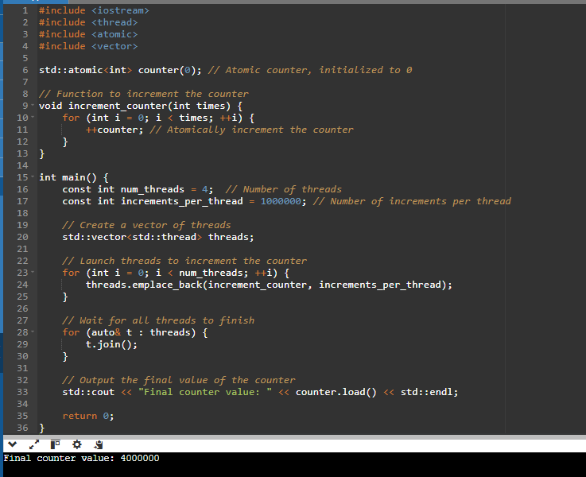
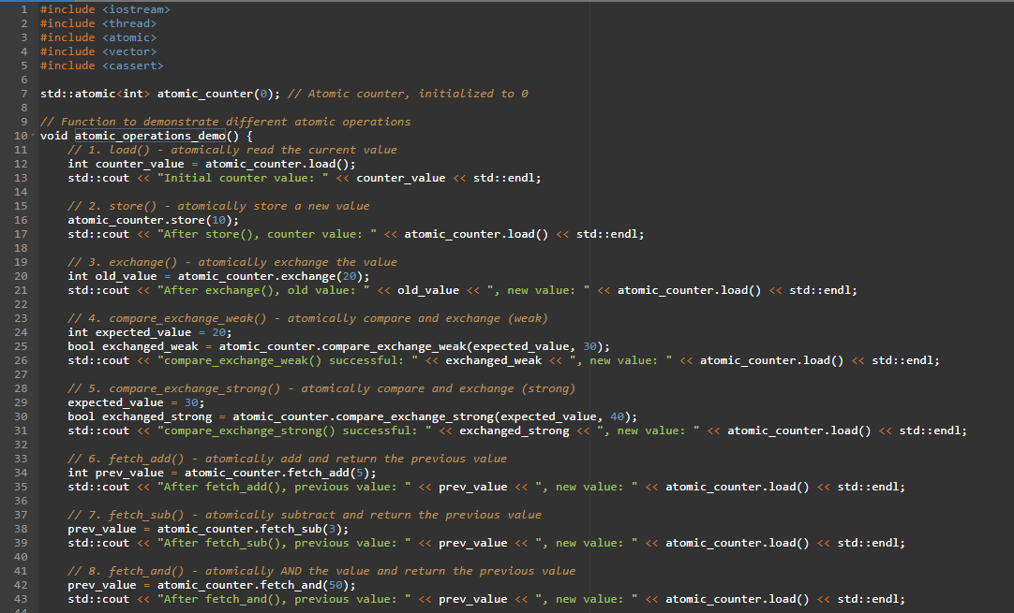
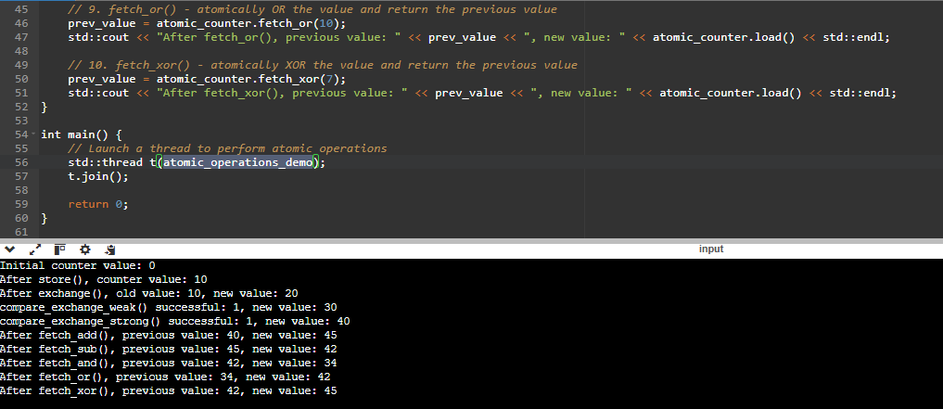

std::forward_list
std::forward_list is a singly-linked list container introduced in C++11. It’s optimized for minimal memory overhead and efficient insertion/removal at the front.
Key Characteristics:
- Singly-linked (only forward traversal)
- Lightweight compared to std::list
- Supports splice_after() instead of splice()
- No size() method (you must count manually)
Example:
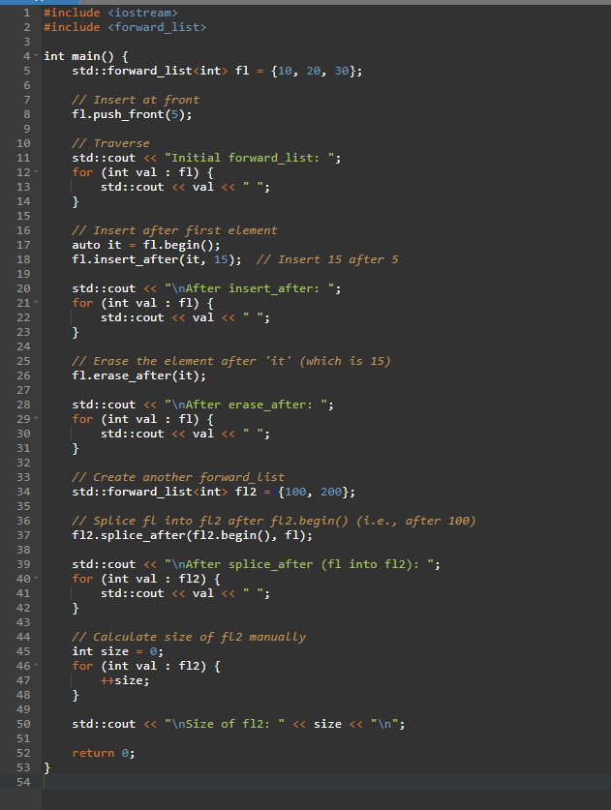
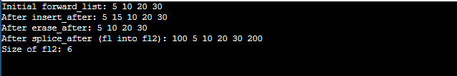

std::forward_list vs std::list
Feature | std::forward_list | std::list (doubly linked)
Link Type | Singly linked | Doubly linked
Memory Overhead | Lower | Higher (extra backward link)
Traversal Direction | Forward only | Forward and backward
push_front / pop_front | ✅ Fast | ✅ Fast
push_back / pop_back | ❌ Not available | ✅ Available
insert_after / erase_after | ✅ Yes | ❌ (has insert / erase)
splice_after() | ✅ Supported | ❌ (has splice)
size() | ❌ Not available | ✅ Yes

C++14

C++14 includes the following new language features

binary literals
In C++, binary literals are a way to represent integral values using binary notation. They allow you to express numeric values directly in binary form. Binary literals were introduced in the C++14 standard.
To write a binary literal in C++, you prefix the number with 0b or 0B. After the prefix, you can use a sequence of 0 and 1 digits to represent the binary value.
Let’s see example of binary literals:
Example 1:
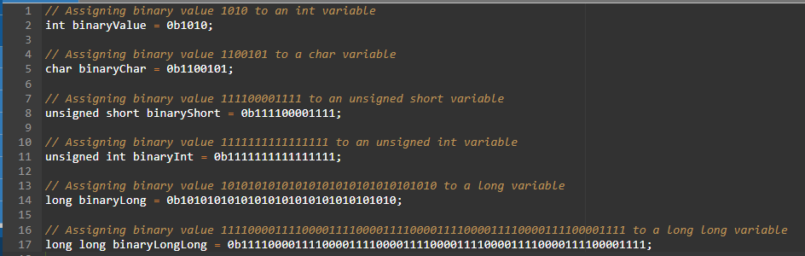

Example 2:
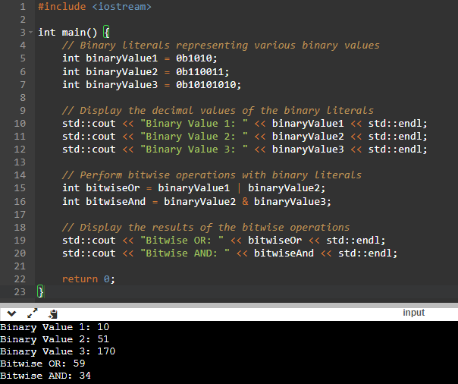

generic lambda expressions
Generic lambda expressions in C++ refer to lambda expressions that can accept parameters of different types without explicitly specifying the types. This feature was introduced in C++14 and provides a concise way to write generic code using lambda functions.
To define a generic lambda expression, you can use the auto keyword as the parameter type.
Syntax of generic lambda expressions:
auto name_of_function = [capture list]( parameter list auto) -> return_type {
// lambda function body
};

Let’s see example of generic lambda expressions:
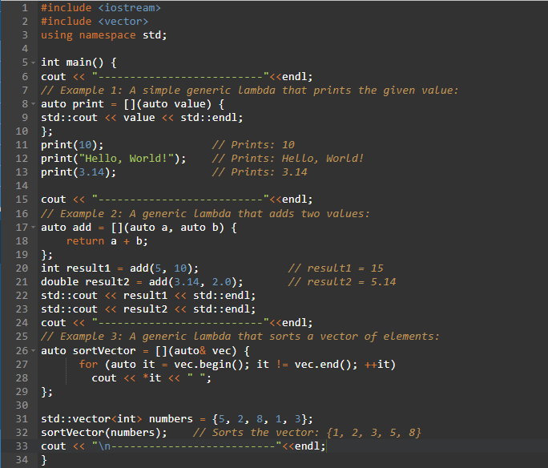
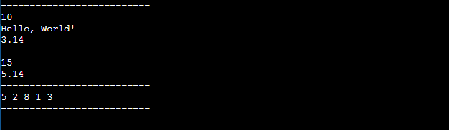

lambda capture initializers
Lambda capture initializers are a feature introduced in C++14 that allows you to provide initializers for variables captured by value in a lambda expression. It provides a way to specify initial values for the captured variables when the lambda is defined.
Syntax of Lambda capture initializers:
[capture_list](parameter_list) mutable(optional) exception_attribute(optional) -> return_type(optional) {
// Lambda body }
Let’s see example of Lambda capture initializers:
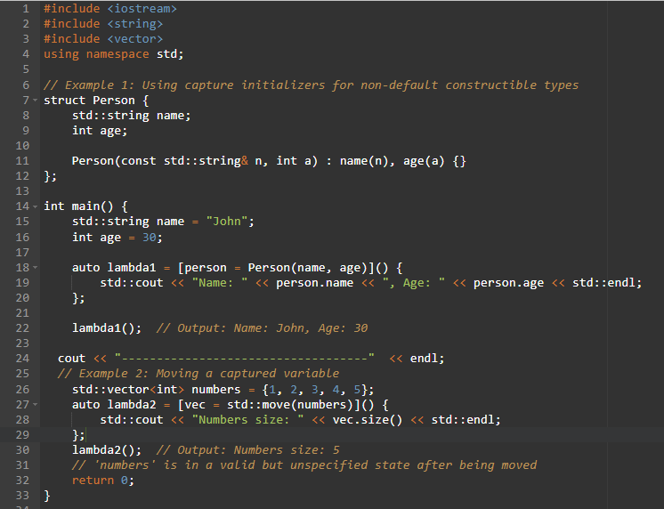

return type deduction
In C++, return type deduction allows the compiler to deduce the return type of a function based on its implementation. This feature was introduced in C++14 and can be particularly useful in simplifying code and reducing verbosity.
Let’s see examples of return type deduction:
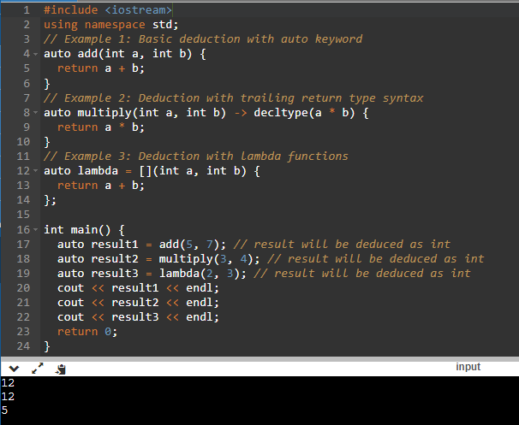

decltype(auto)
In C++, the decltype(auto) keyword is used to declare a variable with the type automatically deduced from an expression. It combines the behavior of auto type deduction with the decltype type deduction.
Let’s see example of decltype auto:
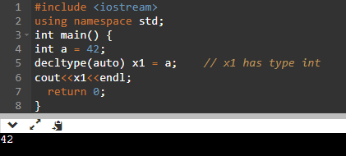

relaxing constraints on constexpr functions
In C++, constexpr functions are a powerful feature that allow you to compute values at compile time. However, there are some constraints on what you can do within a constexpr function, which can limit their usability in certain scenarios. In C++14 and earlier, the restrictions were quite strict, but C++17 introduced some relaxations to these constraints. Let's explore these constraints and see how they have been relaxed with examples.
C++14 Constraints:
In C++14 and earlier, constexpr functions were limited to a subset of the language features. The restrictions included:
- Only a limited set of expressions were allowed, such as arithmetic, logical, bitwise, and comparisons.
- No loops or recursion were allowed.
- Function calls were limited to other constexpr functions.
- Limited support for control flow statements like if and switch.
C++17 Relaxations:
C++17 relaxed some of the constraints on constexpr functions, making them more flexible. The key relaxations include.
- Loops: C++17 allows the use of loops (e.g., for, while) in constexpr functions. This enables iterative computations at compile time.
- Branching: C++17 allows the use of if statements and other control flow constructs within constexpr functions, enabling more complex decision-making at compile time.
- Local variables: C++17 allows the use of local variables within constexpr functions, expanding the range of computations that can be done.
Let’s see examples of relaxing constraints on constexpr functions:
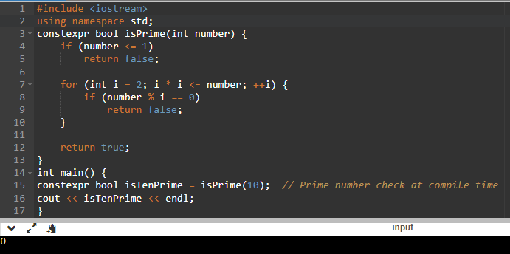

variable templates
In C++, templates allow you to write generic code that can work with different types. Variable templates, introduced in C++14, extend this concept to variables. They allow you to define variables whose types can be parameterized or deduced based on the context in which they are used.
Let’s see examples of variable templates:
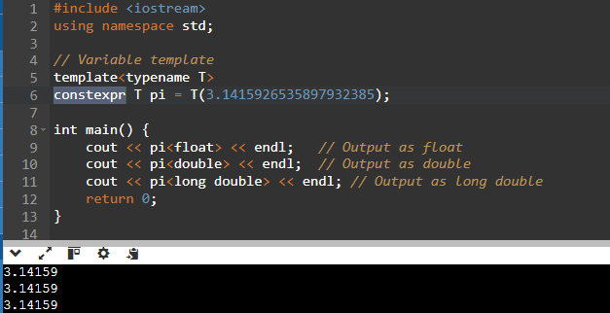

aggregate classes with default non-static member initializers
In C++, aggregate classes are typically defined as classes that have no user-declared constructors, no private or protected non-static data members, no base classes, and no virtual functions. However, starting from C++11, aggregate classes can also have non-static data members with default initializers.
In C++14, if you want to have default initializers for non-static data members in an aggregate class, you'll need to use constructors or provide default values explicitly in the member initialization list.
Let’s see example of aggregate classes with default non-static member initializers:
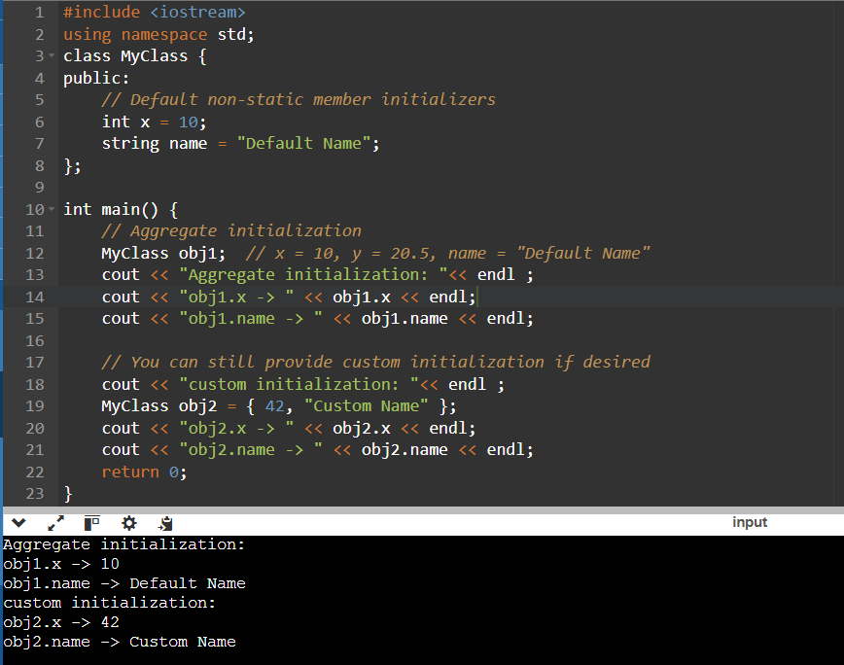

digit separators
In C++, digit separators are used to improve the readability of numeric literals by inserting underscores (_) between groups of digits. This feature was introduced in C++14.
Let’s see example of digit separators:
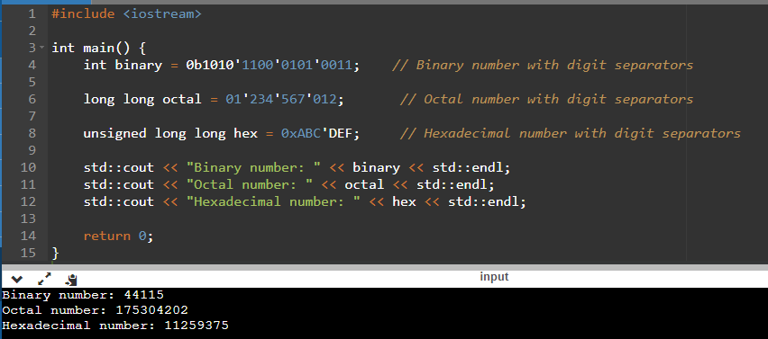

C++14 includes the following new library features:

std::shared_timed_mutex and std::shared_lock
In C++, std::shared_timed_mutex and std::shared_lock are part of the Standard Library's concurrency support introduced in C++14. They provide a mechanism for multiple readers and exclusive writer access to a shared resource.
std::shared_timed_mutex is a synchronization primitive that allows concurrent access to the shared resource. It provides both shared (read) and exclusive (write) locking mechanisms. Multiple threads can acquire the shared lock simultaneously, allowing concurrent read access, while only one thread can hold the exclusive lock for write access.
Let’s see example of std::shared_timed_mutex and std::shared_lock:
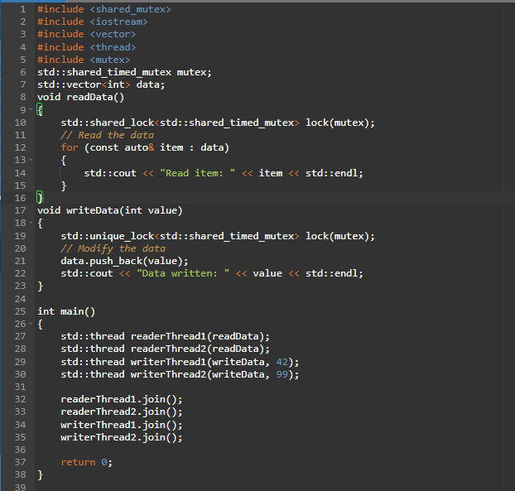
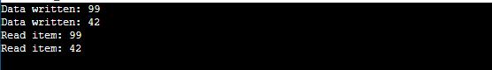

std::integer_sequence
std::integer_sequence is a C++ template class introduced in C++14. It represents a compile-time sequence of integers. It is primarily used in conjunction with variadic templates to expand a sequence of integers as template arguments.
Let’s see example of std::integer_sequence:
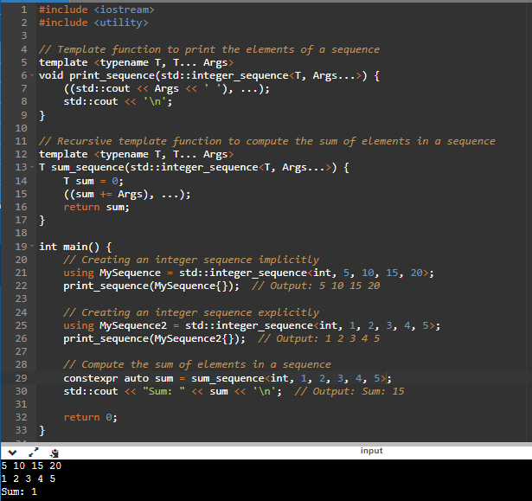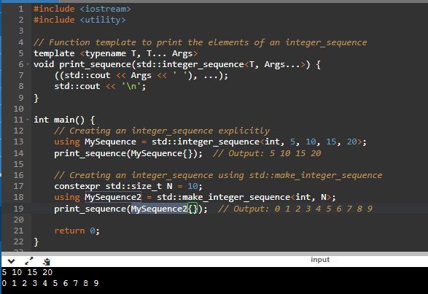

std::exchange
std::exchange is a utility function introduced in C++14 that allows you to exchange the value of an object with a new value and obtain the previous value in a single expression. It provides a convenient way to atomically update an object while obtaining its previous value.
Syntax of std::exchange:
template<class T, class U = T>
T exchange(T& obj, U&& new_value);
Let’s see example of std::exchange:
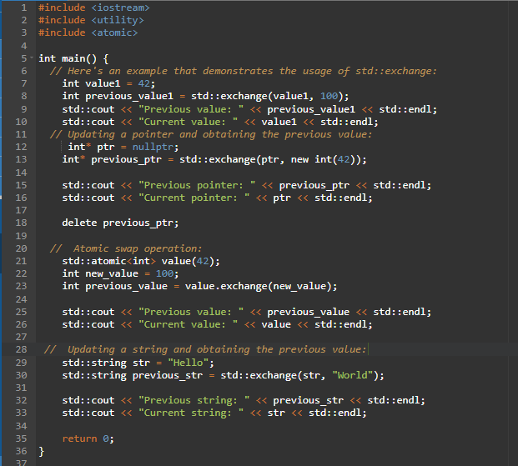
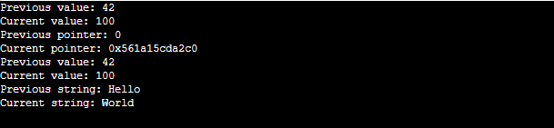

std::quoted
std::quoted is a function provided by the C++ Standard Library that allows you to manipulate and process quoted strings. It is particularly useful when dealing with input/output operations, such as parsing or printing formatted data.
Let’s see example of std::quoted:
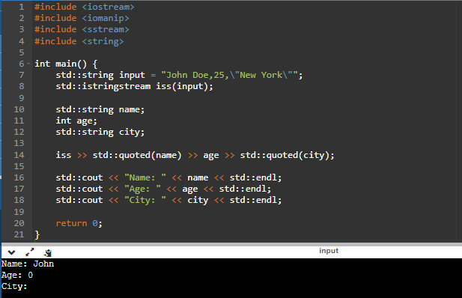

std::make_unique for array
In C++14, std::make_unique was enhanced to allow creating unique pointers for dynamically allocated arrays. This helps to avoid using raw new[] and ensures exception safety and better memory management.
Let’s see example of std::make_unique:
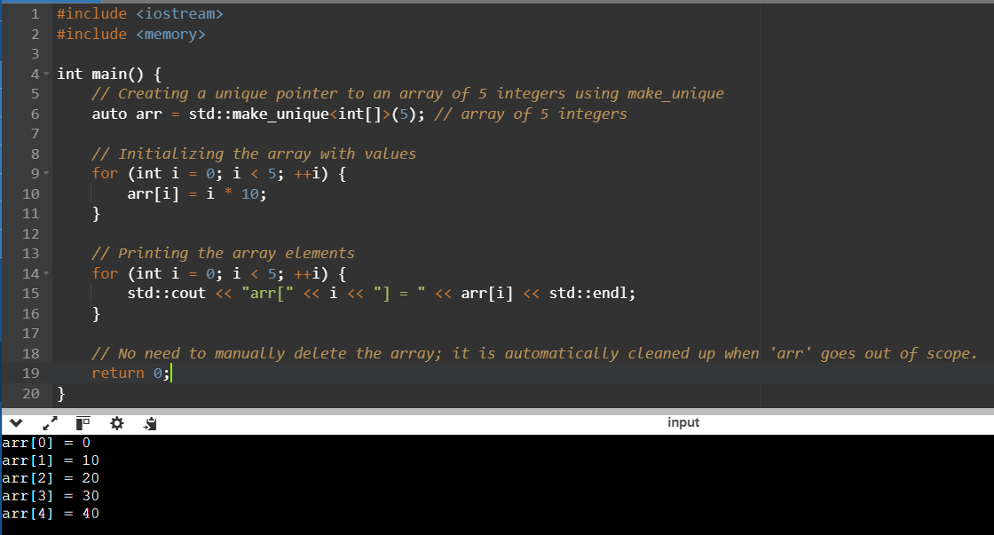

C++17

C++17 includes the following new language features

Template Argument Deduction for Class Templates
In C++17, the compiler can deduce template arguments for class templates, just like it already does for functions. You no longer need to explicitly specify the template parameters when creating an object if they can be deduced from the constructor arguments.
Before C++17:
template <typename T>
class MyPair {
T first, second;
public:
MyPair(T a, T b) : first(a), second(b) {}
};

int main() {
MyPair<int> p(1, 2); // Template argument <int> must be provided
}

After C++17:
template <typename T>
class MyPair {
T first, second;
public:
MyPair(T a, T b) : first(a), second(b) {}
};

int main() {
MyPair p(1, 2); // Template argument <int> is deduced automatically
}

Use Case:
This feature makes code cleaner, shorter, and easier to write, especially when working with generic code. It's particularly helpful in utility/helper types, like pairs, wrappers, containers, etc.

Declaring Non-Type Template Parameters with auto
Before C++17, you had to explicitly specify the type of non-type template parameters (e.g., int, char, etc.). With C++17, you can use auto instead, and the compiler will deduce the type of the non-type parameter.
Before C++17:
#include <iostream>
using namespace std;

template<int N>
void print() {
std::cout << "Value: " << N << '\n';
}

int main() {
print<42>();// here if you pass other then int it will give error.
}
Output:
Value: 42

After C++17:
#include <iostream>
using namespace std;

template<auto N>
void print() {
std::cout << "Value: " << N << '\n';
}

int main() {
print<42>(); // int
print<'A'>(); // char
print<true>(); // bool
}

Output:
Value: 42
Value: A
Value: 1

Use Case:
This feature gives you flexibility. You don't need to write multiple template versions for different types (int, char, bool, etc.). One generic version using auto is enough.

Fold Expressions
Fold expressions allow you to apply a binary operator to all arguments in a parameter pack (...). It's used in variadic templates.
Before C++17:
Writing fold logic was complicated and needed recursion or helper functions.
After C++17:
#include <iostream>
using namespace std;

template<typename... Args>
auto sum(Args... args) {
// Print each argument

((cout <<args << " "), ...); // Fold expression to print each argument with a space
cout << endl;

// Return the sum
return (args + ...); // Fold expression for sum
}

int main() {

int return_value = sum(1, 2, 3, 4, 5);

std::cout << "Sum = " << return_value << '\n'; // Output: Sum = 15
}
Output:
1 2 3 4 5
Sum = 15

Use Case:
Fold expressions are essential for cleaner and safer variadic templates. It makes implementing things like sum, all_of, any_of, etc., very concise.

New Rules for auto Deduction from Braced-Init-List
In C++17, using auto with braced-initializers like {1, 2} no longer deduces to std::initializer_list. Instead, it causes a compile error unless the context is clear.
Before C++17:
auto a = {1, 2}; // ✅ OK → std::initializer_list<int>
auto b{1}; // ✅ OK → int
auto c{1, 2}; // ✅ OK → std::initializer_list<int>
- The compiler allows braced initializers with or without =.
- Even auto c{1, 2}; deduces to std::initializer_list<int>.
After C++17:
auto a = {1, 2}; // ✅ OK → std::initializer_list<int> (with =)
auto b{1}; // ✅ OK → int
auto c{1, 2}; // ❌ ERROR: ambiguous!
- auto c{1, 2}; is ambiguous — the compiler doesn't know what to deduce.
- This was introduced to prevent confusion between aggregate initialization, initializer_list, and constructor calls.
Use Case:
- You might think you're initializing a std::vector<int>, a std::pair<int, int>, or something else.
- But pre-C++17, the compiler silently turns this into an initializer_list, which can lead to subtle bugs and misunderstandings.

constexpr
- constexpr means "can be evaluated at compile time."
- If a variable or function is marked constexpr, the compiler will attempt to evaluate it during compilation — making the code faster at runtime and enabling compile-time checks or computations.
- In C++11 and C++14 constexpr will not supoort Loops, if, switch, try, Lambdas but in C++17 it will support all.
Before C++17:
#include <iostream>
using namespace std;

int main() {

constexpr auto square = [](int x) {
return x * x;
};

constexpr int result = square(5); // ❌ ERROR: Lambda not allowed in constexpr

}

After C++17:
// lamda
#include <iostream>
using namespace std;

int main() {

constexpr auto square = [](int x) {
return x * x;
};

constexpr int result = square(5); // Lambda allowed in constexpr

}

//if
#include <iostream>
#include <type_traits>

template <typename T>
void printType(const T& val) {
if constexpr (std::is_integral_v<T>) {
std::cout << "Integer: " << val;
} else {
std::cout << "Not an integer";
}
}

int main() {
printType(42); // Works fine: "Integer: 42"
printType(3.14); // Works fine: "Not an integer"
}

Use Case:
- Faster Execution: If something can be precomputed at compile time, the binary runs faster.
- Template Meta-Programming: You can use constexpr lambdas inside templates, enabling powerful compile-time logic.
- Cleaner Code: No need to define a separate constexpr function — you can now use lambdas for short, one-off computations at compile time.

Lambda Capture *this by Value
C++17 allows you to capture *this by value inside a lambda, meaning it captures a copy of the object.
Before C++17:
#include <iostream>
#include <functional>

struct MyStruct {
int x = 42;

// This returns a lambda that captures `this` by reference (i.e., pointer to obj)
std::function<int()> getLambda() const {
return [this]() {
return x; // Accesses member x via the pointer 'this'
};
}
};

int main() {
std::function<int()> lam; // Declare lambda holder

{
MyStruct obj; // A local object created inside this block
lam = obj.getLambda(); // Lambda captures 'this' (i.e., &obj)

// So at this point:
// - lam holds a lambda that depends on a pointer to 'obj'
// - BUT it doesn't copy the object; it just remembers where it was
} // ⚠️ obj is destroyed here! its memory is reclaimed

// Now calling lam() is DANGEROUS!
// Because lam tries to access `x` through a dangling pointer (obj is gone)
std::cout << lam() << '\n'; // ❌ Undefined behavior — may crash or print garbage
}
Output:
42

- This means the lambda holds a pointer to the original object. If the object is destroyed before the lambda is called — undefined behavior!
After C++17:
#include <iostream>
#include <functional>

struct MyStruct {
int x = 42;

std::function<int()> getLambda() const {
return [*this]() { return x; }; // capture this by value (C++17)
}
};

int main() {
std::function<int()> lam; // declare 'lam' before using it

{
MyStruct obj;
lam = obj.getLambda(); // captures a copy of obj
} // obj goes out of scope and is destroyed

std::cout << lam() << '\n'; // ✅ safe! prints 42
}

Output:
42
- This captures the current object by value — i.e., it makes a copy of the entire object at the time the lambda is created.
Use Case:
Previously, [this] was always captured by reference. This feature [*this] helps when using lambdas asynchronously or after the object is destroyed — the copy is safe.

Inline Variables
C++17 allows variables (especially const or constexpr) to be marked inline, which means they can be defined in a header file without violating the One Definition Rule (ODR).
Before C++17:
You’d typically declare the variable in a header and define it in one .cpp file:
// header.h
extern const int max_value;

// source.cpp
const int max_value = 100;

After C++17:
// header.h
inline constexpr int max_value = 100; // No need for a separate .cpp file

Use Case:
Useful for defining global constants in headers (especially for templates) without needing a source file. Cleaner, safer, and more modern C++ style.

Nested Namespaces
C++17 introduces a shorthand to define nested namespaces.
Before C++17:
#include <iostream>
namespace mylib {
namespace utils {
void log() {}
}
}

int main() {

mylib::utils::log();

}

After C++17:
#include <iostream>
namespace mylib::utils {
void log() {}
}

int main() {

mylib::utils::log();

}

Use Case:
Improves readability and saves space, especially for deep namespace hierarchies like in large codebases or libraries.

Structured Bindings
Structured bindings allow unpacking tuples, Maps, pairs, structs, or even arrays into named variables directly.
Before C++17:
Without structured bindings, you had to manually extract elements from a tuple or pair, which could become verbose:
#include <iostream>
#include <tuple>
using namespace std;

int main() {

std::tuple<int, std::string> person = {25, "Alice"};

int age = std::get<0>(person);
std::string name = std::get<1>(person);

std::cout << age << ", " << name << '\n'; // Output: 25, Alice
}
Output:
25, Alice

After C++17:
Tuple:
#include <iostream>
#include <tuple>
using namespace std;

int main() {

std::tuple<int, std::string> person = {25, "Alice"};

// Structured bindings directly unpack the tuple into variables
auto [age, name] = person; // 'age' gets the 1st element, 'name' gets the 2nd

std::cout << age << ", " << name << '\n'; // Output: 25, Alice
}
Output:
25, Alice

Maps:
#include <iostream>
#include <map>

int main() {

std::map<int, std::string> m = {{1, "one"}, {2, "two"}, {3, "three"}};

// Loop through map entries using structured bindings
for (auto& [key, value] : m) {
std::cout << key << " -> " << value << '\n';
}
}

Pairs:
#include <iostream>
#include <utility> // For std::pair

int main() {
// Creating a pair
std::pair<int, std::string> person = {1, "Alice"};

// Structured binding to unpack the pair into named variables
auto [id, name] = person; // 'id' gets the first element, 'name' gets the second

std::cout << "ID: " << id << ", Name: " << name << '\n'; // Output: ID: 1, Name: Alice

return 0;
}

Arrays:
#include <iostream>

int main() {
int arr[3] = {1, 2, 3};

// Unpack array elements into variables
auto [a, b, c] = arr; // 'a' gets arr[0], 'b' gets arr[1], 'c' gets arr[2]

std::cout << a << ", " << b << ", " << c << '\n'; // Output: 1, 2, 3
}

structs:
#include <iostream>

struct Point {
int x, y;
};

int main() {

Point p = {3, 4};

// Unpack struct fields directly into variables
auto [x, y] = p; // 'x' gets p.x, 'y' gets p.y

std::cout << x << ", " << y << '\n'; // Output: 3, 4
}

Use Case:
Makes code cleaner and more expressive, especially when working with complex return types or maps. Less boilerplate.

Selection Statements with Initializer
Previously, you had to declare variables before the if, switch, or while statements, even if the variable was only used within those blocks. With C++17, you can now declare and initialize a variable directly within the selection statement itself, making the code more concise and limiting the variable's scope to just that statement.
Before C++17:
//if
int value = getValue();
if (value > 10) {
std::cout << "Big value: " << value;
}

//switch
int x = getCode();
switch (x) {
case 1: std::cout << "Code 1"; break;
default: std::cout << "Other code";
}

After C++17:
//if
if (int value = getValue(); value > 10) {
std::cout << "Big value: " << value;
}

//switch
switch (int x = getCode(); x) {
case 1: std::cout << "Code 1"; break;
default: std::cout << "Other code";
}

Use Case:
Useful for scoping, cleaner logic, and avoiding polluting the outer scope with temporary variables.

UTF-8 Character Literals (u8'')
C++17 introduces UTF-8 character literals using the syntax u8'c', which represents a character encoded in UTF-8
Example:
char8_t c = u8'a'; // char8_t introduced in C++20, but u8 literals were introduced in C++17
Note: char8_t is formally introduced in C++20, but the u8 character literal (e.g., u8'ñ') is valid from C++17 onwards.
Use Case:
Use UTF-8 literals when you're dealing with international characters or text encoding-sensitive systems. Ensures character literals are properly encoded.

Direct-List-Initialization of Enums
C++17 allows you to directly list-initialize enums using brace {} syntax.
Before C++17:
Color c = Green; // only this syntax was allowed

After C++17:
enum Color { Red, Green, Blue };
Color c{Green}; // ✅ OK in C++17

Use Case:
Improves uniform initialization across types and works well with constexpr and template-based programming.

New Attributes: [[fallthrough]], [[nodiscard]], [[maybe_unused]]
Attributes in C++ provide hints to the compiler to control warnings and improve code clarity, safety, and intent. C++17 introduced several standardized ones.
[[fallthrough]]
Used inside a switch statement to explicitly indicate intentional fallthrough from one case to another. This avoids compiler warnings.
#include <iostream>

void testFallthrough(int n) {
switch (n) {
case 1:
std::cout << "Case 1\n";
[[fallthrough]]; // 👈 Tells the compiler this fallthrough is intentional
case 2:
std::cout << "Case 2\n";
break;
default:
std::cout << "Default case\n";
}
}

int main() {
testFallthrough(1);
}
Output:
Case 1
Case 2

Without [[fallthrough]], many compilers may warn that you forgot a break.

[[nodiscard]]
Tells the compiler that the return value should not be ignored. Helps catch bugs where you forget to handle a return code or result.

[[nodiscard]] int getStatus() {
return -1;
}

int main() {
getStatus(); // ⚠️ May trigger compiler warning: return value ignored
// int n = getStatus(); it will not give any warning here.
}
Output:
main.cpp: In function ‘int main()’:
main.cpp:6:14: warning: ignoring return value of ‘int getStatus()’, declared with attribute ‘nodiscard’ [-Wunused-result]
6 | getStatus(); // ⚠️ May trigger compiler warning: return value ignored
| ~~~~~~~~~^~
main.cpp:1:19: note: declared here
1 | [[nodiscard]] int getStatus() {

Use it with functions where ignoring the result can lead to bugs (e.g., status/error codes, important calculations).

[[maybe_unused]]
Avoids warnings about unused variables or functions, which may be intentional (e.g., in platform-specific or debugging code).

int main() {
[[maybe_unused]] int debugOnlyValue = 42; // No warning even if unused

// Some code that doesn't use debugOnlyValue
}
Useful in templates, debugging code, or cross-platform functions where a variable is only used in certain configurations.
Use Case:
Helps with static analysis, code correctness, and documenting intent in your code.

__has_include
__has_include is a preprocessor feature that lets you check if a header is available before including it.
Example:
#if __has_include(<optional>)
#include <optional>
using std::optional;
#else
#error "std::optional not supported by this compiler!"
#endif

int main() {
optional<int> val = 10;
}

Use Case:
Useful in cross-platform or library development, where headers may not be available in all environments. Prevents compile errors gracefully.

Class Template Argument Deduction (CTAD)
C++17 allows the template arguments of class templates to be deduced automatically, just like function templates.
std::pair
#include <iostream>
#include <utility>

int main() {
std::pair p(42, 3.14); // Deduce as std::pair<int, double>

std::cout << "First: " << p.first << ", Second: " << p.second << '\n';
}

You don’t have to write:
std::pair<int, double> p(42, 3.14);

std::vector
#include <vector>
#include <iostream>

int main() {
std::vector v = {10, 20, 30}; // Deduce as std::vector<int>

for (int n : v) std::cout << n << ' ';
}
Works perfectly when initializer list provides enough type info.

User-defined class with template
Let’s define a custom template class:
template<typename T, typename U>
struct MyPair {
T first;
U second;

MyPair(T a, U b) : first(a), second(b) {}
};

int main() {
MyPair mp(5, 3.5); // Deduce as MyPair<int, double>

std::cout << "First: " << mp.first << ", Second: " << mp.second << '\n';
}

The compiler deduces <int, double> from constructor arguments (5, 3.5).

std::tuple
#include <tuple>
#include <iostream>

int main() {
std::tuple t(1, 2.0, "hello"); // std::tuple<int, double, const char*>

std::cout << std::get<2>(t) << '\n'; // prints "hello"
}

std::map
CTAD also helps when constructing things like maps using helper functions:
#include <map>
#include <string>
#include <iostream>

int main() {
std::map m = {
std::pair{1, "one"},
std::pair{2, "two"}
};

for (const auto& [k, v] : m)
std::cout << k << " => " << v << '\n';
}
std::pair{1, "one"} also uses deduction guide (CTAD).

Use Case:
Reduces redundant template typing, especially useful with modern templated types like std::pair, std::tuple, std::vector, etc.

C++17 includes the following new library features

std::variant
std::variant is a type-safe union in C++.Unlike traditional C++ unions,It can hold one value out of multiple types, but only one at a time. which can lead to undefined behavior if accessed incorrectly, std::variant ensures only one of the specified types is active and tracks it safely at runtime. Resolved at compile-time
It is part of the <variant> header and introduced in C++17.
Example:
#include <variant>
#include <iostream>
#include <string>

int main() {
std::variant<int, float, std::string> data;
//int
data = 10;
std::cout << "int value : "<< std::get<int>(data) << "\n"; // prints: 10
//float
data = 10.5f;
std::cout << "float value : " << std::get<float>(data) << "\n"; // prints: 10
//string
data = std::string("Hello");
std::cout << "string value : "<< std::get<std::string>(data) << "\n"; // prints: Hello
}
Output:
int value : 10
float value : 10.5
string value : Hello

Advanced Concepts:
- std::visit
std::visit is a visitor function — it allows you to safely access the value stored in a std::variant, It prints the current value inside data, no matter what type it is.
Example:
#include <variant>
#include <iostream>
#include <string>

int main() {
std::variant<int, float, std::string> data;

data = 42;
std::visit([](auto&& value) {
std::cout << "Value: " << value << '\n';
}, data); // Output: Value: 42

data = std::string("Hello");
std::visit([](auto&& value) {
std::cout << "Value: " << value << '\n';
}, data); // Output: Value: Hello

}
Output:
value : 42
value : Hello

- std::holds_alternative<T>()
It checks whether the std::variant currently holds a value of type T.
Syntax: std::holds_alternative<T>(variant_variable)
Example:
#include <iostream>
#include <variant>

int main() {
std::variant<int, float, std::string> data;

data =42;
data ="Hello";

if (std::holds_alternative<int>(data)) {
std::cout << "It holds an int!\n";
} else if (std::holds_alternative<std::string>(data)) {
std::cout << "It holds a string!\n";
}

//it will give current hold value only.
}
Output:
It holds a string!

- std::get_if<T>()
It tries to retrieve a pointer to the value if the variant currently holds type T. If it doesn't, it returns nullptr.
Syntax:
if (auto ptr = std::get_if<T>(&variant_variable)) {
// use *ptr safely
}
Note: You need to pass the address (&) of the variant.
Example:
#include <iostream>
#include <variant>

int main() {
std::variant<int, float, std::string> data = 3.14f;

if (auto val = std::get_if<float>(&data)) {
std::cout << "Float value = " << *val << "\n";
} else {
std::cout << "Not a float!\n";
}
}
Output:
Float value = 3.14

Use Case:
- Replace union with type safety
- Implement finite state machines
- Store one of several types in a single variable
- Useful for generic APIs, parsing, configuration objects, etc.

std::optional
std::optional<T> is a wrapper introduced in C++17 that can either contain a value of type T or no value at all.
Why do we need it?
Traditionally in C++, when a function might fail or might not find a result, you'd use:
- -1 or 0 or some sentinel value
- Return a pointer and use nullptr to indicate "nothing"
- Throw an exception
- These approaches work, but can be error-prone or unclear.
std::optional<T> improves this by:
- Making intentions clear (this function might return nothing)
- Avoiding magic values like -1
- Providing type safety without needing raw pointers
Example:
#include <iostream>
#include <optional>

std::optional<int> getValue(bool success) {
if (success)
return 42;
else
return std::nullopt;
}

int main() {
std::optional<int> result = getValue(true); // Change to true to test with value

if (result)
std::cout << "Found: " << *result << "\n";
else
std::cout << "Nothing found\n";

// ✅ Default Value if Empty
int valueWithDefault = result.value_or(100); // Uses 100 if result has no value
std::cout << "Value (with default): " << valueWithDefault << "\n";

// ✅ Check and Access
if (result.has_value()) {
std::cout << "Result has value: " << result.value() << "\n";
} else {
std::cout << "Result has no value.\n";
}

// ✅ Modify in-place
result = 55;
std::cout << "Modified value: " << result.value() << "\n";

result.reset(); // Clear the value
std::cout << "Value after reset: ";
if (result) {
std::cout << *result << "\n";
} else {
std::cout << "No value\n";
}

return 0;
}

Output:
Found: 42
Value (with default): 42
Result has value: 42
Modified value: 55
Value after reset: No value

Note:
To observe that both *result and result.value() give you access to the value stored inside a std::optional<T>. But there are a few subtle differences between the two:
1. result.value()
- Returns: A reference to the value inside the optional.
- Behavior: Throws a std::bad_optional_access exception if result is empty.
- Safer in expressive intent: Explicit and clear you are expecting a value.
Example:
std::optional<int> result;
// result.value(); // ❌ Throws exception if result is empty
2. *result
- Returns: Also a reference to the value.
- Behavior: Undefined behavior if result is empty — no safety checks!
- Faster: No runtime check; good when you're sure the value is there.
Example:
std::optional<int> result;
// *result; // ❌ Undefined behavior if result is empty

Use Case:
- Replace raw pointers or sentinel values (-1, nullptr, etc.)
- Safer function return for "maybe a value"
- Makes nullability explicit
- Great in config systems, input parsing, and fallback logic

std::any
- std::any is a type-safe container for single values of any type. It works like a safer, more modern alternative to void*, allowing you to store and retrieve any type without needing explicit casting or inheritance.
- You can assign any copyable type to a std::any object.
- You must retrieve the value using std::any_cast<T>(), and the cast must match the actual type inside.
- Resolved at runtime

Example:
#include <any>
#include <iostream>
#include <string>
#include <vector>

int main() {
// Part 1: Basic usage of std::any
std::any a = 42; // a holds an int
std::cout << "Single any (int): " << std::any_cast<int>(a) << "\n";

a = std::string("Hello"); // now holds a std::string
std::cout << "Single any (string): " << std::any_cast<std::string>(a) << "\n";

if (auto ptr = std::any_cast<std::string>(&a)) {
std::cout << "string : " <<*ptr; // ✅ Safe access
} else {
std::cout << "Not a string!";
}

// Part 2: Using std::vector<std::any> to store multiple types
std::vector<std::any> values;
values.push_back(10); // int
values.push_back(std::string("C++")); // std::string
values.push_back(3.14); // double

std::cout << "\nIterating over std::vector<std::any>:\n";
for (auto& val : values) {
if (val.type() == typeid(int)) {
std::cout << "int: " << std::any_cast<int>(val) << "\n";
} else if (val.type() == typeid(std::string)) {
std::cout << "string: " << std::any_cast<std::string>(val) << "\n";
} else if (val.type() == typeid(double)) {
std::cout << "double: " << std::any_cast<double>(val) << "\n";
} else {
std::cout << "Unknown type\n";
}
}

return 0;
}
Output:
Single any (int): 42
Single any (string): Hello
string : Hello
Iterating over std::vector<std::any>:
int: 10
string: C++
double: 3.14

Use Case:
- Store heterogeneous types in containers or data models
- Runtime polymorphism without inheritance
- Useful for plugin systems, event handling, and reflection-style systems

std::string_view
std::string_view is a non-owning, lightweight reference to a string (or part of a string). It acts like a "window" into an existing string.
- Introduced in C++17
- It does not copy the string — it just points to the original data
- Great for performance when you don’t need to own or modify the string
Why not just use std::string?
std::string owns the data. Every time you pass it around or slice it, it can create copies, which can be expensive.
With std::string_view, you get:
- Faster code (no copies)
- Safer than raw pointers
- Simpler APIs for read-only string handling
Example:
#include <string_view>
#include <iostream>

void print_view(std::string_view sv) {
std::cout << sv << "\n"; // Print the view
}

int main() {
std::string str = "Hello, C++17!";
std::string_view sv = str; // No copy, just points to str's data

print_view(sv); // Prints: Hello, C++17!
}
Output:
Hello, C++17!

Important points:
1. Function parameters
Instead of:
void greet(const std::string& name);

Use:
void greet(std::string_view name); // More flexible!

Now you can pass:
std::string
string literals ("Hello")
char[]

All without overloading or converting types.

2. Substring without copying

std::string str = "Hello World";
std::string_view sv = str;

std::string_view first_word = sv.substr(0, 5);
std::cout << first_word; // "Hello"
Unlike std::string.substr(), std::string_view.substr() does not copy the characters!

3. Efficient parsing

std::string_view input = "key=value";
auto pos = input.find('=');
std::string_view key = input.substr(0, pos);
std::string_view value = input.substr(pos + 1);
Perfect for config parsers, command-line tools, or log processing.

Things to Watch Out For
- No ownership → If original string is destroyed, the view becomes invalid!
- Don't use string_view if the source string might go out of scope

std::string_view bad_view;
{
std::string temp = "Oops!";
bad_view = temp; // ❌ temp is destroyed here!
}
// bad_view is now dangling!

Use Case:
- Avoid unnecessary copies when passing strings to functions.
- Used for string slices, where you want to refer to a substring without copying data.
- Highly useful when working with string literals, large datasets, or when implementing functions that handle parts of strings.

std::invoke
std::invoke is a utility function that invokes a callable object (function pointer, lambda, or member function) with a set of arguments. It simplifies the syntax and handles different types of callable objects uniformly.
Example:
#include <iostream>
#include <functional>

void greet(int x) {
std::cout << "Hello: " << x << "\n";
}

struct MyClass {
void show(int x) {
std::cout << "Value: " << x << "\n";
}
};

int main() {
// 1. Using std::invoke with a regular function
std::invoke(greet, 5); // ✅ Equivalent to greet(5)

// 2. Using std::invoke with a lambda
auto say = [](int x) {
std::cout << "Hi: " << x << "\n";
};
std::invoke(say, 10); // ✅ Calls the lambda

// 3. Using std::invoke with a member function and object
MyClass obj;
std::invoke(&MyClass::show, obj, 42); // ✅ Calls obj.show(42)

// 4. Using std::invoke with a member function and object pointer
MyClass* ptr = &obj;
std::invoke(&MyClass::show, ptr, 55); // ✅ Calls ptr->show(55)

return 0;
}
Output:
Hello: 5
Hi: 10
Value: 42
Value: 55

Real-world Example: Function Dispatcher
#include <iostream>
#include <functional>

// Template that safely calls any callable with arguments
template<typename Callable, typename... Args>
void call_safely(Callable&& fn, Args&&... args) {
std::invoke(std::forward<Callable>(fn), std::forward<Args>(args)...);
}

// A normal function
void greet(const std::string& name) {
std::cout << "Hello, " << name << "!\n";
}

// A class with a member function
struct MyClass {
void print_sum(int a, int b) {
std::cout << "Sum: " << (a + b) << "\n";
}
};

int main() {
// 1. Calling a normal function
call_safely(greet, "Pavan");

// 2. Calling a lambda
auto lambda = [](int x) {
std::cout << "Lambda square: " << x * x << "\n";
};
call_safely(lambda, 6);

// 3. Calling a member function
MyClass obj;
call_safely(&MyClass::print_sum, obj, 10, 20);

// 4. Calling a functor
struct Functor {
void operator()(const std::string& msg) {
std::cout << "Functor says: " << msg << "\n";
}
};

Functor fun;
call_safely(fun, "C++ is powerful!");

return 0;
}
Output:
Hello, Pavan!
Lambda square: 36
Sum: 30
Functor says: C++ is powerful!

Use Case:
- Simplifies calling member functions or any callable with the right arguments.
- Makes generic programming more robust, as it can be used with different types of callable objects.
- Particularly useful when working with higher-order functions or callback mechanisms.

std::apply
std::apply applies a function to a tuple (or any sequence of arguments). It unpacks the tuple into function arguments, enabling easy work with variadic templates.

Example:
#include <iostream>
#include <tuple>
#include <functional>

void sum(int a, int b, int c) {
std::cout << "Sum: " << a + b + c << "\n";
}

int main() {
auto args = std::make_tuple(1, 2, 3);

// Apply the sum function to the tuple args
std::apply(sum, args); // Output: Sum: 6
}

Use Case:
- Great for working with tuples or variadic template functions.
- Simplifies invoking functions with a set of arguments contained in a tuple, especially in generic code.

std::byte
std::byte is a distinct type representing a raw byte. It provides better type safety than using char or unsigned char for binary data.
Example:
#include <iostream>
#include <cstddef>

int main() {
std::byte b = std::byte{42}; // Initializing with a byte value

// Print byte as an integer (casting)
std::cout << "Byte value: " << std::to_integer<int>(b) << "\n";
}
Output:
Byte value: 42

Use Case:
- Byte manipulation in low-level code.
- Safer alternative to using char or unsigned char for binary data.
- Memory buffers, network protocols, and serialization.

Splicing
C++17 introduces splicing operations for std::list and std::forward_list, allowing you to move elements from one container to another without copying.
Example: std::list
#include <iostream>
#include <list>

int main() {
std::list<int> list1 = {1, 2, 3};
std::list<int> list2 = {4, 5, 6};

// Move all elements from list2 to the end of list1
list1.splice(list1.end(), list2);

std::cout << "list1: ";
for (int n : list1) std::cout << n << " "; // Output: 1 2 3 4 5 6
std::cout << "\nlist2 size: " << list2.size(); // Output: 0
}
Output:
list1: 1 2 3 4 5 6
list2 size: 0
Note: std::move also we can use but it remove list1 data and moved to the list2 data.
Example:
#include <iostream>
#include <list>

int main() {
std::list<int> list1 = {1, 2, 3};
std::list<int> list2 = {4, 5, 6};

list1 = std::move(list2);

std::cout << "list1: ";
for (int n : list1) std::cout << n << " "; // Output: 1 2 3 4 5 6
std::cout << "\nlist2 size: " << list2.size(); // Output: 0
}

Output:
list1: 4 5 6
list2 size: 0

Use Case:
- Efficiently transfer elements between containers without copying them.
- Especially useful in optimized data structures and algorithms that need to move elements around without reallocation.

Parallel Algorithms
C++17 added parallel execution support to many algorithms in the Standard Library (like sort, for_each, transform, etc). This means:
You can automatically run algorithms in parallel (on multiple CPU cores) without writing threads or managing concurrency yourself.

Why It Matters
Traditionally, algorithms in C++ (like std::for_each) execute sequentially — one element at a time.
In modern multi-core systems, we can do multiple tasks at the same time (in parallel) — so C++17 lets you leverage this automatically just by adding a policy like std::execution::par.
Example:
#include <iostream>
#include <vector>
#include <algorithm>
#include <execution> // Required for parallel policies

int main() {
std::vector<int> v = {1, 2, 3, 4, 5};

// Multiply each element by 2 using parallel execution
std::for_each(std::execution::par, v.begin(), v.end(), [](int& n) {
n *= 2;
});

for (int i : v) {
std::cout << i << " "; // Output: 2 4 6 8 10
}
}

Use Case:
- Speed up computationally expensive operations, especially on multi-core processors.
- Great for algorithms like sorting, searching, and transformations on large datasets.

std::sample
std::sample allows you to select a random subset of elements from a container, using a specified random number generator. This is useful when you want to sample data in a probabilistic manner.
Example:
#include <iostream>
#include <vector>
#include <random>
#include <algorithm>

int main() {
std::vector<int> v = {1, 2, 3, 4, 5, 6};
std::vector<int> result;

std::random_device rd;
std::mt19937 g(rd());

// Sample 3 elements randomly from v
std::sample(v.begin(), v.end(), std::back_inserter(result), 3, g);

for (int n : result) {
std::cout << n << " "; // Random 3 numbers from 1, 2, 3, 4, 5, 6
}
}
Output:
2 3 6

Use Case:
- Random sampling for tasks like Monte Carlo simulations, statistical analysis, or even randomly selecting items (like lottery numbers).
- Can be useful in scenarios where random selections are required, such as shuffling, randomized testing, etc.

std::clamp
std::clamp restricts a value to a given range. If the value is less than the lower bound, it returns the lower bound; if greater than the upper bound, it returns the upper bound; otherwise, it returns the value itself.
Example:
#include <iostream>
#include <algorithm>

int main() {
int value = 10;

// Clamp value between 5 and 15
value = std::clamp(value, 5, 15);

std::cout << "Clamped value: " << value << "\n"; // Output: Clamped value: 10
}
Output:
Clamped value: 10

Note: If value 1 to 4 means the clamp value 5 and if value 16 to N means the clamp value 15.
Use Case:
- Ensuring a value stays within a specific range (e.g., controlling input values).
- Useful in scenarios like limiting brightness levels, capping values in financial calculations, or any situation where a range constraint is necessary.

std::reduce
std::reduce is a parallelizable version of std::accumulate that can be used to reduce a sequence of elements to a single value (like summing, multiplying, etc.). It performs the reduction in parallel if possible, offering potential performance improvements for large datasets.
Example:
#include <iostream>
#include <vector>
#include <numeric>
#include <execution> // For parallel execution policies

int main() {
std::vector<int> v = {1, 2, 3, 4, 5};

// Use std::reduce with parallel execution policy to sum elements
int sum = std::reduce(std::execution::par, v.begin(), v.end(), 0);

std::cout << "Sum: " << sum << "\n"; // Output: Sum: 15
}

Use Case:
- Useful for performing reductions (like sums, products, etc.) on large datasets, especially when parallelization can provide performance benefits.
- Efficient for large-scale data processing, including operations on vectors, arrays, and other collections.

Prefix Sum Algorithms
Prefix sum algorithms compute a sequence where each element is the sum of all previous elements (inclusive or exclusive).
C++17 introduced two powerful algorithms:
- std::inclusive_scan: Includes the current element in the sum.
- std::exclusive_scan: Excludes the current element from the sum.
These can run in parallel using <execution> policies.
Example:
#include <iostream>
#include <vector>
#include <numeric> // For inclusive_scan, exclusive_scan
#include <execution> // For parallel execution policies

int main() {
std::vector<int> v = {1, 2, 3, 4, 5};

// Inclusive scan: includes current element
std::vector<int> inclusive_result(v.size());
std::inclusive_scan(std::execution::par, v.begin(), v.end(), inclusive_result.begin());

std::cout << "Inclusive scan result: ";
for (int n : inclusive_result) {
std::cout << n << " "; // Output: 1 3 6 10 15
}

// Exclusive scan: excludes current element
std::vector<int> exclusive_result(v.size());
std::exclusive_scan(std::execution::par, v.begin(), v.end(), exclusive_result.begin(), 0);

std::cout << "\nExclusive scan result: ";
for (int n : exclusive_result) {
std::cout << n << " "; // Output: 0 1 3 6 10
}

return 0;
}

Difference Between Inclusive and Exclusive:
Index | Input | Inclusive Sum | Exclusive Sum
0 | 1 | 1 (1) | 0 (starts with init)
1 | 2 | 1+2 = 3 | 1
2 | 3 | 1+2+3 = 6 | 1+2 = 3
3 | 4 | 1+2+3+4 = 10 | 1+2+3 = 6
4 | 5 | 1+2+3+4+5 = 15 | 1+2+3+4 = 10
Use Cases:
- Running totals (like expenses, sales, or scores)
- Parallel histogram calculation
- Signal or time-series processing
- Cumulative distributions in statistics
- Efficient transformations on GPUs and multi-core systems

GCD and LCM
C++17 introduces built-in functions for computing greatest common divisor (GCD) and least common multiple (LCM), making it easier to perform these operations without having to implement them manually.
Example:
#include <iostream>
#include <numeric>

int main() {
int a = 56;
int b = 98;

// Compute GCD
int gcd = std::gcd(a, b);
std::cout << "GCD: " << gcd << "\n"; // Output: GCD: 14

// Compute LCM
int lcm = std::lcm(a, b);
std::cout << "LCM: " << lcm << "\n"; // Output: LCM: 392
}

Use Case:
- Used in number theory, cryptography, and mathematical applications.
- GCD and LCM are common in simplifying fractions, solving Diophantine equations, or calculating periodicity in signal processing.

std::not_fn
- std::not_fn is a function adapter introduced in C++17.
- It negates (i.e., flips) the result of a given callable (like a lambda, function pointer, or functor).
- If a function returns true, std::not_fn(f) will return false, and vice versa.
Example:
#include <iostream>
#include <algorithm>
#include <vector>
#include <functional> // For std::not_fn

int main() {
std::vector<int> v = {1, 2, 3, 4, 5};

// Predicate to check if a number is odd
auto is_odd = [](int n) { return n % 2 != 0; }; // ✅ is_odd returns true

// Use std::not_fn to create is_even
auto is_even = std::not_fn(is_odd); // ✅ Now returns true for even numbers

std::cout << "Even numbers: ";
for (int n : v) {
if (is_even(n)) {
std::cout << n << " "; // Output: 2 4
}
}
}
Output:
Even numbers: 2 4

Let’s say:
- is_odd(3) returns true
- std::not_fn(is_odd)(3) returns false
So std::not_fn wraps any callable and inverts its result using ! (logical NOT).
Use Case:
- Useful when you need to invert predicates in algorithms without writing separate negation logic.
- Common in scenarios like filtering or transformation where you need to negate conditions.

String Conversion to/from Numbers
C++17 introduces convenient functions for converting strings to numbers and numbers to strings. The <string> header provides std::stoi, std::stol, std::stof, std::to_string, etc., to facilitate these conversions.
Full Example: std::stoi, std::stol, std::stoll, std::stof, std::stod, std::to_string, etc.
#include <iostream>
#include <string>

int main() {
std::string int_str = "12345";
std::string long_str = "9876543210";
std::string float_str = "3.14159";
std::string double_str = "2.718281828";

// String to number conversions
int num_int = std::stoi(int_str); // string to int
long num_long = std::stol(long_str); // string to long
long long num_llong = std::stoll(long_str); // string to long long
float num_float = std::stof(float_str); // string to float
double num_double = std::stod(double_str); // string to double

// Print converted numbers
std::cout << "Integer: " << num_int << "\n";
std::cout << "Long: " << num_long << "\n";
std::cout << "Long Long: " << num_llong << "\n";
std::cout << "Float: " << num_float << "\n";
std::cout << "Double: " << num_double << "\n";

// Number to string conversions
std::string str_from_int = std::to_string(num_int);
std::string str_from_long = std::to_string(num_long);
std::string str_from_float = std::to_string(num_float);
std::string str_from_double = std::to_string(num_double);

// Print converted strings
std::cout << "String from int: " << str_from_int << "\n";
std::cout << "String from long: " << str_from_long << "\n";
std::cout << "String from float: " << str_from_float << "\n";
std::cout << "String from double: " << str_from_double << "\n";

return 0;
}
Output:
Integer: 12345
Long: 9876543210
Long Long: 9876543210
Float: 3.14159
Double: 2.71828
String from int: 12345
String from long: 9876543210
String from float: 3.141590
String from double: 2.718282

Use Case:
- Parsing user input or reading data from files where numbers are stored as strings.
- Serialization, logging, or debugging where numerical values need to be converted to strings.

Type Trait Variable Templates (e.g., is_same_v)
In C++17, type trait variable templates were introduced to make code cleaner and more readable.
Before C++17, you had to write:
std::is_same<T, U>::value
In C++17 and later, you can now simply write:
std::is_same_v<T, U>
This _v suffix gives you the boolean value directly, avoiding the need for .value.
Example:
#include <type_traits>
#include <iostream>

int main() {
// Check if types are the same using is_same_v
std::cout << std::boolalpha;

std::cout << "int and int are same? " << std::is_same_v<int, int> << "\n"; // true
std::cout << "int and float are same? " << std::is_same_v<int, float> << "\n"; // false

// Compile-time checks
static_assert(std::is_same_v<char, char>, "Types must match");
static_assert(!std::is_same_v<int, double>, "Types must not match");

return 0;
}
Output:
int and int are same? true
int and float are same? false
Note: In C++17, for almost all type traits, you can use the _v suffix as a shorthand to get the value directly.
Use Case:
- Cleaner and more expressive syntax in template metaprogramming
- Used with static_assert for compile-time checks
- Helps in writing more readable and modern C++ code

std::is_invocable
std::is_invocable is a type trait introduced in C++17 that checks at compile-time if a given function (or callable object like lambda, functor, etc.) can be called with specific argument types.
Example:
#include <type_traits>
#include <iostream>

// A simple function that takes an int
void test(int) {}

int main() {
// Check if 'test' can be called with an int
std::cout << std::boolalpha;

static_assert(std::is_invocable_v<decltype(test), int>, "Valid"); // checking condition in compile time and if you give string it will throe error

std::cout << "Can test() be called with int? "
<< std::is_invocable<decltype(test), int>::value << "\n"; // true

std::cout << "Can test() be called with float? "
<< std::is_invocable<decltype(test), float>::value << "\n"; // true (float is implicitly convertible to int)

std::cout << "Can test() be called with std::string? "
<< std::is_invocable<decltype(test), std::string>::value << "\n"; // false

return 0;
}
Output:
Can test() be called with int? true
Can test() be called with float? true
Can test() be called with std::string? false

Use Case:
- Used in template metaprogramming to safely check if a function can be called with certain arguments.
- Prevents compile-time errors when writing generic code.
- Works with functions, lambdas, function pointers, and even std::function.

std::is_swappable
std::is_swappable<T> is a C++17 type trait that checks — at compile-time — if std::swap() can be used on a type T. This is helpful when you're writing generic code that might need to swap objects and you want to ensure it's safe.
Example:
#include <type_traits>
#include <vector>
#include <iostream>
#include <algorithm> // for std::swap

int main() {
std::cout << std::boolalpha;

// Check if vector<int> is swappable
std::cout << "Is std::vector<int> swappable? "
<< std::is_swappable<std::vector<int>>::value << "\n"; // true

// Let's try with a custom type that disables swapping
struct NotSwappable {
NotSwappable() = default;
NotSwappable(const NotSwappable&) = delete; // non-copyable
NotSwappable& operator=(const NotSwappable&) = delete;
};

std::cout << "Is NotSwappable swappable? "
<< std::is_swappable<NotSwappable>::value << "\n"; // false

return 0;
}
Output:
Is std::vector<int> swappable? true
Is NotSwappable swappable? false

Use Case:
- In template code, before calling std::swap(obj1, obj2), use std::is_swappable<T> to check if T can actually be swapped.
- Prevents compilation errors in generic algorithms that assume types can be swapped.

std::make_from_tuple
std::make_from_tuple<T>(tuple) is a C++17 utility that lets you construct an object of type T using the values inside a tuple as constructor arguments.
In other words, it unpacks the tuple and forwards the values to the constructor of T.
Example:
#include <tuple>
#include <utility> // for std::make_from_tuple
#include <iostream>
#include <string>

struct Person {
std::string name;
int age;

Person(std::string n, int a) : name(n), age(a) {}
};

int main() {
// Step 1: Create a tuple containing constructor arguments
auto args = std::make_tuple("Alice", 30);

// Step 2: Construct Person by unpacking the tuple
Person p = std::make_from_tuple<Person>(args);

// Step 3: Use the constructed object
std::cout << p.name << ", " << p.age << "\n"; // Output: Alice, 30
}
Output:
Alice, 10

Use Case:
Simplifies construction from tuple-packed arguments (common in generic code or metaprogramming).

std::as_const
std::as_const(T& t) is a C++17 utility function that returns a const reference to a non-const object.
It’s a safe way to prevent modification of a variable without copying it.
Think of it as a way to temporarily say: “I only want to read this, not modify it.”
Example:
#include <utility> // for std::as_const
#include <vector>
#include <iostream>

// A function that only reads data, does not modify it
void read_only(const std::vector<int>& v) {
for (int val : v) { // but here if you put int &val it will give error.
std::cout << val << " ";
}
std::cout << "\n";
}

int main() {
std::vector<int> data{1, 2, 3};

// Call read-only function using std::as_const to ensure no modification
read_only(std::as_const(data)); // safe: guarantees no modification

// read_only(data); // also okay, but std::as_const makes the intent clearer
}
Output:
1 2 3

Use Case:
Helps avoid accidental modification by explicitly marking objects as read-only.

std::aligned_alloc
Allocates memory with a specific alignment.
Exxample:
#include <cstdlib>
#include <iostream>

int main() {
// Allocate 128 bytes of memory aligned to 64-byte boundary
void* ptr = std::aligned_alloc(64, 128);
if (ptr) {
std::cout << "Memory allocated at address: " << ptr << '\n';
std::free(ptr); // Deallocate the memory
} else {
std::cerr << "Allocation failed\n";
}
}
Output:
Size of ptr: 8
Memory allocated at address: 0x5a4f230f0300

- alignment: Must be a power of two (e.g., 8, 16, 32, 64...)
- size: Must be a multiple of alignment
Use Case:
Useful for SIMD operations or hardware that requires aligned memory.

map / set extract, merge
Extract elements from one container and merge them into another without copying or moving elements.
Example:
#include <map>
#include <iostream>

int main() {
std::map<int, std::string> source{{1, "one"}, {2, "two"}};
std::map<int, std::string> destination;

auto node = source.extract(1); // Remove node with key 1
destination.insert(std::move(node)); // Insert into destination

std::cout << destination[1] << '\n'; // Output: one
}
Output:
one

Use Case:
Efficient transfer of elements between containers without reallocation or copy.

try_emplace, insert_or_assign
Efficient ways to insert or update elements in associative containers like map.
Example:
#include <map>
#include <iostream>

int main() {
std::map<int, std::string> m;

m.try_emplace(1, "one");
m.insert_or_assign(1, "uno");

std::cout << m[1]; // Output: uno
}
Output:
uno

Use Case:
Avoids unnecessary copies and constructions in maps.

array support for std::shared_ptr
You can now use std::shared_ptr with arrays (T[]).
Example:
#include <memory>
#include <iostream>

int main() {
std::shared_ptr<int[]> arr(new int[3]{1, 2, 3});
std::cout << arr[1]; // Output: 2
}

Use Case:
Manages dynamic arrays with shared ownership and automatic deallocation.

